Technaxx® * User Manual
4G Kids-Watch
with temperature measurement and GPS tracking

Before using the device the first time, read the user manual carefully.
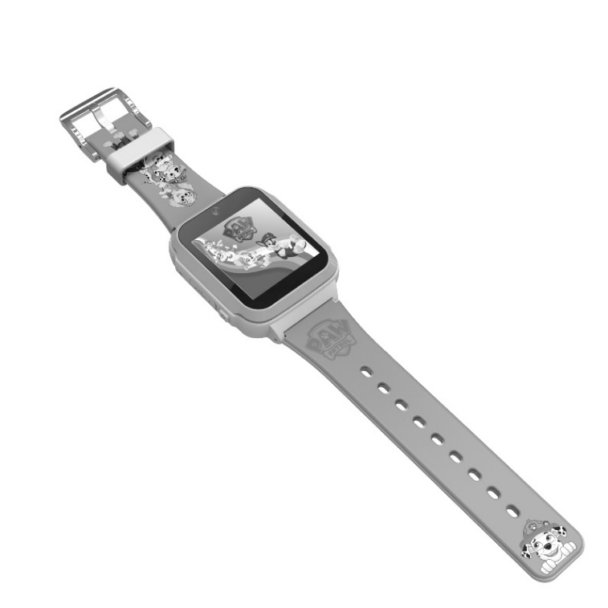
This appliance is not intended for use by persons (including children) with reduced physical, sensory or mental capabilities, or lack of experience and knowledge, unless they have been given supervision or instruction concerning use of the appliance by a person responsible for their safety. Children should always be supervised by an adult during use. Not suitable for children under 3 years of age.

Keep this user manual for future reference or product sharing carefully. Do the same with the original accessories for this product. In case of warranty, please contact the dealer or the store where you bought this product.

Enjoy your product * Share your experience and opinion on one of the well-known internet portals.
Contents
Warnings 3
Safety instructions 3
Features 4
Product overview 4
Technical specifications 4
Box contents 5
SIM Card specification 5
Prepare SIM Card 5
Install SIM Card 6
Function of the buttons 6
SOS Button 6
Power / Return Button 6
Charging 6
Download 4G Locafind App 7
Activation procedure 7
4G Kids-Watch Menu 8
Chat 8
Contacts 8
Videocall 8
Video 9
Camera 9
Photos 9
Fitness 9
Setting 9
General 10
Sound 10
Display 10
Watch face 10
Menu 11
Tracker ID 11
Network 11
About 11
Tools 12
Buddies 12
Exercise reminder 12
Calculator 12
Stopwatch 12
Timer 12
Temperature 13
Vital values 13
4G LocaFind App 14
Tracker (Home page) 14
Chat 14
Message 15
Me (Account settings) 16
Child information (Tracker) 17
Tracker list 18
Location 18
Call 18
Access 19
More 19
Map 21
Location 22
Vital values 22
Steps (Fitness) 22
Heart rate 23
Blodd pressure 23
Body temperature 24
Blood oxygen 24
Declaration of Conformity 25
Support 25
Care and maintenance 25
Disposal 26

Warnings
●Keep packaging parts away from children. They are not part of the product. ●Danger of burns from battery acid! The battery can be life-threatening if swallowed. In case of contact with battery acid, rinse the affected area with clean water and consult a doctor immediately! ●Keep the product away from moisture, wetness and extreme heat. ●Never immerse the product in water or other liquids. ●Technical specifications are subject to change without notice. ●Never fully discharge the battery, as this will shorten its useful life. ●Please clean the wristband regularly with warm water and soapy water. This will help prevent discoloration over time. ●If the battery needs to be stored, it is recommended to store it with 30% of its charge capacity. Protect from direct sunlight. Ideal storage temperature: 10-20°C. ●Keep the product away from small children.

Safety instructions
●Conversion or modification of the product will affect product safety. ●All modifications and repairs to the device or accessories must be carried out exclusively by the manufacturer or by persons expressly authorized by the manufacturer. ●The independent opening of the product and the performance of any repairs is not permitted! Handle the device with care. It can be damaged by shocks, impacts or even by falling from a low height. ●Never heat the battery above 60°C, do not drop it and do not throw it into a fire. There is a risk of explosion/fire! ●Do not short-circuit the battery terminals. ●Do not subject the battery to mechanical stress. Ensure that the battery is not dropped, subjected to impacts, bent, twisted or disassembled. If the battery overheats, immediately interrupt the charging process. A battery that overheats or deforms during charging is defective and should no longer be used.

Features
- Voice and video calls
- GPS location and safety zone setup
- SOS button
- Always be in touch with your child
- Free 4G LocaFind app for configuration, calls and tracking
- Photo function with fun filters
- Shoot videos of adventures yourself
- Step counter
- Heart rate, blood pressure, blood oxygen and temperature measurement

Product overview
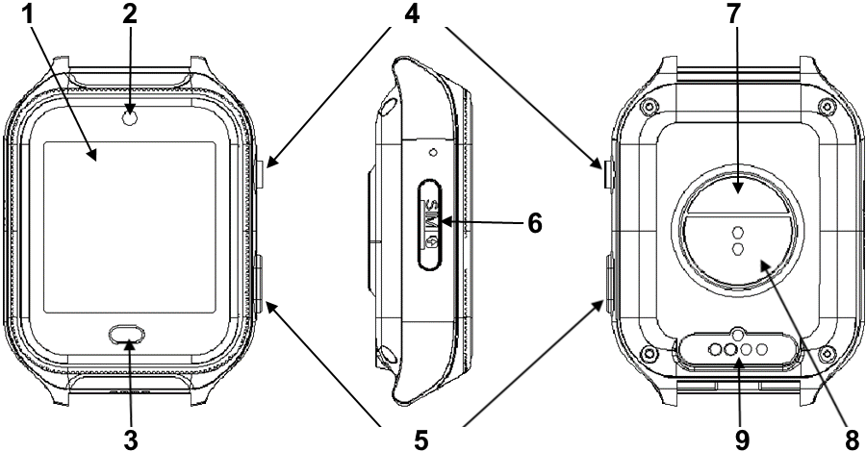
1 | Touch-Display | 6 | SIM card slot
2 | Camera | 7 | Thermometer sensor
3 | Touch Button | 8 | Heart rate sensor
4 | SOS Button | 9 | Charging pins
5 | Power / Return Button

Technical specifications
- 1.54" (3.9cm) color touch display with 240x240 pixels
- Memory: 512MB RAM, 4GB ROM
- 750mAh battery, up to 1.5 days runtime, 3 days standby
- 4G and 3G support
- WLAN 2.4GHz
- Wristband length:22.6cm; wrist circumference: 10-16cm
- Weight and dimensions:58g / (L)57 x (W)42 x (H)17.5mm

Box contents
Check the box contents:
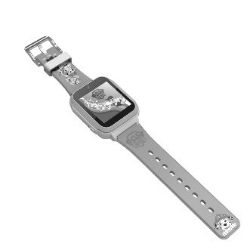 |  | 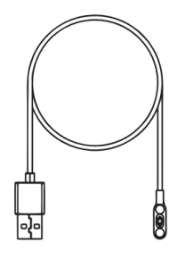
4G Kids Watch | User Manual | Charging cable
NOTE: Please use Technaxx authorized accessories.

CAUTION: Risk of explosion if battery is re-placed by an incorrect type. Do not remove or attempt to remove the non-user-replaceable battery. If you have a problem with the battery, please contact the customer support.

SIM Card specification
Important: Make sure that the contract/prepaid card you are using supports IP cameras and that the network operator allows the connection to the mobile network.
Info: Some network operators exclude devices like IP cameras from using the mobile network by IMEI fencing.

Prepare SIM Card
IMPORTANT: You must remove PIN code from SIM card before use. If the PIN code was forgotten to be removed, it can also be entered via the clock. Note that the PIN code must be re-entered each time the clock is restarted.
4G Kids Watch is compatible with nano-SIM cards of most major mobile providers in the European Union. In order for the watch to work properly, a minimum of 500MB data allowance per month is recommended. | 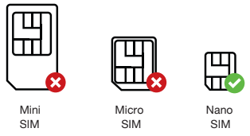

Install SIM Card
(1) With your nano SIM card’s gold contacts facing up, place card into SIM holder tray.  (2) Make sure the tray is facing up so that your card doesn’t fall out.  (3) Steadily slide the tray all the way into the slot. |  |  |  | 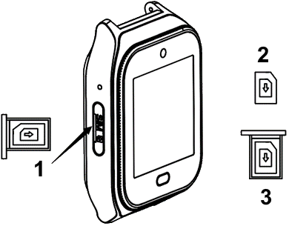
1 | SIM slot | 2 | Nano SIM |  | 3 | SIM holder tray

Function of the buttons
SOS Button  (1) Press and hold for 5 sec to initiate SOS.  Power / Return Button  (1) Press and hold for 4seconds to turn it on or off.  Note: Off is only possible when SIM card is not inserted or recognized. Otherwise the watch restarts.  (2) Short press to return. |  |  |  | 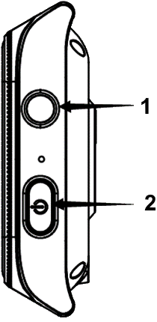
1 | SOS Button | 2 | Power / Return Button

Charging
This device has a rechargeable battery. It must be fully charged before first use. NOTE: Charge the battery of the device every 2–3 month if it is not used!
(1) Use only Technaxx authorized magnetic charging cable.  (2) Connect the magnetic charging cable as shown on the right.  (3) Charge for the watch more than 15 minutes from complete power off before use. Please use an output voltage of 5V and current above 500mA. |  |  |  | 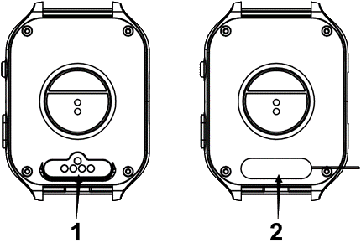
1 | Charging Port | 2 | Connect charging cable

Download 4G Locafind App
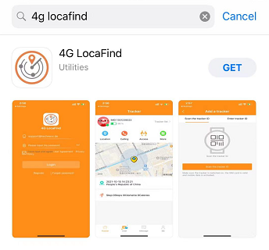
4G LocaFind app is available in Apple and Google app store. Search the App by “4G LocaFind”.

Activation procedure
(1) Ensure the SIM is active with sufficient voice and data allowance.
(2) If necessary, charge the watch.
(3) Open 4G LocaFind App and register if it is the first time.
(4) Go to “Me”, press on the robot icon and add your mobile number.
(5) Scan the QR code of the watch with the app. Can be found at:
Settings (tap 3 times to open) Tracker ID
(6) Choose your relationship with the child.
(7) Provide your child’s profile information as well as the phone number of the watch (Mobile No. of Tracker).
(8) Once it’s successfully connected, the watch may take a few minutes to fully synchronize with the app.

NOTE: The service performance may vary by the mobile network coverage.

4G Kids-Watch Menu
Functions and settings of the clock briefly explained. The touch display (1) is mainly used to navigate through the menu. To exit a function or setting, or to return to a previous setting, press either the touch button (3) or power/return button (5).

To see the signal strength of the cellular network and the current battery level of the watch, drag/swipe down the screen from the top of the display. Here you also get a fast access to volume, settings, screen brightness, fitness and the cleaning tool.

Chat
The chat is a group chat. Everyone who has access to the watch via the 4G LocaFind app can use it.
Voice messages and photos can be sent in the chat. By pressing and holding the microphone on the display, voice messages up to 15s long can be created. By pressing the icon at the bottom right, the taken photos are displayed. Select a photo to send it. If no photos have been taken with the camera, no photos are displayed here.

Contacts
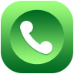 | Shows contacts that have been entered via the 4G LocaFind app under Phonebook. After the first start, no contacts are stored here yet. Therefore, you will see the text "Add contacts via phonebook in the app" here.  Deposited contacts are called via the mobile network as a voice call and any costs are incurred, depending on the selected tariff options of the SIM card inserted in the watch.

Videocall
Shows the people who have access to the watch via the 4G LocaFind app, as well as friends who also have a watch and have been connected.
All the people listed here can be contacted via video call. To start the video call, simply press on the name of the desired call partner.
A data plan option (recommended: 300-500MB) is required for video calls.

Video
With the Video function, you can record small, simple videos. These are saved on the watch.
Info: However, the videos can only be played back on the watch. There is no possibility to export them.

Camera
With the Camera function, shoot photos either with or without filters. Change the filters by pressing the arrow keys on the display. You can take a photo by pressing the shutter button at the bottom left. You can access the photos you have taken by pressing the icon at the bottom right.

Photos
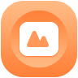 | Under Photos you will find all photos taken as well as videos. Scroll through the overview to view the photos/videos. By pressing on a photo, it will be enlarged. A trash can appears at the top right edge, which you can use to delete the photo/video.  In the overview, you can select photos/videos by pressing Select. The selected photos/videos get a green tick. By pressing the trash can in the upper right corner, all selected photos/videos are deleted.

Fitness
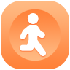 | The steps covered are displayed here. After the first start, no steps are displayed here yet. Therefore, you will see the text "Please open the steps in the app" here. To activate the function, open the 4G LocaFind app and select the step counter setting under More and activate it.

Setting
To open the settings, press the display 3 times in succession. You will now find the following settings:
General, Sound, Display, Dial, Menu, Tracker ID, Network and About.

General
- Here you can manually "Set date and time". However, this is only necessary in exceptional cases. The current date and time are synchronized via the existing Internet connection.
- If you want to change the "Language" this is possible here. Choose between the languages: Cestina, Dansk, Deutsch, English, Espanol, Francais, Italiano, Nederlands, Norsk bokmal, Polski, Portugues, Suomi, Svenska, Русский and український.
- The “Allow external calls” setting allows you to specify whether or not phone calls not saved by you in the phonebook in the 4G LocaFind app can be accepted on the watch. By default, the setting is set to No. This means it is not possible to call the watch if the phone number is not stored in the watch.
- Restart the watch or reset the watch via the "Restart and reset" setting.

Sound
- Customize the "Ringtone" for voice and video calls to your preference.
- Adjust the "Volume" for calls, media and ringtone here.
- Customize the type of notification, by ring & vibrate, ring only or vibrate only, under "Ring, Vibrate".

Display
- Under "Adjust brightness", change the illumination intensity of the display.
- Under "Automatically turn off the screen", select the interval 15s, 30s or 1min after which the display automatically turns off when not in use.
- Activate the "Display lock" and store a 4-digit code that only you can use to unlock the clock. Hint: Do not forget it!

Watch face
- Under "Replace watch face" you can select one of the pre-installed watch faces to display the time.
- You can display captured photos as a watch face via "Custom watch face".

Menu
- Choose between Standard, Rotate or Zoom Out to adjust the "Swipe Effect" to your needs. The swipe effect occurs when swiping and thus switching between functions (icons).
- In "Menu mode" you change the number of displayed functions (icons) per page. You can display the functions (icons) in Four icons, Single icon or Nine icons per page in the menu.
- Via "Swap motif" you can adjust the background in the menu. To do this, select one of the preinstalled backgrounds.

Tracker ID
- You need the "Tracker ID" to connect the watch with the 4G LocaFind app. Scan the QR code with the 4G LocaFind app. The QR code contains only the Tracker ID. The tracker ID is used to register the watch with the server.
- Scan the QR code under "Download App" to download the 4G LocaFind App from the corresponding Appstore (Android/iOS).

Network
- Connect the watch to known "WLAN" routers to save power and improve location.
- The "APN" is automatically selected by the inserted SIM card. If there are still problems with mobile reception, you can adjust the APN of your provider here.
- If it is necessary abroad, switch the "Data roaming" on or off here.
- The "Mobile data" should always be switched on, because all data is transmitted via it. Without mobile data, there is no communication between the watch-server app.

About
- The "cleaning tool" can be used to clear the temporary memory as well as the cache of the clock. If the watch seems slower than usual or hangs in execution, use these functions. No photos/videos will be deleted as a result.
- The watch has a non-expandable internal "memory". You can check the allocation of this here.
- Under "System update" you can see the currently installed firmware version. If a system update is necessary, it is performed here.
- The displayed QR code contains the device's IMEI. This is also displayed in full underneath.
- Here you will find the "MAC address" of the clock, which can be seen in WLAN networks or is necessary for the router settings.

Tools
Under tools you will find the friends, motion reminder, calculator, stopwatch and timer functions.

Buddies
To add friends, at least one other 4G Kids-Watch from Technaxx is required. A maximum of 4 friends can be added. The prerequisite for this is an inserted SIM card with a booked data tariff. To add, both watches must be at a maximum distance of 20cm from each other. Shake both watches at the same time. The vibration indicates that the friend search has started. The search is successful when the tracker ID is displayed and the icon in the watch has changed from black and white to colorful. The friends can now exchange voice messages or video calls with each other.

Exercise reminder
Set an exercise reminder. This reminds you to move regularly.

Calculator
A simple calculator with the 4 basic arithmetic operations.

Stopwatch
Simple stopwatch with seconds, minutes and hours display.
Info: The stopwatch must remain open and cannot continue to run in the background. If you go back by pressing the touch button (3) or the power/return button (5), the stopwatch is reset. When the stopwatch is running, the display is not automatically switched off.

Timer
The timer is set by swiping over hours, minutes and seconds. Press Start to start.
Info: The timer continues to run in the background and even when the display is switched off.

Temperature
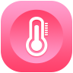 | Measure the body temperature and the skin temperature.  - The body temperature measurement can only be started when the watch is put on the wrist. If the watch is not worn on the wrist, you will see the prompt "Put on watch" on the display. If you see "Wear tracker for 5 minutes" in the display, you can start the measurement. The longer the watch is worn on the wrist, the more accurate the temperature, as the sensor must first adapt to the skin temperature.  - The skin temperature measurement can be started at any time.  - The history shows the last measured body temperatures.  Info: The displayed body temperature is a value calculated from the skin temperature and serves only as a reference value and may differ from the actual value.

Vital values
Measure blood pressure, heart rate (pulse) and blood oxygen.
The measurement can only be started if the watch is attached to the wrist. If the watch is not attached to the wrist, you will see the "Put on watch" prompt in the button on the display. As soon as a measurement can be performed, the button shows "Start measurement". Press it and wait until the measurement is completed.
Info: The measured values serve only as a reference value and may differ from the actual values.

4G LocaFind App
Functions and settings of the app briefly explained.

Tracker (Home page)
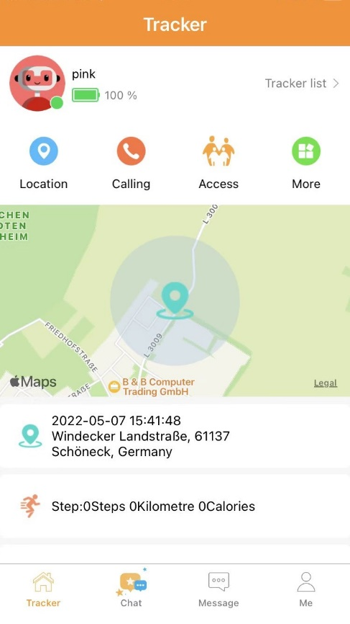 | The home page shows you the information about the selected tracker/watch. From here it is possible to make settings for the watch, as well as perform interactions with the watch.  Chat, location (safety zone, playback), call (mobile) and under More video call or voice call (Internet), as well as the photo album. Furthermore, you can activate intervals for measuring heart rate, blood pressure, blood oxygen and body temperature here. Under More, it is also possible to activate automatic tracking and the pedometer.

Chat
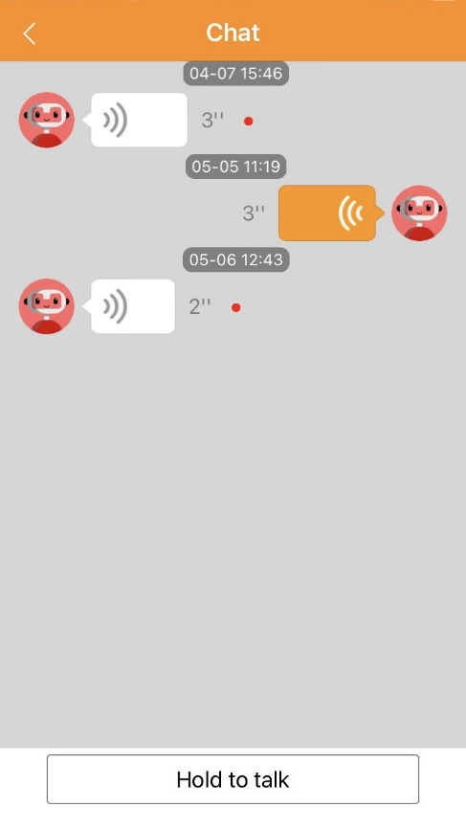 | The chat function is a group chat. It only uses voice messages for communication. It is also possible to send photos to the chat from the watch. All persons who have been given access to the watch use this chat.  Info: There are no individual chats.  To send a voice message press and hold the "Hold to speak" button while speaking. The maximum length is 10s. The voice message can be canceled by swiping up while recording.

Message
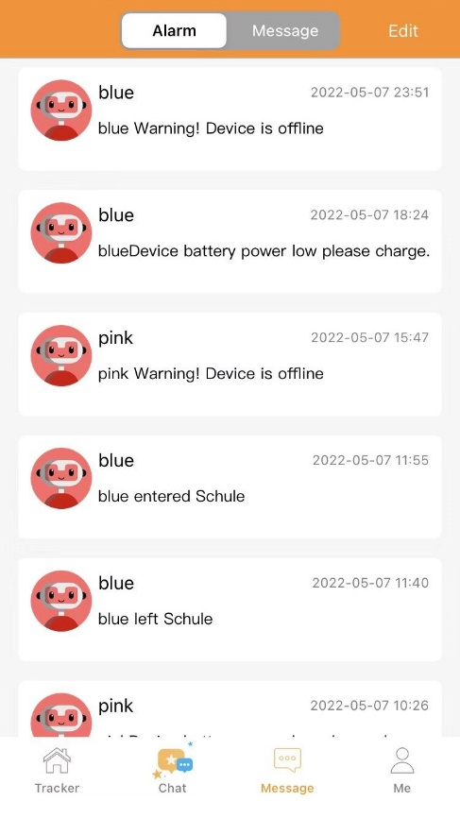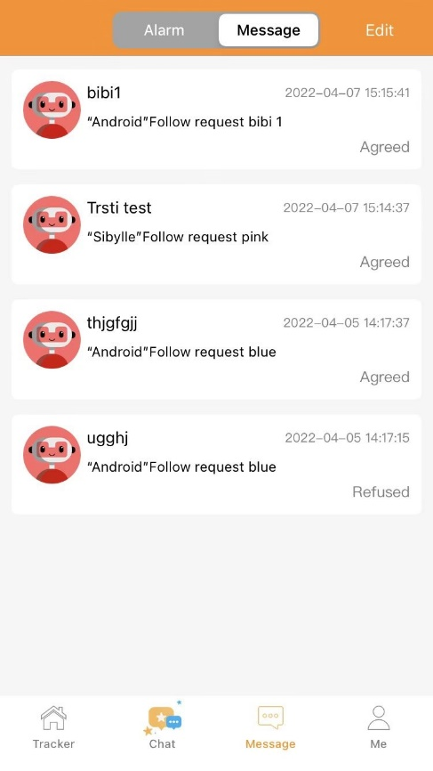 | The item Message is divided into Alam and Message.  - Alarm: Under Alarm you will find notifications which you can also receive as push notifications.  - Entering/leaving the security zone  - The device needs to be charged because the battery is low.  - The device is offline. Either because it has no reception or because it has been switched off.  - The vital signs are abnormal. When receiving such a notification, it is recommended to check the value in the overview and contact the child if necessary.  - Message: Under Message, requests from other people about access to the clock are displayed to you as an admin. Confirm the requests to allow the person to access the clock.  Info: Make sure that the corresponding person should really get access!

Me (Account settings)
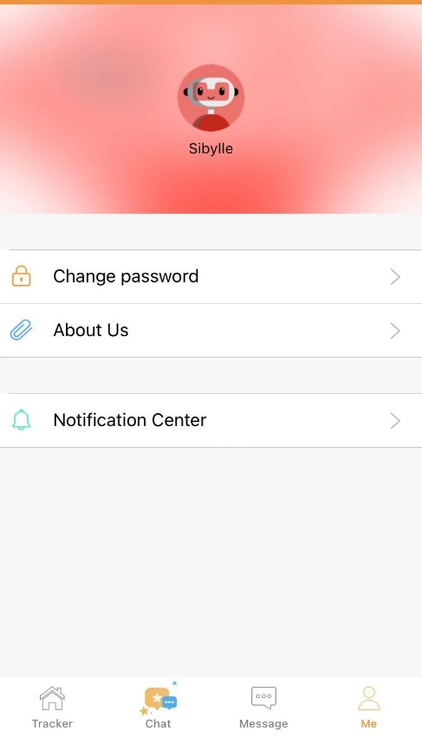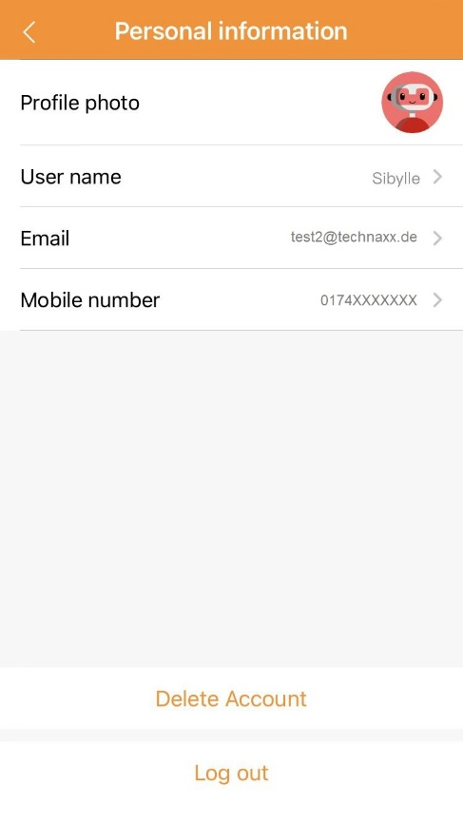 | Under Me you will find the data of your account  - Profile: Click on the profile picture (robot). A new page will open.  - Profile picture: Change your profile picture.  - Username: Enter a username. This will be displayed on the clock.  - Email: Displays the email address you registered with.  - Cell phone number: Enter the cell phone number of your smartphone.  - Delete account: Your account will be deleted irrevocably after confirmation.  - Logout: The current account will be logged out after confirmation.  - Change password: To change the password enter your current password under old password and then assign a new one. The new password must be repeated in the third line for confirmation.  - About us: app version, address, terms of use and privacy policy.  - Message Center: Change the settings of incoming push notifications.

Child information (Tracker)
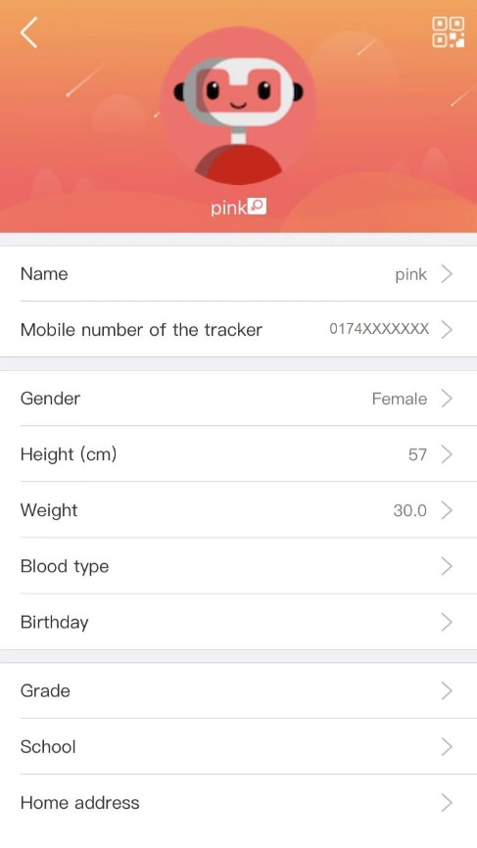 | 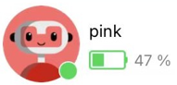  Entering the data of the tracker / child. To update, change or add data click on the profile picture (robot).  - Name: Freely selectable, should be specified to distinguish different trackers.  - Mobile number of the tracker: Enter the mobile number of the SIM card inserted in the watch. This is important so that you can communicate with the watch via the app.
- Information such as height and weight provide more accurate values for steps and vital signs.
- The remaining information is generally not necessary. However, they can be seen by anyone who has access to the watch.
Info: The information can only be changed and adjusted by the administrator.

Tracker list
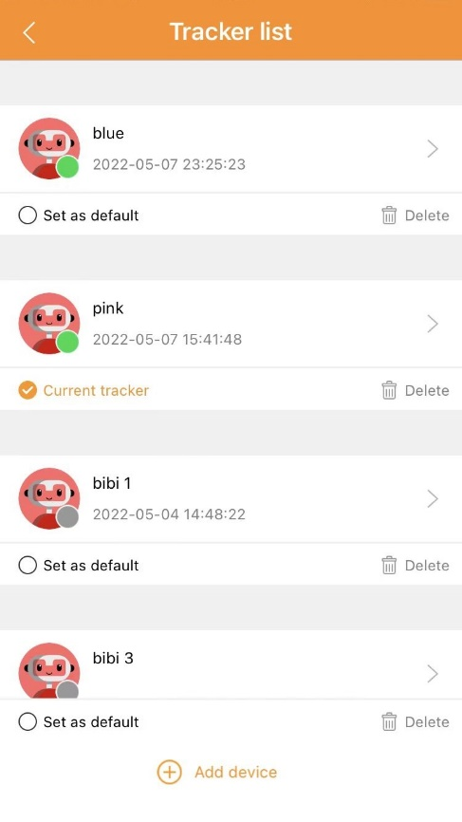 | In the tracker list you will find all trackers / watches that you have added to your 4G LocaFind account. Overview:  - The online / offline status of the watch is displayed. Green = Online; Gray = Offline  - Set Default / Current Tracker: Shows which clock is displayed on the home page. By pressing on the name you open the home page of the clock.  - Delete: If you are the administrator you can choose to "Delete only yourself". Then the administrator role will be transferred to the next person. Or you can choose "Delete all contacts". This will delete all people who have access to the watch.
- Add "₊": Add more watches / trackers. By scanning the QR code (Tracker ID). Then follow the instructions in the app.

Location
Click Location to manually retrieve the current location of the clock. The location on the map updates automatically.
Info: The location can only be retrieved if the watch has reception via mobile data. This is necessary for the transmission of the location

Call
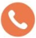 | Click Call to start a voice call via the mobile network with the clock.  Info: The watch also needs reception on the cellular network to accept the call.  If the call fails, please check if the phone number of your smartphone is stored in the 4G LocaFind app under More / Phonebook.

Access
Manage the people who have access to the watch.
Only the administrator can delete members, change the relationship or give administrator rights to another person.
Info: Only one person can be an administrator!

More
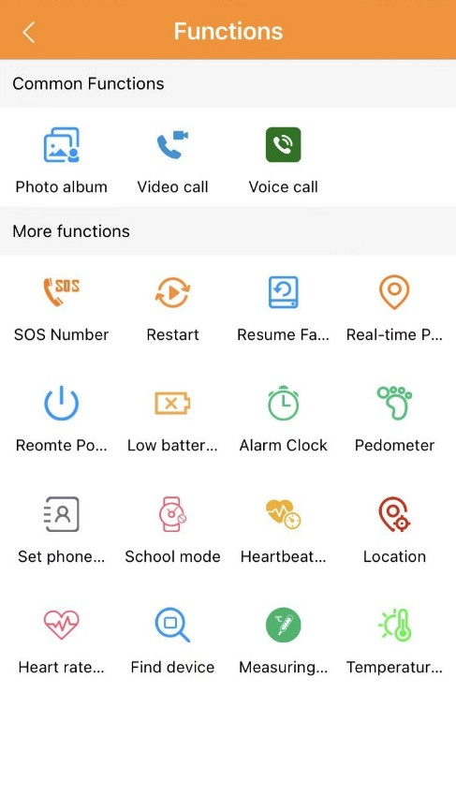 | 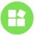  Under More you will find "General functions" and "Other functions". By pressing Execute, the settings are saved and transferred/synchronized to the watch.  Info: Settings under "Additional functions" can only be made by the admin of the watch!  General functions  - Photo album: Here you can find the pictures sent from the watch to the app.  - Video call: Start a video call to the watch here. This is done via the internet.  - Voice call: Start a voice call to the watch here. This is done via the Internet.
Other functions
    - Emergency no. (SOS): Store up to 3 phone numbers that will be called in succession after the SOS button on the watch is triggered.
    - Restart: Restart the watch remotely.
    - Factory settings: Remotely reset the watch to factory settings.
    - Locate: Manually retrieve the current location of the watch.
    - Power off: Remotely turn off the watch.
Important: Switching on the watch can then only be done on the watch itself and no longer remotely!
    - Battery warning: Activate the battery warning to receive push notifications when the battery is low.
    - Alarm Clock: Set up to 5 different alarms for your child.
    - Pedometer: Enable the pedometer to have the watch count the steps your child has taken.
    - Phone book: Open the option to add phone numbers that are allowed to call the watch via the mobile network.
Info: Phone numbers that are not entered here cannot call the clock if "Allow external calls" is deactivated (No) in the watch.
    - School mode: The clock cannot be accessed in the stored time interval. Only access to the time and SOS calls are possible during the activated school mode. Up to 10 time intervals can be set up.
Info: The "Search tracker" function during activated school mode only makes the display light up. But calls make the watch ring, just not when the watch is set to vibrate.
    - Heart rate: Set the interval in which the heart rate, blood pressure and blood oxygen are automatically measured. The interval must be specified in seconds. Sensible entries: 30min = 1800s; 15min = 900s or 10min = 600s. The measurement is displayed under Tracker (home page).
    - Location: Activate/deactivate the automatic locating. If automatic locating is enabled, a location is determined every 15min. The location is displayed under Tracker (home page) on the map.
    - Heart. Measurement: Perform a manual measurement of heart rate, blood pressure and blood oxygen. The measurement is displayed under Tracker (home page).
- Search tracker: The watch will start ringing after you click execute. The ringing on the watch can only be stopped by pressing a button, touch button (3) or power/return button (5)) on the watch.
    - Temp. measurement: Perform a manual measurement of the body temperature. The measurement is displayed under Tracker (home page).
- Body temperature: Set the interval at which the body temperature should be measured automatically. The interval must be specified in full hours. Useful to enter: 1h. The measurement is displayed under Tracker (home page).

Map
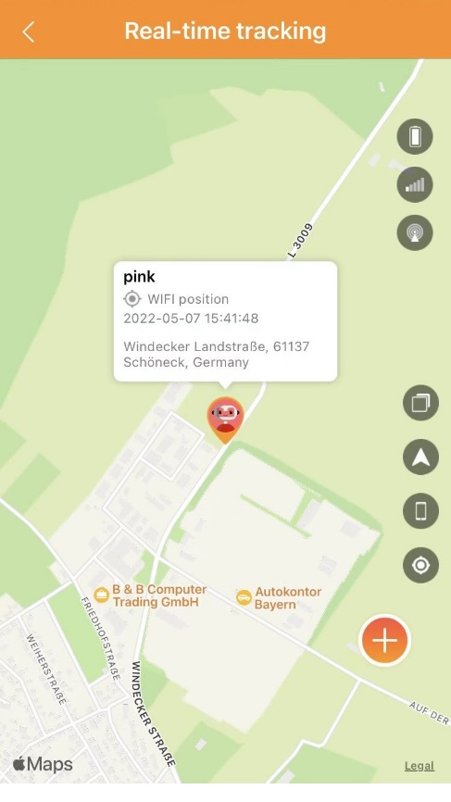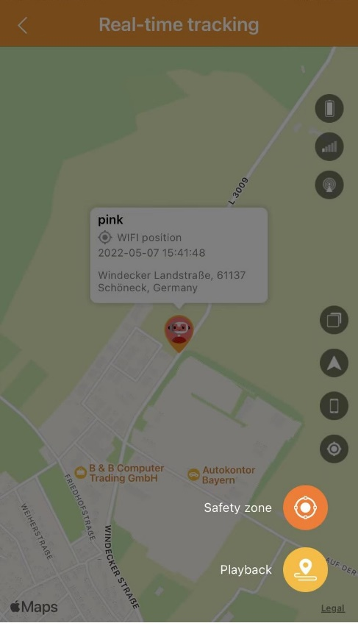 | 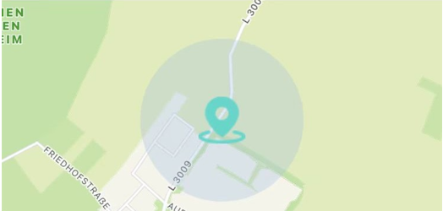  The last transmitted location is displayed on the map. Pressing on the map opens the real-time tracking. The symbols, from top to bottom, on the right side in the picture have the following meaning:  - Battery level of the watch  - Mobile signal strength of the watch  - Location signal strength of the watch  - Switch map view (map view; satellite view)  - (iOS only) Switch to view in Apple Maps / Google Maps  - (iOS only) Show / hide smartphone location  - Query location manually  - Use the "₊" to set up security zones as well as open playback.  - Create safety zones such as for home or school. If the child enters the stored safety zone, you will receive a push notification.  - When creating the safety zone, you assign a name and choose whether you want to be notified when leaving, entering or leaving&entering. With Execute the security zone will be saved.  Info: Up to 3 security zones can be created.  Tip: Activate the automatic location.  - The playback shows the determined locations. The manual as well as the automatic locations are displayed.

Location
Clicking on the location opens the map.

Vital values
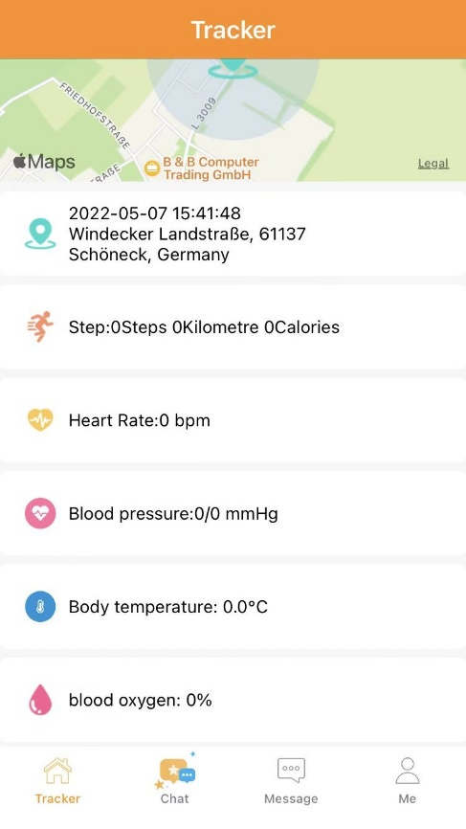 | On the home page of the watch (Tracker), you can see the transmitted vital values of the watch. If this is not the case, activate the corresponding functions under More.  - Steps = Step counter  - Heart rate manual: Heart rate  - Heart rate auto: Heart. Measurement  - Blood pressure manual: Heart rate  - Blood pressure auto. Measurement  - Body temperature manual: Body temperature  - Body temperature auto.: Temp. measurement  - Blood oxygen manual: Heart rate  - Blood oxygen auto. Measurement

Steps (Fitness)
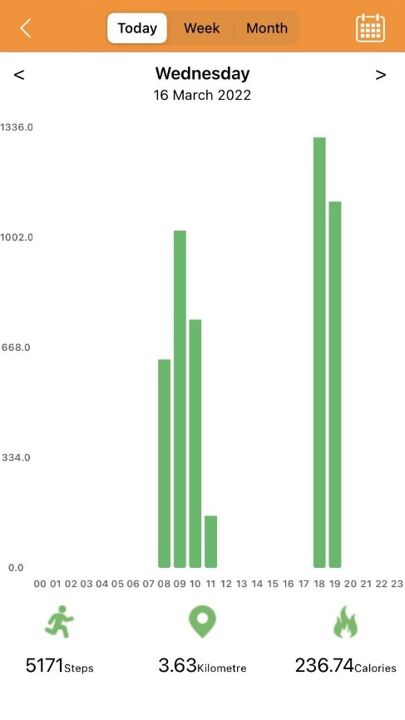 | By clicking on Steps on the home page, you open the bar view of the steps taken. In addition, the kilometers covered and calories burned are displayed.  Important: Kilometers and calories are only calculated values and can differ from the actual value!  The chart can display the values for today, week or month.

Heart rate
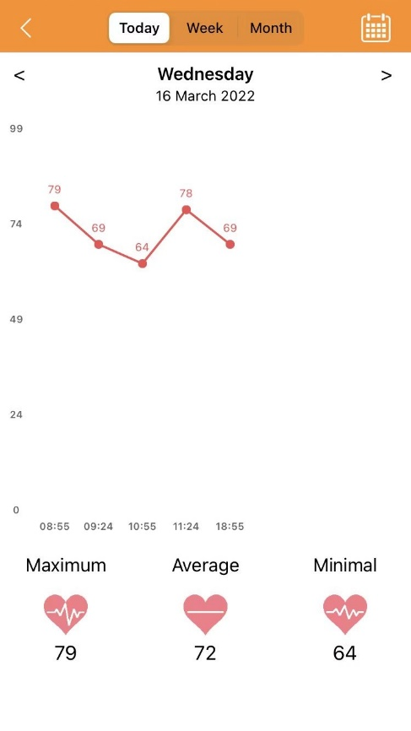 | 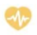  By clicking on Heart rate on the home page, you open the curve view of the heart rate readings. In addition, the maximum, average and minimum heart rate are displayed.  Important: The heart rate is only a measured value and may differ from the actual value! It serves only as a reference value.  The curve can represent the values for today, week or month.

Blodd pressure
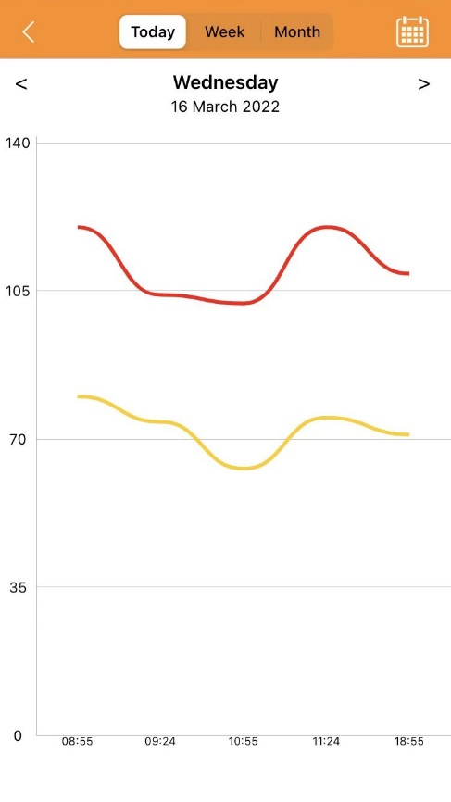 | By clicking on Blood pressure on the home page, you open the curve view over the measured values of the blood pressure.  Important: The blood pressure is only a measured value and may differ from the actual value! It serves only as a reference value.  The curve can represent the values for today, week or month.

Body temperature
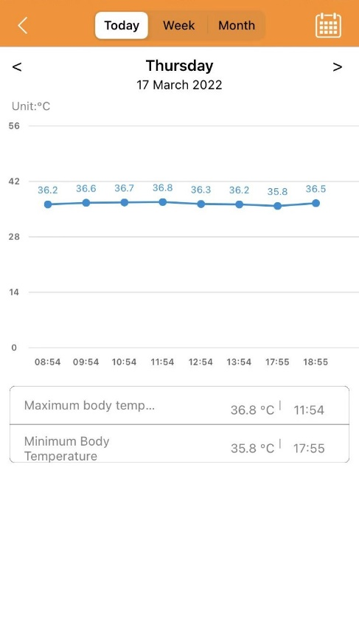 | 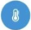  By clicking on Body temperature on the home page, you open the curve view over the measured values of the body temperature. In addition, the maximum and minimum body temperature are displayed.  Important: The body temperature is only a measured value and may differ from the actual value! It serves only as a reference value.  The curve can display the values for today, week or month.

Blood oxygen
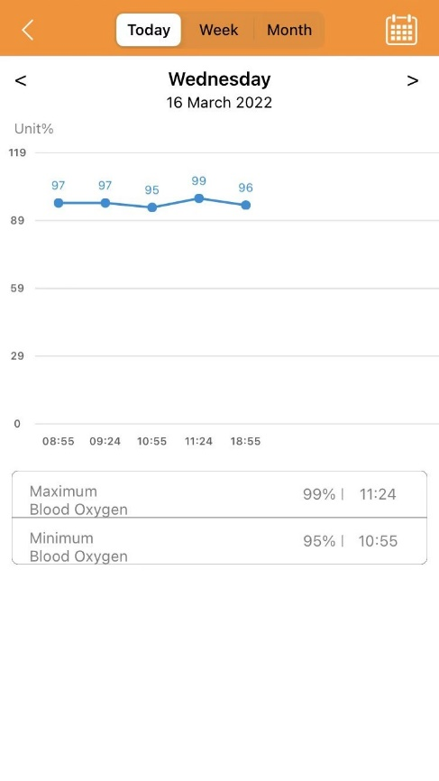 | By clicking on Blood oxygen on the start page, you open the curve view of the measured values of blood oxygen. In addition, the maximum and minimum blood oxygen are displayed.  Important: The blood oxygen is only a measured value and may differ from the actual value! It serves only as a reference value.  The curve can represent the values for today, week or month.

Declaration of Conformity
Products marked with this symbol comply with all applicable Community regulations of the European Economic Area.
A "Declaration of Conformity" in accordance with the applicable directives and corresponding standards has been issued by Technaxx Deutschland GmbH & Co KG. This can be requested at the address www.technaxx.de/ (in the bottom bar "Declaration of Conformity").

4G Kids watch complies with the RF (Radio Frequencies) standards by CE which is measured in 0mm and 10mm away from the body.

Frequency | Power
GSM 3/5/8 | 32dBm(±2dBm)
WCDMA 1/5/8 | 22dBm(±2dBm)
LTE-FDD 1/3/5/7/8/20 | 22dBm(±2dBm)
LTE-TDD 40 | 22dBm(±2dBm)
2.4 b/g/n | 20dBm(±2dBm)
Operating temperature | -10°C to 45°C
Highest SAR value | 1.99W/kg

Support
Service phone No. for technical support: 01805 012643 (14 cent/minute from German fixed-line and 42 cent/minute from mobile networks).
Free Email: support@technaxx.de
The support hotline is available Mon-Fri from 9 am to 1 pm & 2 pm to 5 pm

Care and maintenance
Clean the device only with a dry or slightly damp, lint-free cloth.
Do not use abrasive cleaners to clean the device.
Since this device is an electronic product, avoid the following practices to prevent damage to the product:
●Using the device at extremely high or low temperatures.
●Storage or use in humid environments.
●Use in rain or water.

Disposal
Disposal of the packaging. Sort packaging materials by type upon disposal.
Dispose of cardboard and paperboard in the waste paper. Foils should be submitted for recyclables collection.
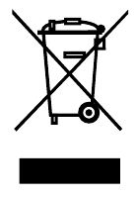
Disposing of old equipment (Applies in the European Union and other European countries with separate collection (collection of recyclable materials) Old equipment must not be disposed of with household waste! Every consumer is required by law to dispose of old devices that can no longer be used separately from household waste, e.g. at a collection point in his or her municipality or district. This ensures that the old devices are properly recycled and that negative effects on the environment are avoided. For this reason, electrical devices are marked with the symbol shown here.

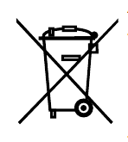
Batteries and rechargeable batteries must not be disposed of in household waste! As a consumer, you are required by law to dispose of all batteries and rechargeable batteries, whether they contain harmful substances* or not, at a collection point in your community/city or with a retailer, to ensure that the batteries can be disposed of in an environmentally friendly manner. * marked with: Cd = cadmium, Hg = mercury, Pb = lead. Return your product to your collection point with the fully discharged battery installed inside!

Made in China
Distributed by:
Technaxx Deutschland GmbH & Co. KG
Konrad-Zuse-Ring 16-18,
61137 Schöneck, Germany

4G Kids-Watch

