Technaxx®
Jumbo Power Bank 15000mAh TX–79
User Manual
The Declaration of Conformity you find here: www.technaxx.de/ (in bar at the bottom “Konformitätserklärung”). Before using the device the first time, read the user manual carefully. This device has a rechargeable battery. It must be fully charged before first use.
Service phone No. for technical support: 01805 012643 (14 cent/minute from German fixed-line and 42 cent/minute from mobile networks). Free Email: support@technaxx.de

Features
● Charging the most mobile devices (e.g Smartphone, tablet PC, ebook reader, etc.)  Built-in rechargeable 15000mAh lithium battery (type 18650) with 3.7V/55.5Wh  Back up power on the go  Usable as charger and torch light at the same time  2 USB outputs for simultaneous charging of two digital devices  Built-in protection against overcurrent, short circuit, overload/-charge and overvoltage  Charging status is shown by 4 LEDs  Ideal for traveling

Technical specifications
Built-in rechargeable 15000mAh lithium battery (type 18650) with 3.7V/55.5Wh
Charging time | ~13–14 hours
Input voltage / Current | DC 5V / 1.5A
Voltage / Current: Output1 & Output2 |  | 5V/1A & 5V/2A
Working temperature | –10°C up to +50°C
Weight / Dimensions | 340g / (L) 16.0 x (W) 6.2 x (H) 2.2cm
Package Contents | Jumbo Power Bank 15000mAh TX–79, Micro USB to USB charging cable, User Manual
View of the device
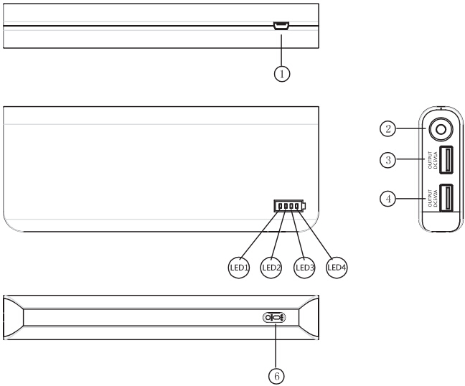
1) Micro USB charging connector
(input)

2) LED indicator (illuminated)

3) Output DC 5V/1A

4) Output DC 5V/2A

5) Battery indicator lights
(LED1–LED4)

6) ON/OFF button

Charge the Power Bank fully before use
(1) Via 5V/1A charger* (*not included) or DC 5V/1.5A wall charger* (*not included). Connect the USB port of the charger with the Micro USB port of the Power Bank by using the provided Micro USB cable. (2) Via Computer/Notebook: Connect the USB port of a computer/notebook with the Micro USB port of the Power Bank by using the provided Micro USB cable. During charging the BLUE LED is lighting. The number of BLUE LED´s lighting is depending on the amount of power in the power bank: 1 LED is lighting → Power Bank is almost empty. 4 LEDs are lighting → Power Bank is almost fully charged. It takes ~13–14 hours to fully charge the Power Bank. When the charging is complete, all LEDs will remain until you disconnect the Power Bank from the power supply. Attention: Charge the power bank fully before use! Charge at least 13–14 hours before first use.
Battery indicator while charging
Capacity | LED1 | LED2 | LED3 | LED4
0-25% | Blinks slowly | Off | Off | Off
25-50% | Turns solid | Blinks slowly | Off | Off
50-75% | Turns solid | Turns solid | Blinks slowly | Off
75-100% | Turns solid | Turns solid | Turns solid | Blinks slowly
Battery indicator while discharging
Capacity | LED1 | LED2 | LED3 | LED4
75-100% | Turns solid | Turns solid | Turns solid | Turns solid
50-75% | Turns solid | Turns solid | Turns solid | Off
25-50% | Turns solid | Turns solid | Off | Off
0-25% | Turns solid | Off | Off | Off

Operating
Press short the On/Off button to get the Power Bank working. The battery indicator shows the existing capacity. Press the On/Off button continuously to turn on or turn off the illuminating indicator. Warning: Make sure voltage of product to be charged is not higher than the capacity of the TX-79, otherwise the Power Bank may be damaged. Refit is not allowed. Short circuit, disassembly, throwing into fire/water are prohibited and keep it away from moisture/water.

Charging your Smartphone or another mobile device
NOTE: For best performance, make sure that Power Bank is fully charged. Regularly examine the USB charging cable for any damage to their cord plug, enclosure and other parts. (1) Insert the end of the included Micro USB cable or the original cable that came with your device into the phone. Insert the other end into Power Bank. (2) Turn the Power Bank on by pressing the power button. The charging process will start. To turn OFF the Power Bank, press and hold the power button long. Charging time will depend on the type of device, your device will display the charging progress. (3) When charging is complete, disconnect the Power Bank from your mobile device.
Capacity | Charging  time | iPhone 5 | iPhone  6s Plus | Sony Z1, Z2 | Galaxy Note3 | Galaxy  S4, S5 | Galaxy S7 edge
15000mAh | ~13–14 hrs. | 7 times | 4 times | 4 times | 3 times | 4 times | 3 times

NOTE
● Because of the power conversion efficiency of the Power Bank and your digital devices, the rated capacity of the Power Bank is not equal to the actual chargeable capacity.  This Power Bank could charge the most of the digital devices, but it is possible that some devices are not supported.  If the Power Bank could not charge your devices, then check if the cable is firmly connected or if the right connector has been chosen, the original cable sold along with your device is always suggested to use.  If the instantaneous current is oversize when charging the digital devices, the Power Bank will turn off to the protected mode automatically.

Important Safeguards / Warnings / Maintenance
● Do not use this unit for anything other than its intended to use.  Do not drop/ bump/shake the device (do not use the unit if it has been damaged in any way).  Do not open/repair/disassamble the device  Do not store the device in high temperature environment/close to open fire/in humid-damp-erosive environments/into water.  Stop using when unusual smell/heating distortion/color-change of the shell material or other abnormal situation happens.  Keep away from children/persons without enough mental ability/persons without enough knowledge to use this product.

Security and Disposal Hints for Batteries: Hold children off batteries. When a child swallowed a battery go to a doctors place or bring the child into a hospital promptly! Look for the right polarity (+) and (–) of batteries! Always change all batteries. Never use old and new batteries or batteries of different types together. Never short, open, deform or load up batteries! Risk of injury! Never throw batteries into fire! Risk of explosion!


Hints for Environment Protection: Packages materials are raw materials and can be recycled. Do not disposal old devices or batteries into the domestic waste. Cleaning: Protect the device from contamination and pollution (use a clean drapery). Avoid using rough, coarse-grained materials or solvents/aggressive cleaner. Wipe the cleaned device accurately. Important Notice: Should battery fluid leak from a battery, wipe the battery case with a soft cloth dry. Distributor: Technaxx Deutschland GmbH & Co.KG, Kruppstr. 105, 60388 Frankfurt a.M., Germany
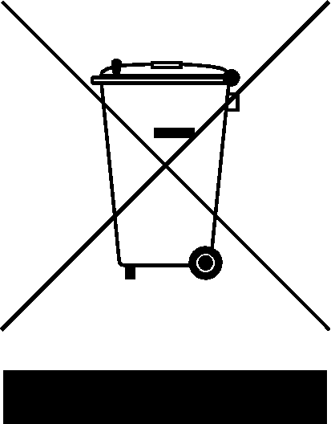

Battery Care Information (the battery is NOT replaceable)
Rechargeable batteries are only to be charged under adult supervision and are only to be charged by adults. Regularly examine the USB charging cable or Smartphone cable** (**not provided) for any damage to their cord plug, enclosure and other parts. In case of damage, do not use it until it has been repaired or replaced.
DISCLAIMER: This charger is meant for using only in conjunction with the appropriate mobile entertainment device. We, the manufacturer, are not responsible for any damages to any mobile entertainment device incurred through use of this product.

