Technaxx®
FMT700 Transmitter
User Manual

FM Transmitter with charging and music playing function.
The charging connector is compatible for iPhone 6 / 6plus / 5s and other iOS devices only!

The Declaration of Conformity for this device is under the Internet link: www.technaxx.de/ (in bottom bar “Konformitätserklärung”). Before using the device the first time, read the user manual carefully.

Service phone No. for technical support: 01805 012643 (14 cent/minute from German fixed-line
and 42 cent/minute from mobile networks). Free Email: support@technaxx.de

Features
● Compatible: iPhone 6, iPhone 6 plus, iPhone 5s, iPod touch (5th generation), iPod nano (7th generation) and iPad (4th generation) ect., iOS devices with 8-pin charging connector slot
● Listen to iPhone / iPod / iPad music from car stereo speakers via FM Transmitter  Charging connector has charging and music playing function  Supports four FM frequency presets, these four frequency can be changed and set by user  Select pre-seted channel and match it with the FM car radio frequency  With Radio-Data-System (RDS)  Big size LCD screen displays digits clearly  Flexible spring cable  Apple MFI licensed product  Easy handling and small size

Technical Specifications
Input | 12–24V (cigar lighter socket of a vehicle)
FM transmitter charging output | 5V / 2.4A
LCD display size | 31 x 20.5 mm
Frequency range | 87.6 – 107.9 MHz
Transmitting distance | ~ 3m maximum
Power input | 12V – 24V
Weight | 40 g (device) / 86 g (device + spring cable)
Dimensions | (L) 10,6 x (W) 4,3 x (H) 3,0 cm
Package Contents | FMT700Transmitter, User Manual

View of device
1 | Input power plug (DC 12–24V)
2 | LCD screen display digits
3 | Music control button
 | Press the button  once to Play or pause the music
 | Press the button twice to play the previous song
 | Press the button three times to play next song
 | Press and hold the button for 3 seconds to Power on/off
 | Frequency preset button “M”
4 | Select the PRESET frequency with pressing the button “M” shortly. You see saved frequency as P1, P2, P3 or P4
5 | With CH– tune down the frequency pressing the button shortly
6 | With CH+ tune up the frequency pressing the button shortly
7 | Retractable spring cable
8 | Charging connector

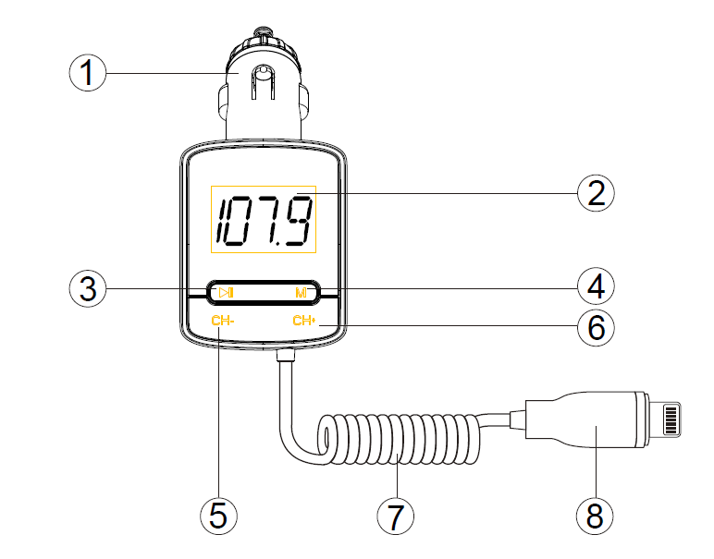

How to preset the 4 frequencies for this device
● This unit can be set 4 pre-set frequencies, they display as P1, P2, P3 and P4.  In order to get a better using effect and not get any interference from local radio station,we suggest all the 4 pre-set frequencies are unoccupied by local fm station.  Press CH+ / CH– to choose the best frequency, then press and hold button “M” for 3 seconds , it will display only one of the P1, P2, P3,or P4, then press CH+ / CH– to choose the one of the four sets, after decided, press button “M” and hold for 3 to fix it and finish the settings.  Press “M” to select one of the four pre-set frequencies, the frequency will show up 1 second after the showing of P1, P2, P3 or P4, and set your car’s FM Radio to the same frequency as any of the pre-set fequency.
NOTE: This product supports low or high transmissions. The low transmission can meet the CE directives but may have interference niose when using it, while the high transmission power will exceed the CE directives but get much better effects when using it. Operations: Press and hold CH+, then press and hold CH– at the same time for 5 seconds.
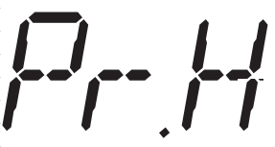

It will display or , repeat the operation to swith between low and high.

Using charging function
When the unit is powered from car lighter socket, plug the charging connector into your iOS devices with 8-pin charging connector, this unit will automatically provide 5V/2.4A output to charge the external device.
Warnings
● To prolong the life of this device, pull it out when starting the engine of the car.
● Do not charge an external iOS device which does not have an 8-pin charging slot.
● Do not attempt to disassemble the device, it may result in short-circuit or even damage.
● Do not drop or shake the device, it may break internal circuit boards or mechanics.
● Keep the device in dry and ventilated environment. Avoid high humidity and high temperature. Also batteries should not be exposed to excessive heat or direct sunlight.
● Keep the device away from little children.

Hints for Environment Protection: Packages materials are raw materials and can be recycled. Do not disposal old devices or batteries into the domestic waste. Cleaning: Protect the device from contamination and pollution (use a clean drapery). Avoid using rough, coarse-grained materials or solvents/aggressive cleaner. Wipe the cleaned device accurately. Important Notice: Should battery fluid leak from a battery, wipe the battery case with a soft cloth dry. Distributor: Technaxx Deutschland GmbH & Co.KG, Kruppstr. 105, 60388 Frankfurt a.M., Germany
