Technaxx®
Additional Bullet & Dome Camera
for Midi Security Kit PRO FullHD 1080P TX-51
for Maxi Security Kit PRO FullHD 1080P TX-50

User Manual
Table of Contents
1 | General Introduction | 3
1.1 | Overview | 3
1.2 | Functions | 3
1.3 | Specifications of the BULLET and DOME camera | 4
2 | Framework & Dimensions & Structure Bullet Camera | 6
3 | Installation Bullet Camera | 7
4 | Menu Bullet Camera | 9
4.1 | Settings | 9
4.2 | Note | 10
5 | Framework & Dimensions & Structue Dome Camera | 11
6 | Installation Dome Camera | 12
7 | Menu Dome Camera | 14
7.1 | Settings | 14
7.2 | Note | 15
8 | Important Safeguards & Warnings | 16
Bedienungsanleitung

Inhaltsverzeichnis

1 | Allgemeine Anweisungen | 17
1.1 | Übersicht | 17
1.2 | Funktionen | 17
1.3 | Spezifikationen der BULLET und DOME Kamera | 18
2 | Rahmen & Maße & Struktur Bullet Kamera | 21
3 | Installation Bullet Kamera | 22
4 | Menü Bullet Kamera | 24
4.1 | Einstellungen | 24
4.2 | Hinweis | 25
5 | Rahmen & Maße & Struktur Dome Kamera | 26
6 | Installation Dome Kamera | 27
7 | Menü Dome Kamera | 30
7.1 | Einstellungen | 30
7.2 | Hinweis | 21
8 | Wichtige Sicherheitshinweise & Warnungen | 32
 | Appendix / Anhang | 34
 | Linux License / Linux Lizenz | 50

1 General Introduction

1.1 Overview
This series megapixel HD camera conforms to the HDCVI standard. It supports video signal high-speed long distance transmission without any delay. It can be controlled by the DVR conforming to the HDCVI.

1.2 Functions
HDCVI Specification: HDCVI（High Definition Composite Video Interface） is an over-coaxial –cable HD video transmission standard. The technology renders two HD video formats by progressive scanning.

ICR: IR cut removal is to filter IR light in the daytime and then auto switch to the general fitter at night. This function allows the camera to output the high sensitivity clear video.

Smart IR technology: The sensor controls the IR light on/off via the combination work of the hardware and software, which realizes the automatically IR light compensation according to the environment illumination.

Auto gain function: To output the standard video signal in the different illumination environments, the amplifier needs to adjust in a wide range. The system can enhance the camera sensitivity in low illumination and enhance the video signal output to get the clear and high definition video.

Auto white balance: The white balance refers to the camera to restore the white object color. It allows the camera to automatically adjust the color temperature in indoor and outdoor environment, just like our human eyes does.

Auto exposure: System can automatically set shutter speed and iris value according to the snapshot video exposure condition.

Auto electronic shutter: The system can automatically adjust the electronic shutter when the environment light changes.

Auto Focus Technology: Detect the location of main screen by the camera auto focus algorithm, and auto adjust focus motor according to the current focus situation, which would realize zoom control the entire auto focus. The image stays clear during the process of zooming.

OSD: User-friendly on-screen display for you to select the different functions.

3D NR: Comparing with the general 2D denoise function, the 3D denoise function can not only denoise the brightness of the video separation signal and saturation signal, it can also denoise the original data from CCD. It greatly enhances noise reduction performance and guarantees clear and bright video.

1.3 Specifications
ENGLISH
Features & Technical Specifications BULLET CAMERA
Video resolution: 1980 × 1225 @ 30 fps (PAL)
High-performance CMOS image sensor with 2.4 Mega pixel
Supports HDCVI HD video output
Transmission distance up to 300m via 75-3 coaxial cable without data loss
High speed, long distance real-time transmission
Automatic ICR switch to realize surveillance both in the daytime and at night
Automatically: exposure, white balance, electronic shutter, gain function
Restore clear and vivid video
Supports IR function with IR LED distance max. 15m
Protection class IP66 (dust and waterproof)
Video frame rate: 25/30/50/60 fps @ 720P & 25/30 fps @ 1080p
Min. illumination: 0.05 Lux @ F1.2 (AGC ON), 0 Lux with IR switched on
Electronic shutter: 1/3 sec. ~ 1/100000 sec. (PAL)
1-channel BNC HDCVI HD video output & CVBS standard definition video output
BLC (BackLight Control): automatically
IR light only is active for video recordings in night mode
Noise reduction of 2D/3D
Colour or Black/White: selectable
Horizontal angle of view: 105.5° ~ 32.9°
Focal length: 2.7 ~ 12.0mm / automatic zoom
Fixed aperture for the brightness
Power: DC 12V ± 10%
Power consumption: 7.44W max. (Input 12V/0.62A) IR 15m max.
Working temperature: – 30°C ~ 60°C
Indoor and outdoor installation: wall mount
Weight / Dimensions: 550 g / (L) 21,3 x (W) 8,0 × (H) 7,2 cm
Package Contents: Bullet camera for Midi Security Kit PRO FullHD 1080P TX-50 & Maxi Security Kit PRO FullHD 1080P TX-51, 1x BNC 18.3m video cable, 3x screws and 3x dowels, User Manual
Features & Technical Specifications DOME CAMERA
Video resolution: 1980 × 1225 @ 30 fps (PAL)
High-performance CMOS image sensor with 2.4 Mega pixel
Supports HDCVI HD video output
Transmission distance up to 300m via 75-3 coaxial cable without data loss
High speed, long distance real-time transmission
Automatic ICR switch to realize surveillance both in the daytime and at night
Automatically: exposure, white balance, electronic shutter, gain function
Restore clear and vivid video
Supports IR function with IR LED distance max. 15m
Protection class IP66 (dust & waterproof) & IK10 (shockproof)
Video frame rate: 25/30/50/60 fps @ 720P & 25/30 fps @ 1080p
Min. illumination: 0.05 Lux @ F1.2 (AGC ON), 0 Lux with IR switched on
Electronic shutter: 1/3 sec. ~ 1/100000 sec. (PAL)
1-channel BNC HDCVI HD video output & CVBS standard definition video output
BLC (BackLight Control): automatically
IR light only is active for video recordings in night mode
Noise reduction of 2D/3D
Colour or Black/White: selectable
Horizontal angle of view: 105.5° ~ 32.9°
Focal length: 2.7 ~ 12.0mm / automatic zoom
Fixed aperture for the brightness
Power: DC 12V ± 10%
Power consumption: 8.6W max. (Input 12V/0.72A) IR 15m max.
Working temperature: – 30°C ~ 60°C
Indoor and outdoor installation: wall mount / ceiling mount
Weight / Dimensions: 450 g / Φ 12.2 × (H) 8.9 cm
Package Contents: Dome Camera for Midi Security Kit PRO FullHD 1080P TX-50 & Maxi Security Kit PRO FullHD 1080P TX-51, 1x BNC 18.3m video cable, 3x screws and 3x dowels, User Manual

This device complies with the requirements of the standards referred to the Directive R&TTE 1999/5/EC. The Declaration of Conformity you find here: www.technaxx.de/ (in bar at the bottom “Konformitätserklärung”). Before using the device the first time, read the user manual carefully. Service phone No. for technical support: 01805 012643 (14 cent/minute from German fixed-line and 42 cent/minute from mobile networks). Free Email: support@technaxx.de

Hints for Environment Protection: Packages materials are raw materials and can be recycled. Do not disposal old devices or batteries into the domestic waste. Cleaning: Protect the device from contamination and pollution (use a clean drapery). Avoid using rough, coarse-grained materials or solvents/aggressive cleaner. Wipe the cleaned device accurately. Important Notice: Should battery fluid leak from a battery, wipe the battery case with a soft cloth dry. Distributor: Technaxx Deutschland GmbH & Co.KG, Kruppstr. 105, 60388 Frankfurt a.M., Germany
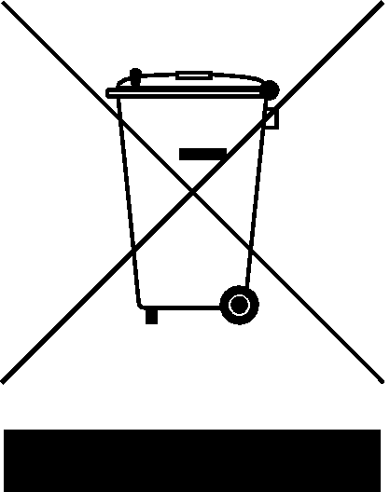

2 Dimensions (unit is mm) & Structure Bullet Camera

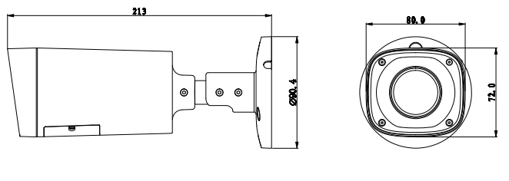
When the standard definition/high definition switch control cable is short circuit, system outputs standard definition video. Otherwise, when the circuit is open, system outputs the high definition video.
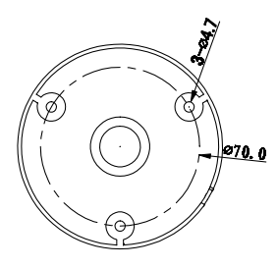
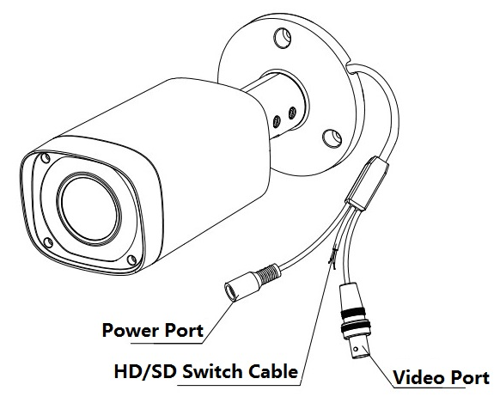

3 Installation Bullet Camera for TX-50 & TX-51
Important: Make sure the installation surface can min support the 3x the weight of the camera and the bracket.

If you drill a hole in the wall, make sure that power cables, electrical cords and/or pipelines are not damaged. When using the supplied mounting material, we do not take the liability for a professional installation. You are entirely responsible to ensure that the mounting material is suitable for the particular masonry, and that the installation is done properly. When working at higher altitudes, there is danger of falling! Therefore, use suitable safeguards.

Step 1: Before you install the bracket, pull the cable through the cable exit of the bracket chassis.

Install the expansion bolt if you want to install in the cement wall (make sure the installation holes of the expansion bolts are the same with the bracket.) Then you can install the bracket. If you want to install in the wood surface, skip the first step and then use the self-tapping screws to install the bracket directly.
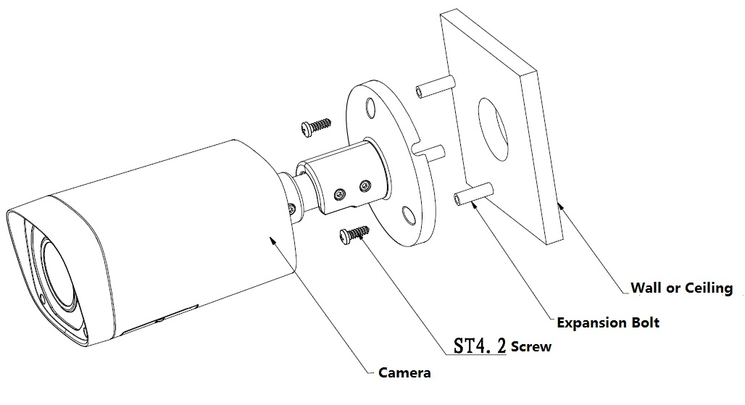

Step 2: Unscrew the M3 x 20 and M3 x 5 screws on the bracket in the direction, adjust the camera to an exact location which needs to be monitored by rotating the bracket and camera body, then secure the bolts.
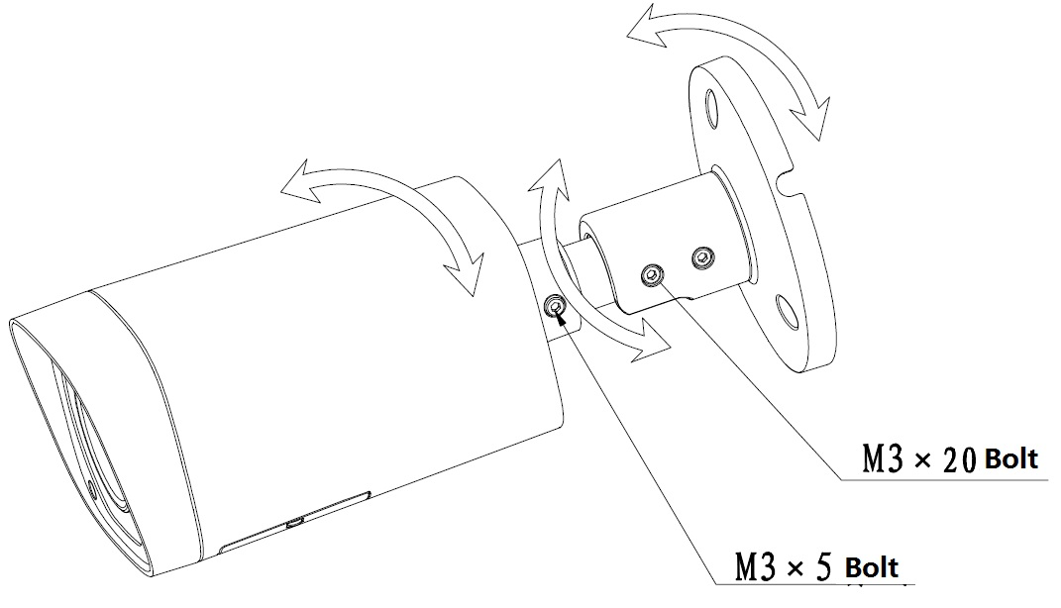

Step 3: Connect the video output port of the device cable to the HDCVI DVR, and connect the power port of the device cable to the power.

Step 4: After the image is shown on the HDCVI DVR, control the interface by HDCVI series DVR PTZ, adjust lens zoom by using coaxial control, and the camera will auto focus to the best position which makes the image clear. So far the camera installation is completed.

4. Menu

4.1 Settings
NOTE: The following operation and interfaces for reference only. Refer to the HDCVI series DVR user’s manual for detailed information.

After connected the camera to the HDCVI series DVR, from Main Menu -> Setting -> System -> PTZ, you need to set control mode as HDCVI and the protocol as DH-SD1. Click Save button to save current setup.

On the preview interface, right click mouse and then select PTZ; you can see this interface.
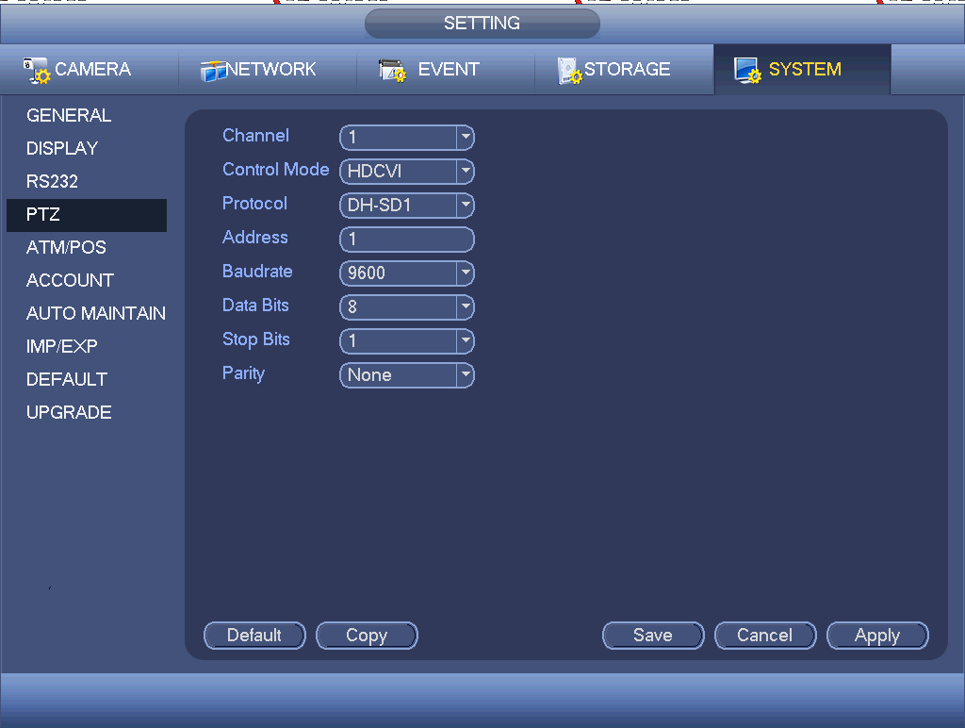
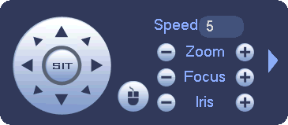

Click Iris “+” to open menu or confirm current operation.
Click Iris “-” to realize auto focus.
Click up/down button to view all the items on the left pane of the following list. Click left/right button to set the corresponding values on the right pane of the following list. If there is “”, click confirm button to go to the 2nd menu. Repeat the previous steps to set detailed value. Click Return button to go back to the previous menu interface.
Click Zoom “+” to zoom in and click Zoom “-” to zoom out.

4.2 Note
Brightness | It is to adjust monitor window bright. The value ranges from 0 to 100. The default value is 50. The larger the number is, the bright the video is. When you input the value here, the bright section and the dark section of the video will be adjusted accordingly. You can use this function when the whole video is too dark or too bright. Note the video may become hazy if the value is too high. The recommended value ranges from 40 to 60.
Contrast | It is to adjust monitor window contrast. The value ranges from 0 to 100. The default value is 50. The larger the number is, the higher the contrast is. You can use this function when the whole video bright is OK but the contrast is not proper. Note the video may become hazy if the value is too low. If this value is too high, the dark section may lack brightness while the bright section may over exposure .The recommended value ranges from 40 to 60.
Saturation | It is to adjust monitor window saturation. The value ranges from 0 to 100. The default value is 50. The larger the number, the strong the color is. This value has no effect on the general brightness of the whole video. The video color may become too strong if the value is too high. For the grey part of the video, the distortion may occur if the white balance is not accurate. Note the video may not be attractive if the value is too low. The recommended value ranges from 40 to 60.
Sharpness | The value here is to adjust the edge of the video. The value ranges from 0 to 100. The larger the value is, the clear the edge is and vice versa. Note there is noise if the value here is too high. The default value is 50 and the recommended value ranges from 40 to 60.
3DNR | It is to reduce video noise. The larger the number is, the lower the noise is. The details of the video may disappear if the value here is too large.
Anti-flicker | - Outdoor: In this mode, you can switch exposure mode to get the effect under the corresponding exposure mode.  - 50Hz: When the current is 50Hz, system can auto adjust the exposure according to the environment brightness in case there is any strip.  - 60Hz: When the current is 60Hz, system can auto adjust the exposure according to the environment brightness in case there is any strip.

5 Dimensions (unit is mm) & Structure Dome Camera
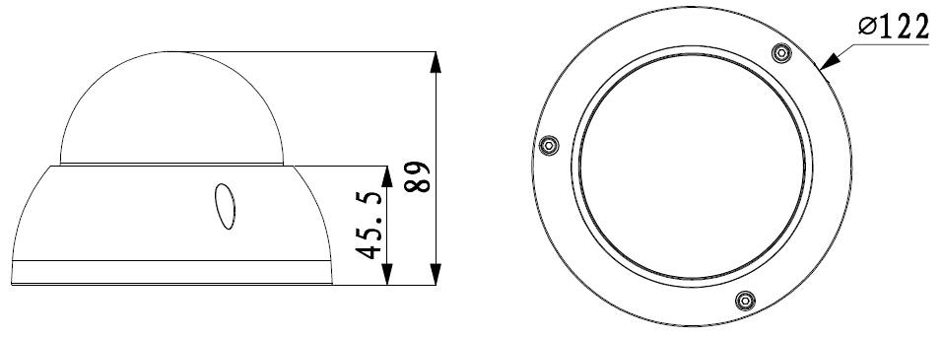
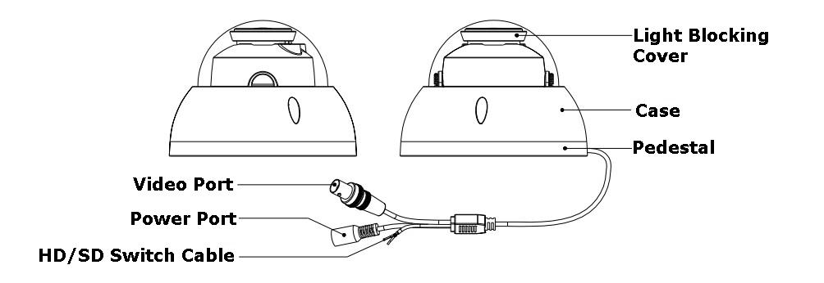

When the standard definition/high definition switch control cable is short circuit, system outputs standard definition video. Otherwise, when the circuit is open, system outputs the high definition video.

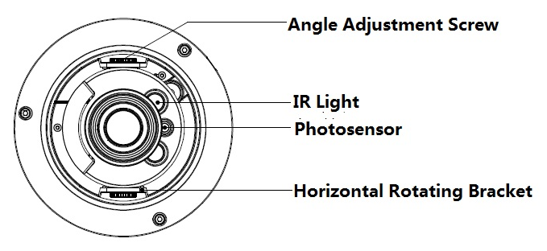

6 Installation Dome Camera for TX-50 & TX-51
Important: Make sure the installation surface can min support the 3x the weight of the camera and the bracket.

If you drill a hole in the wall, make sure that power cables, electrical cords and/or pipelines are not damaged. When using the supplied mounting material, we do not take the liability for a professional installation. You are entirely responsible to ensure that the mounting material is suitable for the particular masonry, and that the installation is done properly. When working at higher altitudes, there is danger of falling! Therefore, use suitable safeguards.

The dome camera usually mainly uses the in-ceiling installation. It can be installed on the ceiling or the wall.
- For side exit cable installation, make sure the side exit cable direction is the same as shown in the installation position map.
- Before you secure the screws on the pedestal, put the cable through the cable exit of the pedestal.
- Before you complete the installation and debug, do not remove the electrostatic film. After you remove the film, do not touch the enclosure in case there is any scratch.
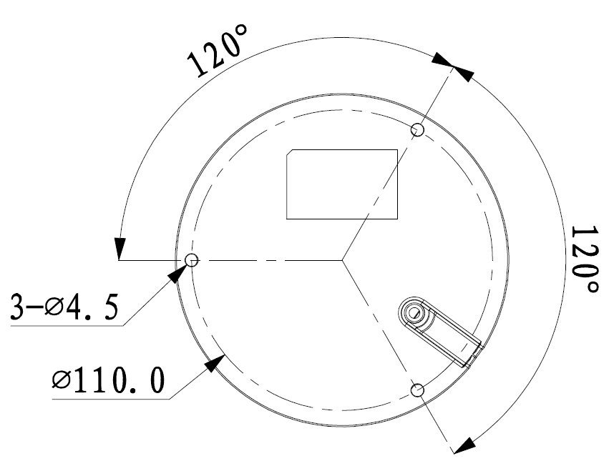
Step 1: Take the installation position map from the accessories bag and then put it on the surface of the ceiling or the wall according to the cable exit position. Dig three holes according to the installation position map and then take three expansion bolts from the accessories bag and put them to the holes you just dug.

Step 2: Use inner hex wrench to remove the three case locking screws and then remove the dome enclosure.

Step 3: Adjust the pedestal position according to the cable exit mode (ceiling/side). Pull the cable through the cable side exit at the installation surface and the pedestal (skip this step if you want to use ceiling exit mode). Line up the screw holes at the bottom of the pedestal to the expansion bolts in the installation surface. Put three self-tapping screws to expansion bolts and then secure firmly. Now the pedestal is on the installation surface.

Step 4: Connect the video output port of the device cable to the HDCVI DVR, and connect the power port of the device cable to the power. After the image is shown on the HDCVI DVR, control the interface by HDCVI series DVR PTZ, adjust lens zoom by using coaxial control, and the camera will auto focus to the best position.

Step 5: Use three case locking screws to secure the dome housing on the pedestal.
Now you have completed the device installation and cable connection. You can use the terminal encode devices to view the monitor video.
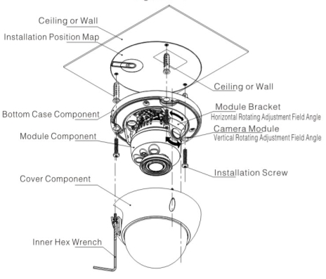

7 Menu

7.1 Settings
NOTE: The following operation and interfaces for reference only. Refer to the HDCVI series DVR user’s manual for detailed information.

After connected the camera to the HDCVI series DVR, from Main Menu -> Setting -> System -> PTZ, you need to set control mode as HDCVI and the protocol as DH-SD1. Click Save button to save current setup.

On the preview interface, right click mouse and then select PTZ; you can see this interface.

Click Iris “+” to open menu or confirm current operation.
Click Iris “-” to realize auto focus.
Click up/down button to view all the items on the left pane of the following list.
Click left/right button to set the corresponding values on the right pane of the list.
If there is “”, click confirm button to go to the 2nd menu. Repeat the previous steps to set detailed value. Click Return button to go back to the previous menu interface.
Click Zoom “+” to zoom in and click Zoom “-” to zoom out.

7.2 Note
Brightness | It is to adjust monitor window bright. The value ranges from 0 to 100. The default value is 50. The larger the number is, the bright the video is. When you input the value here, the bright section and the dark section of the video will be adjusted accordingly. You can use this function when the whole video is too dark or too bright. Note the video may become hazy if the value is too high. The recommended value ranges from 40 to 60.
Contrast | It is to adjust monitor window contrast. The value ranges from 0 to 100. The default value is 50. The larger the number is, the higher the contrast is. You can use this function when the whole video bright is OK but the contrast is not proper. Note the video may become hazy if the value is too low. If this value is too high, the dark section may lack brightness while the bright section may over exposure .The recommended value ranges from 40 to 60.
Saturation | It is to adjust monitor window saturation. The value ranges from 0 to 100. The default value is 50. The larger the number, the strong the color is. This value has no effect on the general brightness of the whole video. The video color may become too strong if the value is too high. For the grey part of the video, the distortion may occur if the white balance is not accurate. Note the video may not be attractive if the value is too low. The recommended value ranges from 40 to 60.
Sharpness | The value here is to adjust the edge of the video. The value ranges from 0 to 100. The larger the value is, the clear the edge is and vice versa. Note there is noise if the value here is too high. The default value is 50 and the recommended value ranges from 40 to 60.
3DNR | It is to reduce video noise. The larger the number is, the lower the noise is. The details of the video may disappear if the value here is too large.
Anti-flicker | - Outdoor: In this mode, you can switch exposure mode to get the effect under the corresponding exposure mode.  - 50Hz: When the current is 50Hz, system can auto adjust the exposure according to the environment brightness in case there is any strip.  - 60Hz: When the current is 60Hz, system can auto adjust the exposure according to the environment brightness in case there is any strip.

8 Important Safeguards & Warnings

8.1 Electrical safety: All installation and operation here should conform to your local electrical safety codes. The power shall conform to the requirement in the SELV (Safety Extra Low Voltage) and the Limited power source is rated 12V DC (24V AC) in the IEC60950-1. We assume no liability or responsibility for all the fires or electrical shock caused by improper handling or installation.

8.2 Transportation security: Heavy stress, violent vibration or water splash are not allowed during transportation, storage and installation.

8.3 Installation: Do not apply power to the camera before completing installation. Install the proper power cut-off device during the installation connection. Always follow the instruction guide the manufacturer recommended.
If this product is installed in the ceiling, make sure the installation position can sustain the min 50N.

8.4 Qualified engineers needed: All the examination and repair work should be done by the qualified service engineers. We are not liable for any problems caused by unauthorized modifications or attempted repair.

8.5 Environment: This series camera should be installed in a cool, dry place away from direct sunlight or strong light, inflammable, explosive substances and etc. This series camera shall work on the specified working temperature. Keep it away from the electromagnetic radiation object and environment. Keep the sound ventilation. Do not allow the water and other liquid falling into the camera.

8.6 Accessories: Be sure to use all the accessories recommended by manufacturer. Before installation, open the package and check all the components are included. Contact your local retailer ASAP if something is broken in your package.

8.7 Maintenance: Shut down the device and then unplug the power cable. Use the dry soft cloth to clean the device. If there is too much dust, use the water to dilute the mild detergent first and then use it to clean the device. Finally use the dry cloth to clean the device. Put the dustproof cap to protect the CCD (CMOS) component when you do not use the camera.

Technaxx®
Zusatzkamera Bullet & Dome
für Midi Sicherheits-Kit PRO FullHD 1080P TX-51
für Maxi Sicherheits-Kit PRO FullHD 1080P TX-50
Bedienungsanleitung

1 Allgemeine Anweisungen

1.1 Übersicht
Diese Serien-Megapixel-HD-Kamera entspricht der HDCVI-Norm. Sie unterstützt Videosignalübertragung mit hoher Geschwindigkeit und großer Entfernung ohne Verzögerung. Sie kann durch den DVR entsprechend der HDCVI gesteuert werden.

1.2 Funktionen
HDCVI-Spezifikation: HDCVI (High Definition Composite Video Interface) ist ein HD-Videoübertragungsstandard über Koaxialkabel. Die Technik gibt zwei HD-Videoformate durch progressives Scanning wieder.

ICR: Die IR Schnittentfernung ist, um die IR-Beleuchtung bei Tag zu filtern und dann den allgemeinen Filter bei Nacht automatisch zu schalten. Diese Funktion ermöglicht, dass die Kamera die hohe Empfindlichkeit ausgibt und das Video klar macht.

Smart IR-Technologie: Der Sensor steuert die IR-Beleuchtung ein/aus über die Kombinationsarbeit der Hardware und Software, die die automatische IR-Beleuchtungskompensation gemäß der Umgebungsbeleuchtung durchführt.

Automatische Verstärkerfunktion: Um das Standardvideosignal in den verschiedenen Beleuchtungsumgebungen auszugeben, muss der Verstärker in einem weiten Bereich ausrichten. Das System kann die Kameraempfindlichkeit bei geringer Beleuchtung verbessern und den Videosignalausgang verbessern, um ein klaren Hochauflösungs-video zu bekommen.

Automatischer Weißabgleich: Der Weißabgleich bezieht sich auf die Kamera, um die Farbe des weißen Objekts wiederherzustellen. Er ermöglicht der Kamera die Farbtemperatur in der inneren und äußeren Umgebung automatisch auszurichten, so wie es unsere menschlichen Augen machen.

Automatische Belichtung: Das System kann automatisch die Auslösergeschwindigkeit und den Blendenwert gemäß der Schnappschuss-Videobelichtungsbedingung einstellen.

Automatischer elektronischer Auslöser: Das System kann automatisch den elektronischen Auslöser anpassen, wenn das Umgebungslicht sich ändert.

ICR: Die IR Schnittentfernung ist, um die IR-Beleuchtung bei Tag zu filtern und dann den allgemeinen Filter bei Nacht automatisch zu schalten. Diese Funktion ermöglicht, dass die Kamera die hohe Empfindlichkeit ausgibt und das Video klar macht.

Smart IR-Technologie: Der Sensor steuert die IR-Beleuchtung ein/aus über die Kombinationsarbeit der Hardware und der Software, die die automatische IR Beleuchtungskompensation gemäß der Umgebungsbeleuchtung durchführt.

3D NR: Im Vergleich zu der allgemeinen 2D-Rauschunterdrückungsfunktion, kann die 3D-Rauschunterdrückungsfunktion nicht nur die Helligkeit des Videotrennungssignal und des Sättigungssignals entrauschen, es kann auch die Originaldaten vom CCD entrauschen. Es verbessert die Geräuschreduzierungsleistung enorm und garantiert ein klares und helles Video.

1.3 Spezifikationen
DEUTSCH
Besondere Merkmale & Technische Details BULLET KAMERA
Videoauflösung: 1980 × 1225 @ 30 fps (PAL)
Hochleistungs-CMOS-Bildsensor mit 2,4 Megapixel
Unterstützt HDCVI HD Videoausgang
Übertragungsreichweite bis zu 300m über 75-3 Koaxialkabel ohne Datenverlust
Echtzeitübertragung mit hoher Geschwindigkeit und großer Entfernung
Automatischer ICR-Schalter für Überwachung bei Tag und auch bei Nacht
Automatisch: Belichtung, Weißabgleich, elektronische Blende, Verstärkerfunktion
Klares und anschauliches Video wiederherstellen
Unterstützt IR-Funktion mit IR LED Reichweite max. 15m
Schutzklasse IP66 (staub- und wassergeschützt)
Videobildrate: 25/30/50/60 fps @ 720P & 25/30 fps @ 1080p
Min. Beleuchtung: 0,05 Lux @ F1.2 (AGC AN), 0 Lux mit IR eingeschaltet
Elektronische Blende: 1/3 Sek. ~ 1/100000 Sek. (PAL)
1-Kanal BNC HDCVI HD Videoausgang & Videoausgang CVBS Standardauflösung
BLC (Hintergrundlicht-Kontrolle): automatisch
IR-Licht ist nur aktiv bei Videoaufnahmen im Nachtmodus
Lärmminderung 2D/3D
Farbe oder Schwarz/Weiß wählbar
Horizontaler Blickwinkel: 105.5° ~ 32.9°
Brennweite: 2,7 ~ 12,0mm / automatischer Zoom
Feste Blende für die Helligkeit
Stromversorgung: DC 12V ± 10%
Stromverbrauch: 7,44W max. (Eingang 12V/0.62A) IR 15m max.
Betriebstemperatur: – 30°C ~ 60°C
Installation Innen- und Aussenbereich: Wandmontage
Gewicht / Maße: 550 g / (L) 21,3 × (B) 8,0 x (H) 7,2 cm
Verpackungsinhalt: Bullet Kamera zum Midi Security Kit PRO FullHD 1080P TX-50 & Maxi Security Kit PRO FullHD 1080P TX-51, 1x BNC 18,3m Videokabel, 3x Schrauben und 3x Dübel, Bedienungsanleitung
Besondere Merkmale & Technische Details DOME KAMERA
Videoauflösung: 1980 × 1225 @ 30 fps (PAL)
Hochleistungs-CMOS-Bildsensor mit 2,4 Megapixel
Unterstützt HDCVI HD Videoausgang
Übertragungsreichweite bis zu 300m über 75-3 Koaxialkabel ohne Datenverlust
Echtzeitübertragung mit hoher Geschwindigkeit und großer Entfernung
Automatischer ICR-Schalter für Überwachung bei Tag und auch bei Nacht
Automatisch: Belichtung, Weißabgleich, elektronische Blende, Verstärkerfunktion
Klares und anschauliches Video wiederherstellen
Unterstützt IR-Funktion mit IR LED Reichweite max. 15m
Schutzklasse IP66 (staub- & wassergeschützt) & IK10 (stoßfest)
Videobildrate: 25/30/50/60 fps @ 720P & 25/30 fps @ 1080p
Min. Beleuchtung: 0,05 Lux @ F1.2 (AGC AN), 0 Lux mit IR eingeschaltet
Elektronische Blende: 1/3 Sek. ~ 1/100000 Sek. (PAL)
1-Kanal BNC HDCVI HD Videoausgang & Videoausgang CVBS Standardauflösung
BLC (Hintergrundlicht-Kontrolle): automatisch
IR-Licht ist nur aktiv bei Videoaufnahmen im Nachtmodus
Lärmminderung 2D/3D
Farbe oder Schwarz/Weiß wählbar
Horizontaler Blickwinkel: 105.5° ~ 32.9°
Brennweite: 2,7 ~ 12,0mm / automatischer Zoom
Feste Blende für die Helligkeit
Stromversorgung: DC 12V ± 10%
Stromverbrauch: 8,6W max. (Eingang 12V/0.72A) IR 15m max.
Betriebstemperatur: – 30°C ~ 60°C
Installation Innen- und Aussenbereich: Wandmontage / Deckenmontage
Gewicht / Maße: 450 g / Φ 12,2 × (H) 8,9 cm
Verpackungsinhalt: Dome Kamera für Midi Security Kit PRO FullHD 1080P TX-50 & Maxi Security Kit PRO FullHD 1080P TX-51, 1x BNC 18,3m Videokabel, 3x Schrauben und 3x Dübel, Bedienungsanleitung
Dieses Gerät ist konform mit den Anforderungen der Normen gemäß Richtlinie R&TTE 1999/5/EG. Hier finden Sie die Konformitätserklärung: www.technaxx.de/ (in der unteren Leiste unter “Konformitätserklärung”). Vor dem ersten Gebrauch lesen Sie die Bedienungsanleitung sorgfältig durch.

Telefonnummer für den technischen Service: 01805 012643 (14 Cent/Minute aus dem deutschen Festnetz und 42 Cent/Minute Mobilfunknetz). Kostenfreie E-Mail: support@technaxx.de

Hinweise zum Umweltschutz: Verpackungen sind recycelbares Rohmaterial. Alte Geräte nicht im Hausmüll entsorgen. Reinigung: Gerät vor Verschmutzung schützen. Keine rauen, groben Materialien oder Lösungsmittel oder andere aggressive Reinigungsmittel verwenden. Gereinigtes Gerät gründlich abwischen. Inverkehrbringer: Technaxx Deutschland GmbH & Co.KG, Kruppstr. 105, 60388 Frankfurt a.M., Deutschland, Kruppstr. 105, 60388 Frankfurt a.M., Germany

2 Maße (Einheit ist mm) & Struktur

Bullet Kamera für Kit TX-50 & TX-51
Wenn das Standardauflösungs-/Hochauflösungsschalter-Steuerkabel kurzgeschlossen ist, gibt das System ein Standardauflösungsvideo aus. Ansonsten, wenn der Stromkreis geöffnet ist, gibt das System das Hochauflösungsvideo aus.

Power Port = Stromanschluss

HD/SD Switch Cable = HD/SD Schalterkabel

Video Port = Videoanschluss

3 Installation Bullet Kamera für TX-50 & TX-51
Wichtig: Stellen Sie sicher, dass die Installationsoberfläche min. das 3-fache des Gewichts der Kamera und der Befestigung stützen kann.

Wenn Sie ein Loch in die Wand bohren, stellen Sie sicher, dass Stromkabel, elektrische Stecker und/oder Rohrleitungen nicht beschädigt sind. Bei Verwendung des bereitgestellten Montagematerials übernehmen wir nicht die Haftung für eine professionelle Installation. Sie sind komplett verantwortlich, um sicher zu stellen, dass das Montagematerial für das spezielle Mauerwerk geeignet ist und dass die Installation richtig durchgeführt wird. Beim Arbeiten auf größeren Höhen, gibt es eine Absturzgefahr. Verwenden Sie daher geeignete Sicherheitshinweise.

Schritt 1: Bevor Sie die Befestigung installieren, ziehen Sie das Kabel durch den Kabelausgang des Befestigungsgehäuses. Installieren Sie den Spreizbolzen, wenn Sie in der Betonmauer einbauen möchten (stellen Sie sicher, dass die Installationslöcher der Spreizbolzen die gleichen sind wie die der Befestigung). Dann können Sie die Befestigung installieren. Wenn Sie die Kamera in einer Holzoberfläche einbauen möchten, überspringen Sie den ersten Schritt und verwenden Sie dann die Schneidschrauben, um die Befestigung direkt einzubauen.

Camera | Kamera |  | Expansion Bolt | Dübel
Screw | Schraube |  | Wall or Ceiling | Montagefläche

Schritt 2: Lösen Sie die M3 x 20 Schrauben (= Bolt) und M3 x 5 Schrauben (= Bolt) auf der Befestigung in der angezeigten Richtung, richten Sie die Kamera an einen genauen Standort aus, der durch die Drehung der Befestigung und des Kameragehäuses überwacht werden muss, sichern Sie dann die Schrauben.

Schritt 3: Verbinden Sie den Videoausgangsanschluss des Gerätekabels mit dem HDCVI DVR und verbinden Sie den Stromanschluss des Gerätekabels mit Strom.

Schritt 4: Nachdem das Bild auf dem HDCVI DVR angezeigt wird, steuern Sie die Schnittstelle durch HDCVI Serie DVR PTZ, richten Sie den Linsenzoom aus durch Verwendung der Koaxialsteuerung und die Kamera wird zur besten Position selbst-fokussieren, die das Bild klar macht. So weit ist die Kamerainstallation abgeschlossen.

4. Menu 4.1 Einstellungen
HINWEIS: Die folgenden Vorgänge und Schnittstellen sind nur zur Referenz. Siehe HDCVI Serie DVR Benutzerhandbuch für detaillierte Information.
Nach Verbindung der Kamera mit der HDCVI Serie DVR, vom Hauptmenu -> Setting -> System -> PTZ, müssen Sie den Kontrollmodus als HDCVI einstellen und das Protokoll als DH-SD1. Klicken Sie die Taste Save, um das aktuelle Setup zu speichern.

Auf der Vorschau-Schnittstelle, machen Sie einen Rechtsklick auf die Maus und wählen Sie dann PTZ; Sie können eine Schnittstelle wie nachstehend angezeigt sehen.
Speed = Geschwindigkeit

Iris = Blende

Klicken Sie auf Blende “+”, um das Menü zu öffnen oder den aktuellen Vorgang zu bestätigen. Klicken Sie auf Blende “-”, um den Autofokus durchzuführen. Klicken Sie die Taste oben/unten, um alle Elemente auf der linken Seite der folgenden Liste zu sehen. Klicken Sie die Taste rechts/links, um die entsprechenden Wert auf der rechten Seite der folgenden Liste zu einzustellen.
Wenn es “” gibt, klicken Sie die Taste bestätigen, um zum 2. Menü zu gehen. Wiederholen Sie die vorherigen Schritte, um den detaillierten Wert einzustellen. Klicken Sie die Taste Zurück, um zurück zur vorherigen Menüschnittstelle zu gehen. Klicken Sie auf Zoom “+”, heranzuzoomen und klicken Sie auf Zoom “-”, um herauszuzoomen.

4.2 Hinweis
Helligkeit | Es dient zur Anpassung der Monitorfenster-Helligkeit. Der Wert reicht von 0 bis 100. Der Standardwert ist 50. Je größer die Zahl ist, desto heller ist das Video. Wenn Sie den Wert hier einsetzen, wird der helle Abschnitt und der dunkle Abschnitt des Videos dementsprechend angepasst. Sie können diese Funktion verwenden, wenn das ganze Video zu dunkel oder zu hell ist. Beachten Sie, dass das Video verschwommen werden kann, wenn der Wert zu hoch ist. Der empfohlene Wert reicht von 40 bis 60.
Kontrast | Es dient zur Anpassung der Monitorfenster-Kontrast. Der Wert reicht von 0 bis 100. Der Standardwert ist 50. Je größer die Zahl ist, desto höher ist der Kontrast. Sie können diese Funktion verwenden, wenn die gesamte Videohelligkeit OK ist, aber der Kontrast nicht richtig ist. Beachten Sie, dass das Video verschwommen werden kann, wenn der Wert zu niedrig ist. Wenn dieser Wert zu hoch ist, kann es im dunklen Abschnitt an Helligkeit mangeln, während der helle Abschnitt überbelichtet werden kann. Der empfohlene Wert reicht von 40 bis 60.
Sättigung | Es dient zur Anpassung der Monitorfenster-Sättigung. Der Wert reicht von 0 bis 100. Der Standardwert ist 50. Je größer die Zahl, desto stärker die Farbe. Dieser Wert hat keine Auswirkung auf die allgemeine Helligkeit des gesamten Videos. Die Videofarbe könnte zu stark werden, wenn der Wert zu hoch ist. Für den grauen Teil des Videos, könnte die Verzerrung auftreten, wenn der Weißabgleich nicht genau ist. Beachten Sie, dass das Video nicht ansprechend werden kann, wenn der Wert zu niedrig ist. Der empfohlene Wert reicht von 40 bis 60.
Schärfe | Der Wert hier, dient zur Anpassung des Randes des Videos. Der Wert reicht von 0 bis 100. Je größer der Wert ist, desto klarer ist der Rand und umgekehrt. Beachten Sie, dass es ein Geräusch gibt, wenn der Wert zu hoch ist. Der Standardwert ist 50 und der empfohlene Wert reicht von 40 bis 60.
3DNR | Es dient zur Reduzierung des Videogeräusches. Je größer die Zahl ist, desto geringer ist das Geräusch. Die Details des Videos können verschwinden, wenn der Wert hier zu groß ist.
Anti-Flicker | - Außenbereich: In diesem Modus können Sie den Belichtungsmodus schalten, um den Effekt unter dem entsprechenden Belichtungsmodus zu bekommen.  - 50Hz: Wenn der Strom 50Hz ist, kann das System automatisch die Belichtung gemäß der Umgebungshelligkeit ausrichten, für den Fall, dass es einen Streifen gibt.  - 60Hz: Wenn der Strom 60Hz ist, kann das System automatisch die Belichtung gemäß der Umgebungshelligkeit ausrichten, für den Fall, dass es einen Streifen gibt.

5 Maße (Einheit ist mm) & Struktur Dome Kamera

Video Port | Videoanschluss |  | Light Blocking Cover | Lichtundurchlässige Abdeckung
Power Port | Stromanschluss |  | Case | Gehäuse
HD/SD  Switch Cable | HD/SD  Schalterkabel |  | Pedestal | Fuß

Wenn das Standardauflösungs-/Hochauflösungsschalter-Steuerkabel kurzgeschlossen ist, gibt das System ein Standardauflösungsvideo aus. Ansonsten, wenn der Stromkreis geöffnet ist, gibt das System das Hochauflösungsvideo aus.

Angle Adjustment Screw | Winkeleinstell-  schraube |  | Photosensor | Lichtsensor
IR Light | IR-Licht |  | Horizontal Rotatiing Bracket | Horizontale drehbare Befestigung

6 Installation Dome Kamera für TX-50 & TX-51
Wichtig: Stellen Sie sicher, dass die Installationsoberfläche min. das 3-fache des Gewichts der Kamera und der Befestigung stützen kann.

Wenn Sie ein Loch in die Wand bohren, stellen Sie sicher, dass Stromkabel, elektrische Stecker und/oder Rohrleitungen nicht beschädigt sind. Bei Verwendung des bereitgestellten Montagematerials übernehmen wir nicht die Haftung für eine professionelle Installation. Sie sind komplett verantwortlich, um sicher zu stellen, dass das Montagematerial für das spezielle Mauerwerk geeignet ist und dass die Installation richtig durchgeführt wird. Beim Arbeiten auf größeren Höhen, gibt es eine Absturzgefahr. Verwenden Sie daher geeignete Sicherheitshinweise.

Bei der Dome-Kamera wird normalerweise die Deckeninstallation angewandt. Sie kann an der Decke oder der Wand installiert werden.

- Für Seitenausgangs-Kabelinstallation, stellen Sie sicher, dass die Seitenausgangs-Kabelrichtung die gleiche ist, wie auf der Installationspositionsplan angezeigt.
- Bevor Sie die Schrauben auf dem Fuß sichern, stecken Sie das Kabel durch den Kabelausgang des Fußes.
- Bevor Sie die Installation beenden und austesten, entfernen Sie nicht den elektrostatischen Film. Nachdem Sie den Film entfernt haben, berühren Sie nicht das Gehäuse, für den Fall, dass es einen Kratzer gibt.

Schritt 1: Nehmen Sie den Installationspositionsplan aus dem Zubehörbeutel und legen Sie Ihn dann auf die Oberfläche der Decke oder der Wand gemäß der Kabelausgangsposition. Machen Sie drei Löcher gemäß des Installationspositionsplan und nehmen Sie dann drei Spreizdübel aus dem Zubehörbeutel und stecken Sie sie in die Löcher, die Sie gerade gemacht haben.

Schritt 2: Verwenden Sie den Innensechskantschlüsssel, um die drei Gehäuseverriegelungsschrauben zu entfernen und dann das Dome-Kameragehäuse zu entfernen.

Schritt 3: Richten Sie die Fußposition gemäß den Kabelausgangsmodus (Decke/Seite) an. Ziehen Sie das Kabel durch den Kabelseitenausgang an der Installationsoberfläche und dem Fuß (überspringen Sie diesen Schritt, wenn Sie den Deckenausgangsmodus verwenden möchten). Richten Sie die Schraubenlöcher auf der Unterseite des Fußes auf die Spreizdübel in der Installationsoberfläche aus. Setzen Sie die drei Schneidschrauben in die Spreizdübel und sichern Sie sie fest. Jetzt ist der Fuß auf der Installationsoberfläche.

Schritt 4: Verbinden Sie den Videoausgangsanschluss des Gerätekabels mit dem HDCVI DVR und verbinden Sie den Stromanschluss des Gerätekabels mit Strom. Nachdem das Bild auf dem HDCVI DVR angezeigt wird, steuern Sie die Schnittstelle durch HDCVI Serie DVR PTZ, richten Sie den Linsenzoom aus durch Verwendung der Koaxialsteuerung und die Kamera wird zur besten Position selbst-fokussieren.

Schritt 5: Verwenden Sie drei Gehäuseverriegelungsschrauben, um das Dome-Kamera-Gehäuse auf dem Fuß zu sichern.

Jetzt haben Sie die Geräteinstallation und Kabelverbindung abgeschlossen. Sie können die Terminal-Verschlüsselungsgeräte verwenden, um das Überwachungsvideo anzusehen.

Ceiling or Wall | Decke oder Wand |  | Ceiling or Wall | Decke oder Wand
Installation Position Map | Installationspositionsplan |  | Module Bracket | Modulbefestigung
Bottom Case Component | Untere Gehäusekomponente |  | Horizontal Rotating Adjustment Field Angle | Horizontaler drehbarer Anpassungsfeldwinkel
Module Component | Modulkomponente |  | Camera Module | Kameramodul
Cover Component | Abdeckungskomponente |  | Vertical Rotating Adjustment Field Angle | Vertikaler drehbarer Anpassungsfeldwinkel
Inner Hex Wrench | Innensechskantschlüssel |  | Installation Screw | Montageschraube

7 Menu 7.1 Einstellungen
HINWEIS: Die folgenden Vorgänge und Schnittstellen sind nur zur Referenz. Siehe HDCVI Serie DVR Benutzerhandbuch für detaillierte Information.
Nach Verbindung der Kamera mit der HDCVI Serie DVR, vom Hauptmenu -> Setting -> System -> PTZ, müssen Sie den Kontrollmodus als HDCVI einstellen und das Protokoll als DH-SD1. Klicken Sie die Taste Save, um das aktuelle Setup zu speichern.

Auf der Vorschau-Schnittstelle, machen Sie einen Rechtsklick auf die Maus und wählen Sie dann PTZ; Sie können eine Schnittstelle wie nachstehend angezeigt sehen.
Speed = Geschwindigkeit

Iris = Blende

Klicken Sie auf Blende “+”, um das Menü zu öffnen oder den aktuellen Vorgang zu bestätigen. Klicken Sie auf Blende “-”, um den Autofokus durchzuführen. Klicken Sie die Taste oben/unten, um alle Elemente auf der linken Seite der folgenden Liste zu sehen. Klicken Sie die Taste rechts/links, um die entsprechenden Wert auf der rechten Seite der folgenden Liste zu einzustellen.
Wenn es “” gibt, klicken Sie die Taste bestätigen, um zum 2. Menü zu gehen. Wiederholen Sie die vorherigen Schritte, um den detaillierten Wert einzustellen. Klicken Sie die Taste Zurück, um zurück zur vorherigen Menüschnittstelle zu gehen. Klicken Sie auf Zoom “+”, heranzuzoomen und klicken Sie auf Zoom “-”, um herauszuzoomen.

7.2 Hinweis
Helligkeit | Es dient zur Anpassung der Monitorfenster-Helligkeit. Der Wert reicht von 0 bis 100. Der Standardwert ist 50. Je größer die Zahl ist, desto heller ist das Video. Wenn Sie den Wert hier einsetzen, wird der helle Abschnitt und der dunkle Abschnitt des Videos dementsprechend angepasst. Sie können diese Funktion verwenden, wenn das ganze Video zu dunkel oder zu hell ist. Beachten Sie, dass das Video verschwommen werden kann, wenn der Wert zu hoch ist. Der empfohlene Wert reicht von 40 bis 60.
Kontrast | Es dient zur Anpassung der Monitorfenster-Kontrast. Der Wert reicht von 0 bis 100. Der Standardwert ist 50. Je größer die Zahl ist, desto höher ist der Kontrast. Sie können diese Funktion verwenden, wenn die gesamte Videohelligkeit OK ist, aber der Kontrast nicht richtig ist. Beachten Sie, dass das Video verschwommen werden kann, wenn der Wert zu niedrig ist. Wenn dieser Wert zu hoch ist, kann es im dunklen Abschnitt an Helligkeit mangeln, während der helle Abschnitt überbelichtet werden kann. Der empfohlene Wert reicht von 40 bis 60.
Sättigung | Es dient zur Anpassung der Monitorfenster-Sättigung. Der Wert reicht von 0 bis 100. Der Standardwert ist 50. Je größer die Zahl, desto stärker die Farbe. Dieser Wert hat keine Auswirkung auf die allgemeine Helligkeit des gesamten Videos. Die Videofarbe könnte zu stark werden, wenn der Wert zu hoch ist. Für den grauen Teil des Videos, könnte die Verzerrung auftreten, wenn der Weißabgleich nicht genau ist. Beachten Sie, dass das Video nicht ansprechend werden kann, wenn der Wert zu niedrig ist. Der empfohlene Wert reicht von 40 bis 60.
Schärfe | Der Wert hier, dient zur Anpassung des Randes des Videos. Der Wert reicht von 0 bis 100. Je größer der Wert ist, desto klarer ist der Rand und umgekehrt. Beachten Sie, dass es ein Geräusch gibt, wenn der Wert zu hoch ist. Der Standardwert ist 50 und der empfohlene Wert reicht von 40 bis 60.
3DNR | Es dient zur Reduzierung des Videogeräusches. Je größer die Zahl ist, desto geringer ist das Geräusch. Die Details des Videos können verschwinden, wenn der Wert hier zu groß ist.
Anti-Flicker | - Außenbereich: In diesem Modus können Sie den Belichtungsmodus schalten, um den Effekt unter dem entsprechenden Belichtungsmodus zu bekommen.  - 50Hz: Wenn der Strom 50Hz ist, kann das System automatisch die Belichtung gemäß der Umgebungshelligkeit ausrichten, für den Fall, dass es einen Streifen gibt.  - 60Hz: Wenn der Strom 60Hz ist, kann das System automatisch die Belichtung gemäß der Umgebungshelligkeit ausrichten, für den Fall, dass es einen Streifen gibt.

8 Wichtige Sicherheitshinweise & Warnungen
4.1 Elektrische Sicherheit: Alle Installationen/Vorgänge hier sollten Ihren lokalen elektrischen Sicherheitscodes entsprechen. Der Strom sollte den Anforderungen in der SELV (Sicherheitsklein-spannung) übereinstimmen und die Stromquelle mit begrenzter Leistung ist mit 12V DC (24V AC) in der IEC60950-1 eingestuft. Wir übernehmen keine Haftung oder Verantwortung für alle Brände oder Stromschläge, die durch falsche Handhabung oder Installation verursacht werden.

4.2 Transportsicherheit: Hohe Belastung, starke Erschütterung oder Wasserspritzer sind während des Transports, der Lagerung und der Installation nicht erlaubt.

4.3 Installation: Versorgen Sie die Kamera vor dem Abschluss der Installation nicht mit Strom. Installieren Sie das richtige Stromabschaltgerät, während der Installationsverbindung. Folgen Sie immer der vom Hersteller empfohlenen Gebrauchsanweisung.
Wenn dieses Produkt in der Decke installiert ist, stellen Sie sicher, dass die Installationsposition min. 50N aushalten kann.

4.4 Qualifizierte Techniker nötig: Die gesamte Untersuchungs- und Reparaturarbeit sollte von den qualifizierten Servicetechnikern durchgeführt werden. Wir haften nicht für Probleme, die durch unautorisierte Änderungen oder versuchte Reparatur verursacht wurden.

4.5 Umgebung: Diese Serienkamera sollte an einem kühlen, trockenen Ort weg von direktem Sonnenlicht oder starkem Licht, entflammbaren, explosiven Substanzen und etc. installiert werden. Diese Serienkamera sollte bei der spezifizierten Arbeitstemperatur funktionieren. Halten Sie sie fern von elektromagnetischen Strahlungsobjekten und -umgebung. Behalten Sie die starke Belüftung. Erlauben Sie nicht, dass Wasser oder eine andere Flüssigkeit in die Kamera eintritt.

4.6 Zubehör: Seien Sie sicher, dass Sie das gesamte vom Hersteller empfohlene Zubehör verwenden. Öffnen Sie vor der Installation die Verpackung und überprüfen Sie alle mitgelieferten Komponenten. Kontaktieren Sie Ihren lokalen Händler SOFORT, wenn etwas in Ihrer Verpackung kaputt ist.

4.8 Wartung: Schalten Sie das Gerät ab und ziehen dann das Stromkabel. Verwenden Sie das trockene weiche Tuch, um das Gerät zu reinigen. Wenn es zu viel Staub gibt, verwenden Sie Wasser, um zuerst das milde Reinigungsmittel zu verdünnen und verwenden Sie es dann, um das Gerät zu reinigen. Verwenden Sie schließlich das trockene Tuch, um das Gerät zu reinigen. Setzen Sie die staubfreie Kappe auf, um die CCD (CMOS)-Komponente zu schützen, wenn Sie die Kamera nicht verwenden.

Dieses Gerät ist konform mit den Anforderungen der Normen gemäß Richtlinie R&TTE 1999/5/EG. Hier finden Sie die Konformitätserklärung: www.technaxx.de/ (in der unteren Leiste unter “Konformitätserklärung”). Vor dem ersten Gebrauch lesen Sie die Bedienungsanleitung sorgfältig durch.

Telefonnummer für den technischen Service: 01805 012643 (14 Cent/Minute aus dem deutschen Festnetz und 42 Cent/Minute aus Mobilfunknetzen). Kostenfreie E-Mail: support@technaxx.de

Hinweise zum Umweltschutz: Verpackungen sind recycelbares Rohmaterial. Alte Geräte nicht im Hausmüll entsorgen. Reinigung: Gerät vor Verschmutzung schützen (mit sauberem Tuch reinigen). Keine rauen, groben Materialien oder Lösungsmittel oder andere aggressive Reinigungsmittel verwenden. Gereinigtes Gerät gründlich abwischen. Inverkehrbringer: Technaxx Deutschland GmbH & Co.KG, Kruppstr. 105, 60388 Frankfurt a.M., Deutschland

Now the APPENDIX follows for both cameras with Functions, Specifications and Hints in the languages French, Italian, Spanish, Polish, Dutch & Czech.

Nun folgt der ANHANG für beide Kameras mit Funktionen, Spezifikationen und Hinweisen in den Sprachen Französisch, Italienisch, Spanisch, Polnisch, Niederländisch & Tschechisch.

FRANCĄIS Fonctions
Spécification HDCVI : HDCVI (Interface vidéo composite haute définition) est un câble coaxial normal de transmission de vidéo HD. La technologie génère deux formats vidéo HD par un balayage progressif.
ICR : Le retrait de coupe de l'IR sert à filtrer la luminosité de l'IR le jour, et à basculer automatiquement sur la position générale la nuit. Cette fonction permet à la caméra de produire une vidéo claire et avec une haute sensibilité.
Technologie Smart IR : Le capteur contrôle l’activation/la désactivation de la luminosité de l'IR par le fonctionnement conjoint du matériel et du logiciel, qui effectue la compensation automatique de la luminosité de l'IR selon la luminosité ambiante.
Fonction gain automatique : Pour la sortie du signal standard vidéo dans des environnements de luminosités différentes, l'amplificateur doit être réglé sur une grande étendue. Le système peut améliorer la sensibilité de la caméra lors de faible luminosité et améliorer la sortie du signal vidéo pour obtenir une vidéo en claire et haute définition.
Equilibre automatique des blancs : L'équilibre des blancs concerne la restauration par la caméra de la couleur d'objets blancs. Il permet à la caméra de régler automatiquement la température de la couleur dans un environnement intérieur et extérieur, tout comme nos yeux humains le font.
Exposition automatique : Le système peut automatiquement régler la vitesse de l'obturateur et la valeur de l'iris selon la condition d'exposition de la prise vidéo.
Obturateur auto électronique : Le système peut automatiquement régler l'obturateur électronique lors de changements de luminosité ambiante.

ITALIANO Funzioni
Specifiche di HDCVI: HDCVI( nterfaccia ad alta definizione del video composito) è un cavo HD sopra-coassiale - standard di trasmissione. La tecnologia rende due formati HD video tramite scanner progressivo.
Tecnologia autofocus: Rilevi la posizione dello schermo principale dalla procedura autofocus della telecamera e l'auto sistema il focus secondo la situazione corrente della messa a fuoco, che realizzerebbe il controllo dello zoom l'intero autofocus. L'immagine rimane chiara durante il processo di zoom.
OSD: Esposizione facile da usare sulla visualizzazione a schermo selezionando le funzioni differenti.
ICR: La rimozione IR filtra la luce IR del giorno e l'auto cambio genera il filtro per la notte. Questa funzione permette alla telecamera di creare video chiari e di alta sensibilità.
Tecnologia IR intelligente: Il sensore controlla la luce accesa/spenta IR tramite il lavoro di hadrware e software che realizza la compensazione di luce IR automaticamente secondo l'illuminazione dell'ambiente.
3D NR: Paragonando alla funzione generale 2D del denoise, il denoise 3D non solo segnala la luminosità del segnale del video e la saturazione del segnale, ma può eliminare i rumori dei dati originali dal CCD. Aumenta notevolmente le prestazioni di riduzione di rumore e garantisce un video luminoso e chiaro.

ESPAÑOL Funciones
Especificaciones HDCVI: HDCVI (High Definition Composite Video Interface, Interfaz de vídeo compuesto en alta definición) es un estándar de transmisión de vídeo HD a través de cable coaxial. La tecnología produce dos formatos de vídeo HD por exploración progresiva.
ICR: El filtro de eliminación de IR es para filtrar la luz de IR durante el día y para cambiar automáticamente al filtro general por la noche. Esta función permite que la cámara tenga una alta sensibilidad y claridad de vídeo.
Tecnología inteligente de IR: El sensor activa y desactiva la luz de IR mediante el trabajo combinado de hardware y software, que realiza una compensación automática de luz por IR según la iluminación ambiental.
Función de autoganancia: Para producir una señal de vídeo estándar en diferentes ambientes de iluminación, en necesario que el amplificador se ajuste en un alcance ancho. El sistema puede aumentar la sensibilidad de la cámara con poca iluminación y aumentar la salida de señal de vídeo para obtener un vídeo nítido de alta definición.
Balance automático de blancos: El balance de blancos se refiere a cómo restituye la cámara el color de un objeto blanco. Permite a la cámara ajustar automáticamente la temperatura del color en interiores y exteriores, como lo hace el ojo humano.
Autoexposición: El sistema puede establecer automáticamente la velocidad del obturador y el valor de iris según las condiciones de exposición de captura de vídeo.
Obturador electrónico automático: El sistema puede ajustar automáticamente el obturador electrónico cuando se producen cambios en la luz ambiental.

POLSKIE Funkcje
Specyfikacje HDCVI: HDCVI（Interfejs kompozytowy wideo wysokiej jakości） to kabel współosiowy, standardowy dla transmisji HD wideo. Technologia obsługuje dwa formaty wideo HD poprzez progresywne skanowanie.
ICR: Usuwanie wycinka IR ma na celu filtrowanie oświetlenia IR podczas dnia i automatyczne przełączanie na ogólny filtr nocą.. Ta funkcja umożliwia kamerze na wyjście dla wysokiej czułości i wyczyszczenie wideo.
Inteligentna technologia IR: Czujnik steruje wł/wył oświetlenia IR poprzez łączoną pracę sprzętu i oprogramowania, co wykonuje automatyczną kompensację oświetlenia IR na podstawie światła w otoczeniu.
Funkcja automatycznego przyrostu: Aby pojawił się standardowy sygnał wideo w różnych środowiskach, wzmacniacz musi dokonać regulacji w szerokim zakresie System może wzmocnić czułość kamery w niskim podświetleniu i wzmocnić sygnał wideo, aby pozyskać czysty obraz wideo wysokiej jakości.
Automatyczny balans bieli: Balans bieli to przywracanie białego koloru danego obiektu. Pozwala kamerze na automatyczną regulację temperatury koloru wewnątrz i na zewnątrz, tak jak robi to ludzkie oko.
Automatyczne naświetlanie: System może automatycznie wyregulować prędkość migawki oraz wartość tęczówki wg warunków naświetlania migawki wideo.
Automatyczna migawka elektroniczna: System może automatycznie wyregulować elektroniczną migawkę podczas zmian oświetlenia w otoczeniu.
NEDERLANDSE Functies
HDCVI Specificaties: HDCVI（High Definition Composite Video Interface） is een standaard voor het versturen van HD video via een coax-kabel. Deze technologie geeft twee HD videoformaten weer via progressieve scanning.
ICR: Het IR-afkapfilter filtert overdag het IR licht uit, en schakelt 's nachts automatisch over op het algemene filter. Door deze functie kan de camera scherpe beelden leveren met hoge gevoeligheid.
Slimme IR technologie: De sensor schakelt het IR licht in/uit via een combinatie van hard- en software, die zorgt voor automatische IR lichtcompensatie volgens de omgevingsbelichting.
Automatische opwaardeerfunctie: Om het standaard videosignaal in verschillende belichtingsomstandigheden te kunnen opleveren dient de versterker een groot bereik te hebben. Het systeem kan de cameragevoeligheid bij slechte lichtomstandigheden verhogen, en het videosignaal opwaarderen om zo een helder en high definition videobeeld te verkrijgen.
Automatische witbalans: De witbalans refereert aan de juiste opname van witte voorwerpen door de camera. Hiermee kan de camera automatisch de juist kleur-temperatuur binnens- en buitenshuis bepalen, net zoals menselijke ogen dit kunnen.
Automatische belichting: Het systeem kan automatisch de sluitersnelheid en diafragma instellen, afhankelijk van de belichtingsomstandigheden.
Automatische elektronische sluiter: Het systeem kan automatisch de elektronische sluiter regelen, als de omgevingsbelichting verandert.

ČEŠTINA Funkce
Specifikace HDCVI: HDCVI（High Definition Composite Video Interface） je norma pro přenos HD videa po koaxiálním kabelu. Tato technologie renderuje dva formáty HD videa pomocí postupného řádkování.
ICR: UV filtr pro filtrování infračerveného světla za denního světla a pak automatické přepnutí na hlavní filtr v noci. Tato funkce umožňuje vysokou citlivost a čistý obraz výstupu z kamery.
Chytrá IR technologie: tento snímač ovládá propustnost infračerveného světla pomocí kombinace hardwaru a softwaru, který provádí automatickou kompenzaci infračerveného světla podle osvětlení prostředí.
Funkce automatického zesílení: Zesilovač potřebuje nastavení v širokém rozsahu kvůli výstupu standardního video signálu za různých světelných podmínek prostředí. Tento systém umí zvýšit citlivost kamery za nízkého osvětlení a zdokonalit výstup video signálu pro získání čistého obrazu s vysokým rozlišením.
Automatické vyvážení bílé: Vyvážení bílé se týká kamery a zobrazení předmětu bílé barvy. Umožnuje kameře automaticky upravovat teplotu barev ve vnitřním a vnějším prostředí, stejně jako to dělají lidské oči.
Automatická expozice: Systém umí nastavit rychlost uzávěrky a hodnotu clony automaticky podle stavu expozice při snímání.
Automatická elektronická uzávěrka: Systém umí automaticky upravovat elektronickou uzávěrku při změně světla prostředí.
FRANCĄIS
Particularités & Caractéristiques techniques BULLET CAMÉRA
Résolution vidéo: 1980 × 1225 @ 30 fps (PAL)
Capteur d'image CMOS de haute performance avec 2,4 méga pixels
Prise en charge de la sortie vidéo HDCVI HD
Distance de transmission ~ 300m par câble coaxial 75-3 sans perte de données
Haute vitesse, transmission longue distance en temps réel
Interrupteur ICR automatique pour effectuer la surveillance à la fois le jour /la nuit
Automatiquement: exposition, équilibre des blancs, obturateur électronique, fonction de gain
Restaure des vidéos claires et nettes
Prise en charge de la fonction IR avec IR LED distance max. 15m
Class de protection IP66 (poussière et l'eau protégée)
Taux de trame vidéo: 25/30/50/60 fps @ 720P & 25/30 fps @ 1080p
Min. luminosité: 0.05 Lux @ F1.2 (AGC ON), 0 Lux avec IR allumé
Obturateur électronique: 1/3 sec. ~ 1/100000 sec. (PAL)
Sortie vidéo HD 1-canal BNC HDCVI & sortie vidéo CVBS standard définition
BLC (contrôle rétroéclairage): automatiquement
Lumière IR uniquement est actif pour les enregistrements vidéo en mode de nuit
Réduction du bruit 2D/3D
Couleur ou Noir/Blanc: sélectionnable
Angle de vue horizontal: 105.5° ~ 32.9°
Distance focale: 2.7 ~ 12.0mm / zoom automatique
Ouverture fixe pour la luminosité
Alimentation: CC 12V ± 10%
Consommation d'alimentation: 7,44W max. (Entrée 12V/0.62A) IR 15m max.
Température opérationnelle: – 30°C ~ 60°C
Installation intérieure et extérieure: montage mural
Poids / Dimensions: 550 g / (Lo) 21,3 x (La) 8,0 × (H) 7,2 cm
Contenu de la livraison: Bullet caméra pour Midi Security Kit PRO FullHD 1080P TX-50 & Maxi Security Kit PRO FullHD 1080P TX-51, 1x BNC 18,3m câble vidéo, 3x vis et 3x chevilles, Manuel d’utilisation
Particularités & Caractéristiques techniques DOME CAMÉRA
Résolution vidéo: 1980 × 1225 @ 30 fps (PAL)
Capteur d'image CMOS de haute performance avec 2,4 méga pixels
Prise en charge de la sortie vidéo HDCVI HD
Distance de transmission ~ 300m par câble coaxial 75-3 sans perte de données
Haute vitesse, transmission longue distance en temps réel
Interrupteur ICR automatique pour effectuer la surveillance à la fois le jour/la nuit
Automatiquement: exposition, équilibre des blancs, obturateur électronique, fonction de gain
Restaure des vidéos claires et nettes
Prise en charge de la fonction IR avec IR LED distance max. 15m
Classe de protection IP66 (poussière et l'eau protégée) & IK10 (antichoc)
Taux de trame vidéo: 25/30/50/60 fps @ 720P & 25/30 fps @ 1080p
Min. luminosité: 0.05 Lux @ F1.2 (AGC ON), 0 Lux avec IR allumé
Obturateur électronique: 1/3 sec. ~ 1/100000 sec. (PAL)
Sortie vidéo HD 1-canal BNC HDCVI & sortie vidéo CVBS standard définition
BLC (contrôle rétroéclairage): automatiquement
Lumière IR uniquement est actif pour les enregistrements vidéo en mode de nuit
Réduction du bruit 2D/3D
Couleur ou Noir/Blanc: sélectionnable
Angle de vue horizontal: 105.5° ~ 32.9°
Distance focale: 2.7 ~ 12.0mm / zoom automatique
Ouverture fixe pour la luminosité
Alimentation: CC 12V ± 10%
Consommation d'alimentation: 8,6W max. (Entrée 12V/0.72A) IR 15m max.
Température opérationnelle: – 30°C ~ 60°C
Installation intérieure et extérieure: montage mural / montage ou plafond
Poids / Dimensions: 450 g / Φ 12,2 × (H) 8,9 cm
Contenu de la livraison: Dôme Caméra pour Midi Security Kit PRO FullHD 1080P TX-50 & Maxi Security Kit PRO FullHD 1080P TX-51, 1x BNC 18,3m câble vidéo, 3x vis et 3x chevilles, Manuel d’utilisation

Cet appareil est conforme aux conditions des normes référencées de la Directive R&TTE 1999/5/CE. Veuillez trouver ici la Déclaration de Conformité: www.technaxx.de/ (sur la barre inférieure “Konformitätserklärung”). Avant la première utilisation, lisez attentivement le manuel d’utilisation.
No. de téléphone pour le support technique: 01805 012643 (14 centimes/minute d’une ligne fixe Allemagne et 42 centimes/minute des réseaux mobiles). Email gratuit: support@technaxx.de
Conseils pour le respect de l'environnement: Matériaux packages sont des matières premières et peuvent être recyclés. Ne pas jeter les appareils ou les batteries usagés avec les déchets domestiques. Nettoyage: Protéger le dispositif de la saleté et de la pollution (nettoyer avec un chiffon propre). Ne pas utiliser des matériaux dures, à gros grain/des solvants/des agents nettoyants agressifs. Essuyer soigneusement le dispositif nettoyé. Remarque importante: Si vous notez une perte de l'électrolyte de la batterie, essuyez le boîtier de la batterie avec un chiffon doux sec. Distributeur: Technaxx Deutschland GmbH & Co.KG, Kruppstr. 105, 60388 Frankfurt a.M., Allemagne

ITALIANO
Particularità & Specifiche tecniche BULLET CAMERA
Risoluzione video: 1980 × 1225 @ 30 fps (PAL)
Sensore ad alto rendimento di immagine CMOS con 2,4 mega pixel
Uscita video HDCVI HD
Distanza della trasmissione ~ 300m di cavo coassiale 75-3 senza perdite di dati
Alta velocità, trasmissione in tempo reale a lunga distanza
Interruttore automatico ICR per realizzare la sorveglianza sia di giorno/di notte
Automaticamente: esposizione di sostegno, equilibrio bianco, otturatore elettronico, controllo di guadagno
Ripristina video vivido e chiaro
Funzione IR di supporto con IR LED distanza mas. 10m
Classe di protezione IP66 (polvere e acqua protetta)
Grado video frame: 25/30/50/60 fps @ 720P & 25/30 fps @ 1080p
Min. illuminazione: 0.05 Lux @ F1.2 (AGC ON), 0 Lux con IR acceso
Otturatore elettronico: 1/3 sec. ~ 1/100000 sec. (PAL)
Uscita video HD 1-canale BNC HDCVI & uscita video CVBS standard definizione
BLC (controllo della retroilluminazione): automaticamente
Luce IR è attivo solo per le registrazioni video in modalità notte
Riduzione del rumore 2D/3D
Colore o Noir/Bianco: selezionabile
Angolo orizzontale di vista: 105.5° ~ 32.9°
Distanza focale: 2,7 ~ 12,0mm / zoom automatico
Apertura fissa per la luminosità
Accensione: CC 12V ± 10%
Consumo di energia: 7,44W mas. (Entrata 12V/0.62A) IR mas. 15m
Temperatura di funzionamento: – 30°C ~ 60°C
Installazione interna ed esterno: montaggio a parete
Peso / Dimensioni: 550 g / (Lu) 21,3 x (La) 8,0 x (A) 7,2 cm
Contenuto della confezione: Bullet camera per Midi Security Kit PRO FullHD 1080P TX-50 & Maxi Security Kit PRO FullHD 1080P TX-51, 1x BNC 18,3m cavo video, 3x viti e 3x tasselli, Manuale dell'utente
Particularità & Specifiche tecniche DOME CAMERA
Risoluzione video: 1980 × 1225 @ 30 fps (PAL)
Sensore ad alto rendimento di immagine CMOS con 2,4 mega pixel
Uscita video HDCVI HD
Distanza della trasmissione ~ 300m di cavo coassiale 75-3 senza perdite di dati
Alta velocità, trasmissione in tempo reale a lunga distanza
Interruttore automatico ICR per realizzare la sorveglianza sia di giorno/di notte
Automaticamente: esposizione di sostegno, equilibrio bianco, otturatore elettronico, controllo di guadagno
Ripristina video vivido e chiaro
Funzione IR di supporto con IR LED distanza mas. 15m
Grado di protezione IP66 (polvere e acqua protetta) & IK10 (antiurto)
Grado video frame: 25/30/50/60 fps @ 720P & 25/30 fps @ 1080p
Min. illuminazione: 0.05 Lux @ F1.2 (AGC ON), 0 Lux con IR acceso
Otturatore elettronico: 1/3 sec. ~ 1/100000 sec. (PAL)
Uscita video HD 1-canale BNC HDCVI & uscita video CVBS standard definizione
BLC (controllo della retroilluminazione): automaticamente
Luce IR è attivo solo per le registrazioni video in modalità notte
Riduzione del rumore 2D/3D
Colore o Noir/Bianco: selezionabile
Angolo orizzontale di vista: 105.5° ~ 32.9°
Distanza focale: 2,7 ~ 12,0mm / zoom automatico
Apertura fissa per la luminosità
Accensione: CC 12V ± 10%
Consumo di energia: 2,2W max. (Entrata 12V/0,18A) IR max. 10m
Temperatura di funzionamento: – 30°C ~ 60°C
Installazione interna ed esterno: montaggio a parete / montaggio a soffitto
Peso / Dimensioni: 450 g / Φ 12,2 × (A) 8,9 cm
Contenuto della confezione: Dome camera per Midi Security Kit PRO FullHD 1080P TX-50 & Maxi Security Kit PRO FullHD 1080P TX-51, 1x BNC 18,3m cavo video, 3x viti e 3x tasselli, Manuale dell'utente

Questo dispositivo aderisce agli standard richiesti ai sensi della Direttiva R&TTE 1999/5/CE. Su questo sito è possibile leggere la Dichiarazione di Conformità: www.technaxx.de/ (sulla barra inferiore "Konformitätserklärung"). Al primo utilizzo del dispositivo, leggere attentamente il manuale dell’utente.
Numero di telefono per supporto tecnico: 01805 012643 (14 centesimo/minuto da linea fissa tedesca e 42 centesimo/minuto da reti mobili). Email: support@technaxx.de
Istruzioni per la tutela dell'ambiente: Materiali di pacchetti sono materie prime e riciclabili. Non smaltire dispositivi vecchi o batterie nei rifiuti domestici. Pulizia: Proteggere il dispositivo da contaminazione e inquinamento (pulire il dispositivo con un panno pulito). Non usare di materiali ruvidi, a grana grossa/solventi/detergenti aggressivi. Asciugare il dispositivo dopo la pulizia. Avviso importante: In caso di perdita di liquido dalla batteria, asciugare l'alloggiamento della batteria con un panno morbido asciutto. Distributore: Technaxx Deutschland GmbH & Co.KG, Kruppstr. 105, 60388 Frankfurt a.M., Germania

ESPAÑOL
Descripción & Especificaciones técnicas BULLET CÁMARA
Resolución de vídeo: 1980 × 1225 @ 30 fps (PAL)
Sensor de imagen CMOS de altas prestaciones con 2,4 Mega píxeles
Soporta salida de vídeo HDCVI HD
Distancia de transmisión ~ 300m a travès cable coaxial 75-3 sin pérdida de datos
Transmisión en tiempo real a alta velocidad y larga distancia
Interruptor ICR automático para vigilancia durante el día y durante la noche
Automáticamente: exposición, balance de blancos, obturador electrónico, control de ganancia
Restablece un vídeo nítido y vivo
Soporta función de IR con IR LED distancia max. 15m
Clase de protección IP66 (polvo e agua protegida)
Tarifa de marco vídeo: 25/30/50/60 fps @ 720P & 25/30 fps @ 1080p
Min. iluminación: 0.05 Lux @ F1.2 (AGC ON), 0 Lux con IR encendido
Obturador electrónico: 1/3 seg. ~ 1/100000 seg. (PAL)
Salida vídeo HD BNC HDCVI 1-canal & salida vídeo CVBS definición estándar
BLC (control de luz de fondo): automáticamente
Luz IR sólamente está activo para las grabaciones de vídeo en modo nocturno
Reducción de ruido 2D/3D
Color o Negro/Blanco: seleccionable
Ángulo de visión horizontal: 105.5° ~ 32.9°
Distancia focal: 2,7 ~ 12,0mm / zoom automático
Apertura fija para el brillo
Alimentación: DC 12V ± 10%
Consumo de potencia: 7,44W max. (Entrada 12V/0.62A) IR max.15m
Temperatura de trabajo: – 30°C ~ 60°C
Instalación en interiores et al aire libre: montaje en pared
Peso / Dimensioni: 550 g / (Lu) 21,3 x (La) 8,0 x (A) 7,2 cm
Contenido del paquete: Bullet cámara para Midi Security Kit PRO FullHD 1080P TX-50 & Maxi Security Kit PRO FullHD 1080P TX-51, 1x BNC 18,3m cable vídeo, 3x tornillos y 3x clavijas, Manual de usuario
Descripción & Especificaciones técnicas DOME CÁMARA
Resolución de vídeo: 1980 × 1225 @ 30 fps (PAL)
Sensor de imagen CMOS de altas prestaciones con 2,4 Mega píxeles
Soporta salida de vídeo HD HDCVI
Distancia de transmisión ~ 300m a travès cable coaxial 75-3 sin pérdida de datos
Transmisión en tiempo real a alta velocidad y larga distancia
Interruptor ICR automático para vigilancia durante el día y durante la noche
Automáticamente: exposición, balance de blancos, obturador electrónico, control de ganancia
Restablece un vídeo nítido y vivo
Soporta función de IR con IR LED distancia max. 15m
Clase de protección IP66 (polvo e agua protegida) & IK10 (a prueba de golpes)
Tarifa de marco vídeo: 25/30/50/60 fps @ 720P & 25/30 fps @ 1080p
Min. iluminación: 0.05 Lux @ F1.2 (AGC ON), 0 Lux con IR encendido
Obturador electrónico: 1/3 seg. ~ 1/100000 seg. (PAL)
Salida vídeo HD BNC HDCVI 1-canal & salida vídeo CVBS definición estándar
BLC (control de luz de fondo): automáticamente
Luz IR sólamente está activo para las grabaciones de vídeo en modo nocturno
Reducción de ruido 2D/3D
Color o Negro/Blanco: seleccionable
Ángulo de visión horizontal: 105.5° ~ 32.9°
Distancia focal: 2,7 ~ 12,0mm / zoom automático
Apertura fija para el brillo
Alimentación: DC 12V ± 10%
Consumo de potencia: 2,2W máx. (Entrada 12V/0,18A) IR máx. 10m
Temperatura de trabajo: – 30°C ~ 60°C
Instalación en interiores et al aire libre: montaje en pared / montaje en techo
Peso / Dimensiones: 450 g / Φ 12,2 × (Al) 8,9 cm
Contenido del paquete: Dome cámara para Midi Security Kit PRO FullHD 1080P TX-50 & Maxi Security Kit PRO FullHD 1080P TX-51, 1x BNC 18,3m cable vídeo, 3x tornillos y 3x clavijas, Manual de usuario

Este dispositivo cumple con los requisitos de las normativas a las que hace referencia la Directiva R&TTE 1999/5/CE. Aquí encontrará la Declaración de Conformidad: www.technaxx.de/ (en la barra inferior “Konformitätserklärung”). Antes de utilizar el dispositivo por primera vez, lea este manual de usuario.
Número de teléfono de ayuda técnica: 01805 012643 (14 céntimos/minuto desde líneas fijas en Alemania y 42 céntimos/minuto desde redes móviles). Email gratuito: support@technaxx.de
Consejos para la protección del medio ambiente: No elimine los dispositivos antiguos junto con los residuos domésticos. Limpieza: Proteja el dispositivo contra la contaminación y la polución. Limpie el dispositivo solo con un paño suave o similar, evitando utilizar materiales rugosos o de grano grueso. NO utilice disolventes ni otros productos de limpieza agresivos. Pase un paño por el dispositivo después de limpiarlo. Distribuidor: Technaxx Deutschland GmbH & Co.KG, Kruppstr. 105, 60388 Frankfurt a.M., Alemania

POLSKIE
Cechy & Specyfikacje techniczne BULLET KAMERA
Rozdzielczość wideo: 1980 × 1225 @ 30 fps (PAL)
Wysokiej jakości czujnik obrazu CMOS 2,4 Mega pixels
Obsługuje wyjście wideo HDCVI HD
Zasięg transmisji do 300m przez kabla współosiowego 75-3 bez utraty danych
Transmisja o wys. prędkości, duże odległości w czasie rzeczywistym
Automatycznie przełącznik ICR celu monitorowania podczas dnia jak i w nocy
Automatycznie: naświetlanie, balans bieli, migawkę elektroniczną, kontrola przyrostu
Przywraca czysty i jasny obraz wideo
Obsługuje funkcję IR z IR LED odległość maks. 15m
Klasa ochrony IP66 (kurz i wodę chronione)
Wideo klatek: 25/30/50/60 fps @ 720P & 25/30 fps @ 1080p
Min. podświetlenie: 0.05 Lux @ F1.2 (AGC ON), 0 Lux włączonym IR
Migawka elektroniczna: 1/3 Sek. ~ 1/100000 Sek. (PAL)
1-kanałowe wyjście wideo BNC HDCVI wysokiej jakości & wyjście wideo CVBS standardowa rozdzielczość
BLC (kontrola podświetlinea): automatycznie
IR światła jest aktywna tylko do nagrán wideo w trybie nocnym
Redukcja szumów 2D/3D
Kolor lub Czarny/Biały: do wyboru
Kąt widzenia w poziomie: 105.5° ~ 32.9°
Dystans ogniskowy: 2,7 ~ 12,0mm / automatyczny zoom
Stała jasności przysłony
Zasilanie: DC 12V ± 10%
Pobór mocy: 7,44W maks. (Wejście 12V/0.62A) IR maks. 15m
Temperatura robocza: – 30°C ~ 60°C
Instalacja wewnątrz i na zewnątrz: montaż ścienny
Waga / Wymiary: 550 g / (D) 21,3 x (S) 8,0 × (W) 7,2 cm
Zawartość pakietu: Bullet kamera do Midi Security Kit PRO FullHD 1080P TX-50 & Maxi Security Kit PRO FullHD 1080P TX-51, 1x BNC 18,3m kabel wideo, 3x śruby i 3x kołki, Instrukcja obsługi
Cechy & Specyfikacje techniczne DOME KAMERA
Rozdzielczość wideo: 1980 × 1225 @ 30 fps (PAL)
Wysokiej jakości czujnik obrazu CMOS 2,4 Mega pixels
Obsługuje wyjście wideo HDCVI HD
Zasięg transmisji do 300m przez kabla współosiowego 75-3 bez utraty danych
Transmisja o wys. prędkości, duże odległości w czasie rzeczywistym
Automatycznie przełącznik ICR celu monitorowania podczas dnia jak i w nocy
Automatycznie: naświetlanie, balans bieli, migawkę elektroniczną, kontrola przyrostu
Przywraca czysty i jasny obraz wideo
Obsługuje funkcję IR z IR LED odległość maks. 15m
Klasa ochrony IP66 (kurz i wodę chronione) & IK10 (odporność na uderzenia)
Wideo klatek: 25/30/50/60 fps @ 720P & 25/30 fps @ 1080p
Min. podświetlenie: 0.05 Lux @ F1.2 (AGC ON), 0 Lux włączonym IR
Migawka elektroniczna: 1/3 Sek. ~ 1/100000 Sek. (PAL)
1-kanałowe wyjście wideo BNC HDCVI wysokiej jakości & wyjście wideo CVBS standardowa rozdzielczość
BLC (kontrola podświetlinea): automatycznie
IR światła jest aktywna tylko do nagrán wideo w trybie nocnym
Redukcja szumów 2D/3D
Kolor lub Czarny/Biały: do wyboru
Kąt widzenia w poziomie: 105.5° ~ 32.9°
Dystans ogniskowy: 2,7 ~ 12,0mm / automatyczny zoom
Stała jasności przysłony
Zasilanie: DC 12V ± 10%
Pobór mocy: 8,6W maks. (Wejście 12V/0.72A) IR maks. 15m
Temperatura robocza: – 30°C ~ 60°C
Instalacja wewnątrz i na zewnątrz: montaż ścienny / montaż sufitowy
Waga / Wymiary: 450 g / Φ 12,2 × (W) 8,9 cm
Zawartość pakietu: Dome kamera dła Midi Security Kit PRO FullHD 1080P TX-50 & Maxi Security Kit PRO FullHD 1080P TX-51, 1x BNC 18,3m kabel wideo, 3x śruby i 3x kołki, Instrukcja obsługi

Jeśli urządzenie jest zgodny z wymaganiami norm określonych dyrektywą Rady R&TTE 1999/5/WE. Deklarację zgodności odnajdziesz na stronie: www.technaxx.de/ (w pasku na dole "Konformitätserklärung"). Przed pierwszym użyciem urządzenia należy dokładnie przeczytać instrukcję obsługi.
Numer telefonu do wsparcia technicznego: 01805 012643 (14 centów/minuta z niemieckiego telefonu stacjonarnego i 42 centów/minuta z sieci komórkowych). Email: support@technaxx.de
Wskazówki dotyczące ochrony środowiska: Materiały opakowania utworzono z surowców wtórnych imożna poddać je recyklingowi. Nie usuwać starych urządzeń ani baterii z odpadami gospodarstwa domowego. Czyszczenie: Chronić urządzenie przed skażeniem i zanieczyszczeniami. Czyścić urządzenie wyłącznie miękką szmatką lub ścierką, nie używać materiałów szorstkich ani ścierających. NIE używać rozpuszczalników ani żrących środków czyszczących. Dokładnie wytrzeć urządzenie po czyszczeniu. Dystrybutor: Technaxx Deutschland GmbH & Co.KG, Kruppstr. 105, 60388 Frankfurt a.M., Niemcy
NEDERLANDSE
Bijzonderheden & Technische specificaties BULLET CAMERA
Videoresolutie: 1980 × 1225 @ 30 fps (PAL)
High-performance CMOS beeldsensor met 2,4 Megapixels
Ondersteuning HDCVI HD video-uitgang
Transmissie-afstand tot 300m via 75-3 coax-kabel zonder gegevensverlies
Real-time verzending op hoge snelheid en grote afstand
Automatische ICR-schakelaar voor surveillance bij zowel daglicht als 's nachts
Automatisch: belichting, witbalans, elektronische sluiter, opwaardeerfunctie
Herstel heldere en contrastrijke video
Ondersteunt IR functie met IR-LED-bereik max. 15m
Beschermingklasse IP66 (stof- en spatwaterdicht)
Video framerate: 25/30/50/60 fps @ 720P & 25/30 fps @ 1080p
Min Lichtsterkte: 0,05 Lux @ F1.2 (AGC AAN), 0 Lux met IR ingeschakeld
Elektronische sluiter: 1/3 Sek. ~ 1/100000 Sek. (PAL)
1-kanaal BNC HDCVI HD video-uitgang & video-uitgang CVBS standaardresolut.
BLC (terug lichtcontrole): automatisch
IR-Licht alleen is actief voor video-opnamen in de nachtmodus
Ruizonderdrukking 2D/3D
Kleur o Zwart/Wit: selecteerbaar
Horizontal beeldhoek: 105.5° ~ 32.9°
Brandpuntsafstand: 2,7 ~ 12,0mm / automatische zoom
Vast diafragma voor helderheid
Voeding: DC 12V ± 10%
Stroomverbruik: 7,44W max. (Ingang 12V/0.62A) IR max. 15m
Gebruikstemperatuur: – 30°C ~ 60°C
Installatie binnen en buiten: muurmontage
Gewicht / Afmetingen: 550 g / (L) 21,3 x (B) 8,0 x (H) 7,2 cm
Inhoud verpakking: Bullet camera voor Midi Security Kit PRO FullHD 1080P TX-50 & Maxi Security Kit PRO FullHD 1080P TX-51, 1x BNC 18,3m videokabel, 3x schroeven en 3x pluggen, Gebruikersaanwijzing
Bijzonderheden & Technische specificaties DOME CAMERA
Videoresolutie: 1980 × 1225 @ 30 fps (PAL)
High-performance CMOS beeldsensor met 2,4 Megapixels
Ondersteuning HDCVI HD video-uitgang
Transmissie-afstand tot 300m via 75-3 coax-kabel zonder gegevensverlies
Real-time verzending op hoge snelheid en grote afstand
Automatische ICR-schakelaar voor surveillance bij zowel daglicht als 's nachts
Automatisch: belichting, witbalans, elektronische sluiter, opwaardeerfunctie
Herstel heldere en contrastrijke video
Ondersteunt IR functie met IR-LED-bereik max. 15m
Beschermingsklasse IP66 (stof- en spatwaterdicht) & IK10 (schokbestendig)
Video framerate: 25/30/50/60 fps @ 720P & 25/30 fps @ 1080
Min Lichtsterkte: 0,05 Lux @ F1.2 (AGC AAN), 0 Lux met IR ingeschakeld
Elektronische sluiter: 1/3 Sek. ~ 1/100000 Sek. (PAL)
1-kanaal BNC HDCVI HD video-uitgang & video-uitgang CVBS standaardresolut.
BLC (terug lichtcontrole): automatisch
IR-Licht alleen is actief voor video-opnamen in de nachtmodus
Ruizonderdrukking 2D/3D
Kleur o Zwart/Wit: selecteerbaar
Horizontal beeldhoek: 105.5° ~ 32.9°
Brandpuntsafstand: 2,7 ~ 12,0mm / automatische zoom
Vast diafragma voor helderheid
Voeding: DC 12V ± 10%
Stroomverbruik: 8,6W max. (Ingang 12V/0.72A) IR max. 15m
Gebruikstemperatuur: – 30°C ~ 60°C
Installatie binnen en buiten: muurmontage / plafondmontage
Gewicht / Afmetingen: 450 g / Φ 12,2 × (H) 8,9 cm
Inhoud verpakking: Dome camera voor Midi Security Kit PRO FullHD 1080P TX-50 & Maxi Security Kit PRO FullHD 1080P TX-51, 1x BNC 18,3m videokabel, 3x schroeven en 3x pluggen, Gebruikersaanwijzing

Dit product is in overeenstemming met de voorschriften die zijn vermeld in Richtlijn R&TTE 1999/5/EC. De Conformiteitsverklaring is te raadplegen op: www.technaxx.de/ (in de onderste balk “Konformitätserklärung”). Voordat u het apparaat de eerste keer, lees aandachtig de gebruiksaanwijzing.
Telefoonnummer voor technische ondersteuning: 01805 012643 (14 cent/minuut vanaf een Duitse vaste lijn en 42 cent/minuut vanaf mobiele netwerken). Gratis E-mail: support@technaxx.de
Aanwijzingen voor milieubescherming: Verpakkingsmaterialen zijn grondstoffen en kunnen opnieuw worden gebruikt. Voer oude apparatuur niet af met het huishoudelijk afval. Reiniging: Bescherm het toestel tegen verontreiniging. Reinig het toestel uitsluitend met een zachte doek. Vermijd het gebruik van ruwe of schurende materialen. Gebruik GEEN oplosmiddelen of andere agressieve schoonmaakmiddelen. Veeg het toestel na het reinigen zorgvuldig af. Distributeur: Technaxx Deutschland GmbH & Co.KG, Kruppstr. 105, 60388 Frankfurt a.M., Duitsland

ČEŠTINA
Vlastnosti & Technické údaje BULLET CAMERA
Rozlišení videa: 1980 × 1225 @ 30 fps (PAL)
Velmi výkonný obrazový snímač CMOS s 2,4 Megapixelů
Podpora HDCVI HD videa
Vzdálenost přenosu ~300m, 75-3 koaxiálním kabelu pro přenos bez ztráty dat
Vysokorychlostní přenos v reálném čase na dlouhou vzdálenost
Automatický ICR spínač pro provádění dozoru za denního světla i v noci
Automaticky: expozici, vyvážení bílé, elektronickou uzávěrku, regulace zesílení
Poskytuje čistý a jasný obraz
Podpora IR funkce s IR LED vzdálenost max. 15m
Třída krytí IP66 (prach a chránĕné vody)
Tarifa de marco vídeo: 25/30/50/60 fps @ 720P & 25/30 fps @ 1080p
Min. osvětlení: 0,05 Lux @ F1.2 (AGC zapnuto), 0 Lux s IR zapnuté
Elektronická uzávěrka: 1/3 Sek. ~ 1/100000 Sek. (PAL)
1-kanálový video výstup BNC HDCVI s velkým rozlišením & video výstup CVBS standardní definition rozlišení
BLC (podsvícení ovládání): automatický
IR svĕtlo je aktivní jen pro video nahrávky v nočním režimu
Redukce šumu 2D/3D
Brava nebo Černá/Bílá: volitelné
Horizontální úhel pohledu: 105.5° ~ 32.9°
Ohnisková vzdálenost: 2,7 ~ 12,0mm / automatický zoom
Pevná clony pro jas
Napájení: DC 12V ± 10%
Spotřeba energie: 7,44W max. (Vstup 12V/0.62A) IR max. 15m
Provozní teplota: – 30°C ~ 60°C
Instalace vnitřní a venkovní: montáž na stěnu
Hmotnost / Rozměry: 550 g / (D) 21,3 x (Š) 8,0 x (V) 7,2 cm
Obsah balení: Bullet camera pro Midi Security Kit PRO FullHD 1080P TX-50 & Maxi Security Kit PRO FullHD 1080P TX-51, 1x BNC 18,3m video kabel, 3x šrouby a 3x hmoždinky, Návod k obsluze
Vlastnosti & Technické údaje DOME CAMERA
Rozlišení videa: 1980 × 1225 @ 30 fps (PAL)
Velmi výkonný obrazový snímač CMOS s 2,4 Megapixelů
Podpora HDCVI HD videa
Vzdálenost přenosu ~300m, 75-3 koaxiálním kabelu pro přenos bez ztráty dat
Vysokorychlostní přenos v reálném čase na dlouhou vzdálenost
Automatický ICR spínač pro provádění dozoru za denního světla i v noci
Automaticky: expozici, vyvážení bílé, elektronickou uzávěrku, regulace zesílení
Poskytuje čistý a jasný obraz
Podpora IR funkce s IR LED vzdálenost max. 15m
Třída ochrany IP66 (prach a chránĕné vody) & IK10 (nárazuvzdorný)
Tarifa de marco vídeo: 25/30/50/60 fps @ 720P & 25/30 fps @ 1080p
Min. osvětlení: 0,05 Lux @ F1.2 (AGC zapnuto), 0 Lux s IR zapnuté
Elektronická uzávěrka: 1/3 Sek. ~ 1/100000 Sek. (PAL)
1-kanálový video výstup BNC HDCVI s velkým rozlišením & video výstup CVBS standardní definition rozlišení
BLC (podsvícení ovládání): automatický
IR svĕtlo je aktivní jen pro video nahrávky v nočním režimu
Redukce šumu 2D/3D
Brava nebo Černá/Bílá: volitelné
Horizontální úhel pohledu: 105.5° ~ 32.9°
Ohnisková vzdálenost: 2,7 ~ 12,0mm / automatický zoom
Pevná clony pro jas
Napájení: DC 12V ± 10%
Spotřeba energie: 2,2W max. (Vstup 12V/0,18A) IR max. 10m
Provozní teplota: – 30°C ~ 60°C
Instalace vnitřní a venkovní: montáž na stěnu / montáž na strop
Hmotnost / Rozměry: 450 g / Φ 12,2 × (V) 8,9 cm
Obsah balení: Dome camera pro Midi Security Kit PRO FullHD 1080P TX-50 & Maxi Security Kit PRO FullHD 1080P TX-51, 1x BNC 18,3m video kabel, 3x šrouby a 3x hmoždinky, Návod k obsluze

Tento výrobek splňuje požadavky norem uvedených ve směrnici Rady R&TTE 1999/5/ES. Prohlášení o shodě naleznete zde: www.technaxx.de/ (v liště “Konformitätserklärung” dole). Před prvním použitím zařízení si pečlivě přečtěte návod k obsluze.
Číslo servisního telefonu technické podpory: 01805 012643 (14 centů/min z pevné linky v Německu a 42 centů/min z mobilních sítí). Email zdarma: support@technaxx.de
Pokyny pro ochranu životního prostředí: Obalové materiály jsou suroviny a lze je opět použít. Obaly oddělit podle jejich druhu a v zájmu ochrany životního prostředí zajistit jejich likvidaci podle předpisů. Vyřazené přístroje a baterie nepatří do domovního odpadu! Odborně se musejí zlikvidovat i staré přístroje a baterie! Čištění: Chraňte zařízení před znečištěním a kontaminací (použijte čistý hadřík). Nepoužívejte hrubé či drsné materiály, rozpouštědla, jiné agresivní čističe. Zařízení po vyčištění otřete. Distributor: Technaxx Deutschland GmbH & Co.KG, Kruppstr. 105, 60388 Frankfurt a.M., Německo

This product includes software developed by third parties, including software which is released under the GNU General Public License Version 2 (GPL v2). This program is free software; you can redistribute it and/or modify it under the terms of the GNU General Public License as published by the Free Software Foundation; either version 2 of the License, or (at your option) any later version. You may obtain a complete machine-readable copy of the source code for the above mentioned software under the terms of GPL v2 without charge except for the cost of media, shipping, and handling, upon written request to Technaxx GmbH & Co. KG, Kruppstraße 105, 60388 Frankfurt am Main, Germany.

This program is distributed in the hope that it will be useful, but WITHOUT ANY WARRANTY; without even the implied warranty of MERCHANTABILITY or FITNESS FOR A PARTICULAR PURPOSE. See the GNU General Public License for more details. You should have received a copy of the GNU General Public License along with this program; if not, write to the Free Software Foundation, Inc., 51 Franklin Street, Fifth Floor, Boston, MA 02110-1301, USA. (Notice from Technaxx: A copy of the GPL is included below).

GNU GENERAL PUBLIC LICENSE: Version 2, June 1991 / Copyright (C) 1989, 1991 Free Software Foundation, Inc. / 51 Franklin Street, Fifth Floor, Boston, MA 02110-1301, USA.

Everyone is permitted to copy and distribute verbatim copies of this license document, but changing it is not allowed.

Preamble

The licenses for most software are designed to take away your freedom to share and change it. By contrast, the GNU General Public License is intended to guarantee your freedom to share and change free software--to make sure the software is free for all its users. This General Public License applies to most of the Free Software Foundation's software and to any other program whose authors commit to using it. (Some other Free Software Foundation software is covered by the GNU Lesser General Public License instead.) You can apply it to your programs, too.

When we speak of free software, we are referring to freedom, not price. Our General Public Licenses are designed to make sure that you have the freedom to distribute copies of free software (and charge for this service if you wish), that you receive source code or can get it if you want it, that you can change the software or use pieces of it in new free programs; and that you know you can do these things.

To protect your rights, we need to make restrictions that forbid anyone to deny you these rights or to ask you to surrender the rights. These restrictions translate to certain responsibilities for you if you distribute copies of the software, or if you modify it.

For example, if you distribute copies of such a program, whether gratis or for a fee, you must give the recipients all the rights that you have. You must make sure that they, too, receive or can get the source code. And you must show them these terms so they know their rights.

We protect your rights with two steps: (1) copyright the software, and (2) offer you this license which gives you legal permission to copy, distribute and/or modify the software.

Also, for each author's protection and ours, we want to make certain that everyone understands that there is no warranty for this free software. If the software is modified by someone else and passed on, we want its recipients to know that what they have is not the original, so that any problems introduced by others will not reflect on the original authors' reputations.

Any free program is threatened constantly by software patents. We wish to avoid the danger that redistributors of a free program will individually obtain patent licenses, in effect making the program proprietary. To prevent this, we have made it clear that any patent must be licensed for everyone's free use or not licensed at all.

The precise terms and conditions for copying, distribution and modification follow.

TERMS AND CONDITIONS FOR COPYING, DISTRIBUTION AND MODIFICATION

0. This License applies to any program or other work which contains a notice placed by the copyright holder saying it may be distributed under the terms of this General Public License. The "Program", below, refers to any such program or work, and a "work based on the Program" means either the Program or any derivative work under copyright law: that is to say, a work containing the Program or a portion of it, either verbatim or with modifications and/or translated into another language. (Hereinafter, translation is included without limitation in the term "modification".) Each licensee is addressed as "you".

Activities other than copying, distribution and modification are not covered by this License; they are outside its scope. The act of running the Program is not restricted, and the output from the Program is covered only if its contents constitute a work based on the Program (independent of having been made by running the Program). Whether that is true depends on what the Program does.

1. You may copy and distribute verbatim copies of the Program's source code as you receive it, in any medium, provided that you conspicuously and appropriately publish on each copy an appropriate copyright notice and disclaimer of warranty; keep intact all the notices that refer to this License and to the absence of any warranty; and give any other recipients of the Program a copy of this License along with the Program. You may charge a fee for the physical act of transferring a copy, and you may at your option offer warranty protection in exchange for a fee.

2. You may modify your copy or copies of the Program or any portion of it, thus forming a work based on the Program, and copy and distribute such modifications or work under the terms of Section 1 above, provided that you also meet all of these conditions:

a) You must cause the modified files to carry prominent notices stating that you changed the files and the date of any change.

b) You must cause any work that you distribute or publish, that in whole or in part contains or is derived from the Program or any part thereof, to be licensed as a whole at no charge to all third parties under the terms of this License.

c) If the modified program normally reads commands interactively when run, you must cause it, when started running for such interactive use in the most ordinary way, to print or display an announcement including an appropriate copyright notice and a notice that there is no warranty (or else, saying that you provide a warranty) and that users may redistribute the program under these conditions, and telling the user how to view a copy of this License. (Exception: if the Program itself is interactive but does not normally print such an announcement, your work based on the Program is not required to print an announcement.)

These requirements apply to the modified work as a whole. If identifiable sections of that work are not derived from the Program, and can be reasonably considered independent and separate works in themselves, then this License, and its terms, do not apply to those sections when you distribute them as separate works. But when you distribute the same sections as part of a whole which is a work based on the Program, the distribution of the whole must be on the terms of this License, whose permissions for other licensees extend to the entire whole, and thus to each and every part regardless of who wrote it.

Thus, it is not the intent of this section to claim rights or contest your rights to work written entirely by you; rather, the intent is to exercise the right to control the distribution of derivative or collective works based on the Program.

In addition, mere aggregation of another work not based on the Program with the Program (or with a work based on the Program) on a volume of a storage or distribution medium does not bring the other work under the scope of this License.

3. You may copy and distribute the Program (or a work based on it, under Section 2) in object code or executable form under the terms of Sections 1 and 2 above provided that you also do one of the following:

a) Accompany it with the complete corresponding machine-readable source code, which must be distributed under the terms of Sections 1 and 2 above on a medium customarily used for software interchange; or,

b) Accompany it with a written offer, valid for at least three years, to give any third party, for a charge no more than your cost of physically performing source distribution, a complete machine-readable copy of the corresponding source code, to be distributed under the terms of Sections 1 and 2 above on a medium customarily used for software interchange; or,

c) Accompany it with the information you received as to the offer to distribute corresponding source code. (This alternative is allowed only for noncommercial distribution and only if you received the program in object code or executable form with such an offer, in accord with Subsection b above.)

The source code for a work means the preferred form of the work for making modifications to it. For an executable work, complete source code means all the source code for all modules it contains, plus any associated interface definition files, plus the scripts used to control compilation and installation of the executable. However, as a special exception, the source code distributed need not include anything that is normally distributed (in either source or binary form) with the major components (compiler, kernel, and so on) of the operating system on which the executable runs, unless that component itself accompanies the executable.

If distribution of executable or object code is made by offering access to copy from a designated place, then offering equivalent access to copy the source code from the same place counts as distribution of the source code, even though third parties are not compelled to copy the source along with the object code.

4. You may not copy, modify, sublicense, or distribute the Program except as expressly provided under this License. Any attempt otherwise to copy, modify, sublicense or distribute the Program is void, and will automatically terminate your rights under this License. However, parties who have received copies, or rights, from you under this License will not have their licenses terminated so long as such parties remain in full compliance.

5. You are not required to accept this License, since you have not signed it. However, nothing else grants you permission to modify or distribute the Program or its derivative works. These actions are prohibited by law if you do not accept this License. Therefore, by modifying or distributing the Program (or any work based on the Program), you indicate your acceptance of this License to do so, and all its terms and conditions for copying, distributing or modifying the Program or works based on it.

6. Each time you redistribute the Program (or any work based on the Program), the recipient automatically receives a license from the original licensor to copy, distribute or modify the Program subject to these terms and conditions. You may not impose any further restrictions on the recipients' exercise of the rights granted herein. You are not responsible for enforcing compliance by third parties to this License.

7. If, as a consequence of a court judgment or allegation of patent infringement or for any other reason (not limited to patent issues), conditions are imposed on you (whether by court order, agreement or otherwise) that contradict the conditions of this License, they do not excuse you from the conditions of this License. If you cannot distribute so as to satisfy simultaneously your obligations under this License and any other pertinent obligations, then as a consequence you may not distribute the Program at all. For example, if a patent license would not permit royalty-free redistribution of the Program by all those who receive copies directly or indirectly through you, then the only way you could satisfy both it and this License would be to refrain entirely from distribution of the Program.

If any portion of this section is held invalid or unenforceable under any particular circumstance, the balance of the section is intended to apply and the section as a whole is intended to apply in other circumstances.
It is not the purpose of this section to induce you to infringe any patents or other property right claims or to contest validity of any such claims; this section has the sole purpose of protecting the integrity of the free software distribution system, which is implemented by public license practices. Many people have made generous contributions to the wide range of software distributed through that system in reliance on consistent application of that system; it is up to the author/donor to decide if he or she is willing to distribute software through any other system and a licensee cannot impose that choice.

This section is intended to make thoroughly clear what is believed to be a consequence of the rest of this License.

8. If the distribution and/or use of the Program is restricted in certain countries either by patents or by copyrighted interfaces, the original copyright holder who places the Program under this License may add an explicit geographical distribution limitation excluding those countries, so that distribution is permitted only in or among countries not thus excluded. In such case, this License incorporates the limitation as if written in the body of this License.

9. The Free Software Foundation may publish revised and/or new versions of the General Public License from time to time. Such new versions will be similar in spirit to the present version, but may differ in detail to address new problems or concerns.

Each version is given a distinguishing version number. If the Program specifies a version number of this License which applies to it and "any later version", you have the option of following the terms and conditions either of that version or of any later version published by the Free Software Foundation. If the Program does not specify a version number of this License, you may choose any version ever published by the Free Software Foundation.

10. If you wish to incorporate parts of the Program into other free programs whose distribution conditions are different, write to the author to ask for permission. For software which is copyrighted by the Free Software Foundation, write to the Free Software Foundation; we sometimes make exceptions for this. Our decision will be guided by the two goals of preserving the free status of all derivatives of our free software and of promoting the sharing and reuse of software generally.

NO WARRANTY

11. BECAUSE THE PROGRAM IS LICENSED FREE OF CHARGE, THERE IS NO WARRANTY FOR THE PROGRAM, TO THE EXTENT PERMITTED BY APPLICABLE LAW. EXCEPT WHEN OTHERWISE STATED IN WRITING THE COPYRIGHT HOLDERS AND/OR OTHER PARTIES PROVIDE THE PROGRAM "AS IS" WITHOUT WARRANTY OF ANY KIND, EITHER EXPRESSED OR IMPLIED, INCLUDING, BUT NOT LIMITED TO, THE IMPLIED WARRANTIES OF MERCHANTABILITY AND FITNESS FOR A PARTICULAR PURPOSE. THE ENTIRE RISK AS TO THE QUALITY AND PERFORMANCE OF THE PROGRAM IS WITH YOU. SHOULD THE PROGRAM PROVE DEFECTIVE, YOU ASSUME THE COST OF ALL NECESSARY SERVICING, REPAIR OR CORRECTION.

12. IN NO EVENT UNLESS REQUIRED BY APPLICABLE LAW OR AGREED TO IN WRITING WILL ANY COPYRIGHT HOLDER, OR ANY OTHER PARTY WHO MAY MODIFY AND/OR REDISTRIBUTE THE PROGRAM AS PERMITTED ABOVE, BE LIABLE TO YOU FOR DAMAGES, INCLUDING ANY GENERAL, SPECIAL, INCIDENTAL OR CONSEQUENTIAL DAMAGES ARISING OUT OF THE USE OR INABILITY TO USE THE PROGRAM (INCLUDING BUT NOT LIMITED TO LOSS OF DATA OR DATA BEING RENDERED INACCURATE OR LOSSES SUSTAINED BY YOU OR THIRD PARTIES OR A FAILURE OF THE PROGRAM TO OPERATE WITH ANY OTHER PROGRAMS), EVEN IF SUCH HOLDER OR OTHER PARTY HAS BEEN ADVISED OF THE POSSIBILITY OF SUCH DAMAGES.

END OF TERMS AND CONDITIONS

How to Apply These Terms to Your New Programs

(1) If you develop a new program, and you want it to be of the greatest possible use to the public, the best way to achieve this is to make it free software which everyone can redistribute and change under these terms.

(2) To do so, attach the following notices to the program. It is safest to attach them to the start of each source file to most effectively convey the exclusion of warranty; and each file should have at least the "copyright" line and a pointer to where the full notice is found.

<one line to give the program's name and an idea of what it does.>
Copyright (C) <yyyy> <name of author>

(3) This program is free software; you can redistribute it and/or modify it under the terms of the GNU General Public License as published by the Free Software Foundation; either version 2 of the License, or (at your option) any later version.

(4) This program is distributed in the hope that it will be useful, but WITHOUT ANY WARRANTY; without even the implied warranty of MERCHANTABILITY or FITNESS FOR A PARTICULAR PURPOSE. See the GNU General Public License for more details.

(5) You should have received a copy of the GNU General Public License along with this program; if not, write to the Free Software Foundation Inc; 51 Franklin Street, Fifth Floor, Boston, MA 02110-1301, USA.

(6) Also add information on how to contact you by electronic and paper mail.

(7) If the program is interactive, make it output a short notice like this when it starts in an interactive mode:

Gnomovision version 69, Copyright (C) year name of author Gnomovision comes with ABSOLUTELY NO WARRANTY; for details type `show w'.

(8) This is free software, and you are welcome to redistribute it under certain conditions; type `show c' for details.

(9) The hypothetical commands `show w' and `show c' should show the appropriate parts of the General Public License. Of course, the commands you use may be called something other than `show w' and `show c'; they could even be mouse-clicks or menu items--whatever suits your program.

(10) You should also get your employer (if you work as a programmer) or your school, if any, to sign a "copyright disclaimer" for the program, if necessary. Here is a sample; alter the names:

(11) Yoyodyne, Inc., hereby disclaims all copyright interest in the program `Gnomovision' (which makes passes at compilers) written by James Hacker.

<signature of Ty Coon>, 1 April 1989 [Ty Coon, President of Vice]

(12) This General Public License does not permit incorporating your program into proprietary programs. If your program is a subroutine library, you may consider it more useful to permit linking proprietary applications with the library. If this is what you want to do, use the GNU Lesser General Public License instead of this License.

