Technaxx®
Pocket Power Bank 5000mAh TX–74
User Manual
The Declaration of Conformity for this device is under the Internet link: www.technaxx.de/ (in bottom bar “Konformitätserklärung”). Before using the device the first time, read the user manual carefully.
Declaration of Conformity: www.technaxx.de/ (in bottom bar “Konformitätserklärung”). Before using it the first time, read the user manual carefully.
This device has a rechargeable battery. It must be fully charged before first use.

Features
● Charging the most mobile devices (e.g Smartphone, tablet PC, ebook reader, etc.)  Rechargeable, portable 5000mAh lithium-polymer battery with 5V/18.75Wh  Back up power on the go  Charging status is shown by 4 LEDs  Ideal for traveling

Technical specifications
Built-in rechargeable 5000mAh lithium-polymer battery with 5V/18.75Wh
Charging time | ~ 5–6 hours
Input voltage/Current | 5V/1 A
Voltage/Current Output | 5V/1.8A
Working temperature | –10°C up to 50°C
Weight / Dimensions | 127g / (L) 9.3 x (W) 4.3 x (H) 2.2cm
Package Contents | Pocket Power Bank 5000mAh TX–74, Micro USB to USB charging cable, User Manual

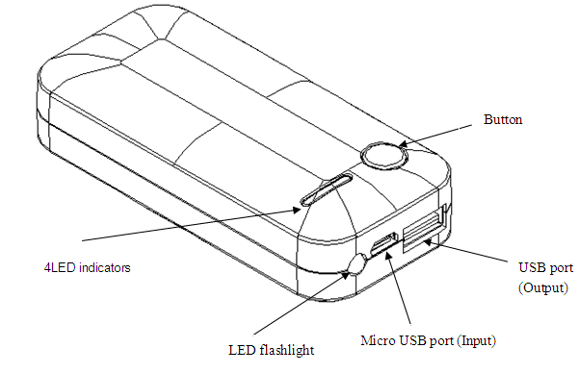

Charge the Power Bank fully before use (~ 5–6 hours) !
➔ Connect the Mini USB port of the charging cable* (*included) to the Power Bank and connect the USB port of the charging cable to the AC adapter with USB slot or to a PC/Notebook (see picture below). ➔ During charging the blue LED is blinking. ➔ The number of blue LED´s lighting is depending on the amount of power in the power bank. ➔ When only one LED is lighting that means the power is almost empty, 4 LED lighting means almost full power.

CAUTION: When charging this product by using the USB charging cable, always hold the charging plug to plug in and out. If you pull the cable instead of the charging plug, the USB charging cable might get damaged and there is a risk of short-circuiting or electric shocks.
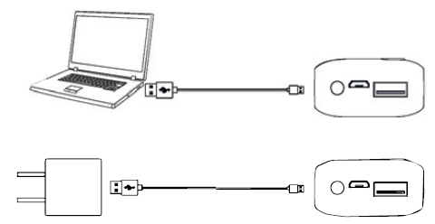
If you only press the power button once, you see the blue LEDs light up. By doing this you can check whether the power bank is fully charged or not.
If the Power Bank is not used for 1 minute, it will turn off automatically.

Capacity | Charging time of the Power Bank | iPhone 5 | Sony Z1, Z2 | Galaxy Note3 | Galaxy  S4, S5
5000mAh | approx. 5–6 hours | 2.2 times | 1 time | 0.9 times | 1 time

How to use your power bank
➔ Simply using the attached USB cable to connect with the “OUT” port of the power bank (see picture below). ➔ Using the other end of the USB cable to charge the digital product, it starts charging automatically. ➔ When the power bank has no output, you have to charge it immediately. ➔ To use the power bank as torch (flashlight) keep pressing the power button and the light turns on. Keep pressing the power button again, the light turns off. ➔ During charging the blue LED´s stays lighting. The number of blue LED´s lighting is depending on the amount of power in the power bank.
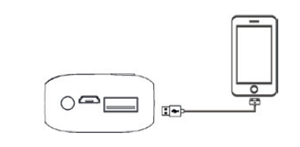

NOTE:  Because of the power conversion efficiency of the Power Bank and your digital devices, the rated capacity of the Power Bank is not equal to the actual chargeable capacity.  This Power Bank could charge the most of the digital devices, but it is possible that some devices are not supported.  If the Power Bank could not charge your devices, then check if the cable is firmly connected or if the right connector has been chosen, the original cable sold along with your device is always suggested to use.  If the instantaneous current is oversize when charging the digital devices, the Power Bank will turn off to the protected mode automatically.

Important Safeguards / Warnings / Maintenance
● Do not use this unit for anything other than its intended to use.  Do not drop/ bump/shake the device (do not use the unit if it has been damaged in any way).  Do not open/repair/disassamble the device  Do not store the device in high temperature environment/close to open fire/in humid-damp-erosive environments/into water.  Stop using when unusual smell/heating distortion/color-change of the shell material or other abnormal situation happens.  Keep away from children/persons without enough mental ability/persons without enough knowledge to use this product.

Security and Disposal Hints for Batteries: Hold children off batteries. When a child swallowed a battery go to a doctors place or bring the child into a hospital promptly! Look for the right polarity (+) and (–) of batteries! Always change all batteries. Never use old and new batteries or batteries of different types together. Never short, open, deform or load up batteries! Risk of injury! Never throw batteries into fire! Risk of explosion!


Hints for Environment Protection: Packages materials are raw materials and can be recycled. Do not disposal old devices or batteries into the domestic waste. Cleaning: Protect the device from contamination and pollution (use a clean drapery). Avoid using rough, coarse-grained materials or solvents/aggressive cleaner. Wipe the cleaned device accurately. Important Notice: Should battery fluid leak from a battery, wipe the battery case with a soft cloth dry. Distributor: Technaxx Deutschland GmbH & Co.KG, Kruppstr. 105, 60388 Frankfurt a.M., Germany
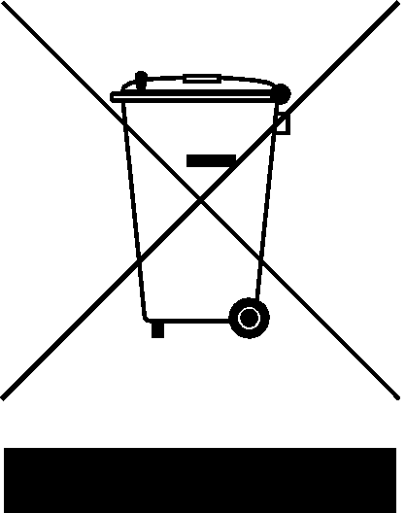

Battery Care Information (the battery is NOT replaceable)
1. Rechargeable batteries are only to be charged under adult supervision.
2. Rechargeable batteries are only to be charged by adults.
3. Regularly examine the USB charging cable or Smartphone cable** (**not provided) for any damage to their cord plug, enclosure and other parts. In case of damage, do not use it until it has been repaired or replaced.
DISCLAIMER: This charger is meant for using only in conjunction with the appropriate mobile entertainment device. We, the manufacturer, are not responsible for any damages to any mobile entertainment device incurred through use of this product.

