Technaxx® * User Manual
FMT900BT Transmitter
FM transmitter & Bluetooth hands-free car kit

This device complies with the requirements of the standards referred to the Directive R&TTE 1999/5/EC. The Declaration of Conformity you find here: www.technaxx.de/ (in bar at the bottom “Konformitätserklärung”). Before using the device the first time, read the user manual carefully.

Turn OFF nearby Bluetooth devices to avoid signal interference!

Service phone No. for technical support: 01805 012643 (14 cent/minute from German fixed-line and 42 cent/minute from mobile networks).
Free Email: support@technaxx.de

Features
● Wireless transmission of phone calls from mobile Bluetooth devices to the FM radio of a vehicle  Supports MicroSD cards & USB flash drives up to 32GB to play MP3/WMA music tracks  1-button function: answering/end calls & redial of the last number  Switch to hands-free mode automatically from music playing status when receiving calls  Built-in microphone for hands-free handling  Two USB outputs for charging mobile devices with 5V/3.4A in total  Trendy and elegant design with LED frequency display  Easy handling and installation

Technical Specifications
Bluetooth | Bluetooth V2.1 with ~8m operating distance
Bluetooth protocol | AVRCP, HFP, A2DP
LCD display size | (L) 2.0 x (W) 0.8cm
Frequency range | 87.6–107.9MHz, max. 3m
Frequency stability | ±10ppml
Power supply | DC 12–24V (cigarette lighter socket of a vehicle)
Music format | MP3, WMA
Storage | MicroSD cards up to 32GB
USB output1 | Charging 5V/2.4A
USB output2 | Charging 5V/1A & data USB flash drive
Material | ABS
Weight / Dimensions | 33g / (L) 8.0 x (W) 4.3 x (H) 3.8cm
Package Contents | FMT900BT Transmitter, User Manual
Compatibility: This device can be paired as a hands-free kit with any compatible Bluetooth 2.1 or higher enabled devices.

View of the FM transmitter
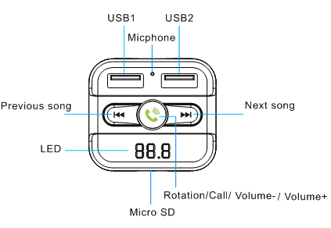
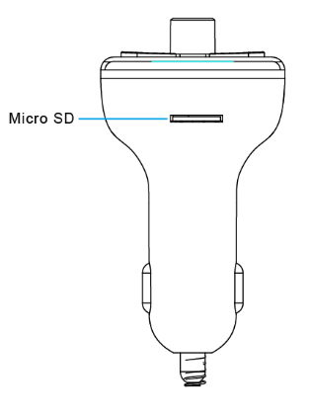

USB1 / USB2 port |  | Previous song
Microphone |  | Next song
LED |  | Rotation / Call / Volume – / Volume +
MicroSD card slot |  | Rotation / Call / Volume – / Volume +

FM Transmitter function
First plug the FM transmitter into the cigarette lighter socket of your vehicle or power port. Second tune your radio to a free FM frequency. Then match the same frequency of this FM transmitter. Now the Frequency Modulation follows:
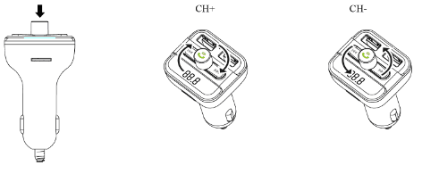
CH+ = increase FM
frequency in 0.1 steps
CH– = decrease FM
frequency in 0.1 steps
Note: Click and hold till frequency is flashing.

Insert a MicroSD card or USB flash drive which contains MP3 files into the MicroSD or USB2 slot (see picture below). The FM transmitter will play and transmit the files automatically to your car stereo system. Follow the picture (see above “View of FM-Transmitter”) to control your music.

USB charger function
If the FM transmitter is powered from a car cigarette lighter socket, you can connect the USB charger port (two ports, both are ok) to your mobile phone with a USB cable* (*not included). The FM transmitter now is working as mobile phone charger.
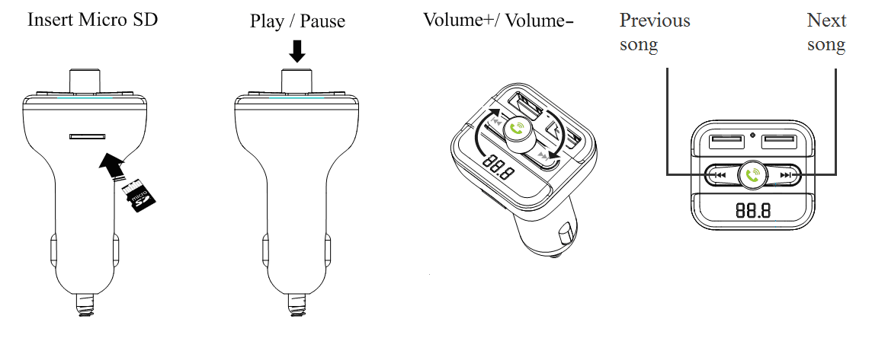

NOTE: Maximum output of USB1 is 2.4A. Maximum output of USB2 is 1A.
Insert MicroSD (card) |  | Previous song
Play / Pause |  | Next song
Volume + / Volume –
Bluetooth pairing
Using the Bluetooth function for the first time, you need to pair your mobile phone with the FM transmitter. 1. step: activate the Bluetooth function on your mobile phone. 2. step: search for the new device. When your mobile phone detects this FM transmitter named "Technaxx FMT900BT”, then pair and connect it. (If needed, use the original password "0000".)

1. Set frequency | Press and hold till frequency keeps flashing.  Rotate clockwise to increase the frequency.  Rotate anticlockwise to decrease the frequency.
2. Play /  Pause music | Press button to play music.  Press the button again to pause music playing.
3. Adjust volume | Rotate in clockwise to increase the volume.  Rotate anticlockwise to decrease volume.
4. Choose music | Press button to play the next song.  Press  button to play the previous song.
5. Answer /  Hang up call | Press button to answer the call.  Press button again to hang off the call.

Bluetooth function
NOTE: In the music playing mode, when there is an incoming call, this FM transmitter will automatically switch to the telephone mode.

Bluetooth calling
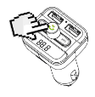
- Press to answer an incoming call.
- Press to hang up a call.
- Press twice to dial the last number automatically.
4. When making a call, you can only dial the phone number by your mobile phone. But once the call is connected, you can use the hands-free function. Note: The use of mobile phones while driving without a hand-free kit is a criminal offense.
Press to answer or hang up a call.

Warnings
● To prolong the life of this device, pull it out when starting the engine of the car.
● Do not remove any cover to avoid the risk of an electric shock or other damages.
● Do not attempt to disassemble the device, it may result in short-circuit or even damage.
● Do not drop or shake the device, it may break internal circuit boards or mechanics.
● Keep the device in dry and ventilated environment. Avoid high humidity and high temperature. Do not expose this unit to rain or moisture, to reduce the risk of fire or electrical shock. The device should not be exposed to dripping or splashing.
● Do not install the device near any heat source, such as radiators, or other equipment that produces heat. Keep the device away from direct sunlight.
● Keep the device away from little children.

Security and Disposal Hints for Batteries: Hold children off batteries. When a child swallowed a battery go to a doctors place or bring the child into a hospital promptly! Look for the right polarity (+) and (–) of batteries! Always change all batteries. Never use old and new batteries or batteries of different types together. Never short, open, deform or load up batteries! Risk of injury! Never throw batteries into fire! Risk of explosion!


Hints for Environment Protection: Packages materials are raw materials and can be recycled. Do not disposal old devices or batteries into the domestic waste. Cleaning: Protect the device from contamination and pollution (use a clean drapery). Avoid using rough, coarse-grained materials or solvents/aggressive cleaner. Wipe the cleaned device accurately. Important Notice: Should battery fluid leak from a battery, wipe the battery case with a soft cloth dry. Distributor: Technaxx Deutschland GmbH & Co.KG, Kruppstr. 105, 60388 Frankfurt a.M., Germany
