Technaxx® User Manual
4-Port USB Car Charger with 3-Cigarette lighter sockets TE11
The Declaration of Conformity is under the Internet link: www.technaxx.de/ (in bottom bar “Konformitätserklärung”); Before using the device, read the user manual carefully.

Service phone No. for technical support: 01805 012643 (14 cent/minute from German fixed-line and 42 cent/minute from mobile networks). Free Email: support@technaxx.de

Universal 4-port USB car charger with 3-cigarette lighter sockets
for mobile devices with DC 12V input
Features
● Charging of 4 USB devices simultaneously
● Fast and efficient desk charger with 6.8A
● Smart IC for auto-voltage detect
● Over voltage and over current protection
● ON / OFF switch with LED indicator
● Voltage warning flash-display under 12V
● Rubber grip for stable charging contact
● 1m car charging cable fixed on the charger
● 2x 3M double-sided adhesive sticker for fixation
● Stain-resistant treatment surface finish
IMPORTANT: It is your responsibility to check traffic and safety regulations in your area to ensure the lawful use of this device.

Technical Specifications
USB charger | Output current max. 5V / 6.8A
Single output current charger |  | 2x 1.0A and 2x 2.4A
Input current | DC 12V ~ 24V (car cigarette lighter) 7A
Power | maximum 120W
Safety | 5V 7A over voltage and over current protection
Material | Stain-resistant treatment surface finish
Weight charger | 180 g
Dimensions | Charger: (L) 11 x (W) 5.4 x (H) 2.9 cm  Cigarette lighter adapter: (L) 6.5 x (W) 3.4 x (H) 3.6 cm
Package Contents | 4-port USB & 3-Socket Car Charger TE11, User Manual

Product overview
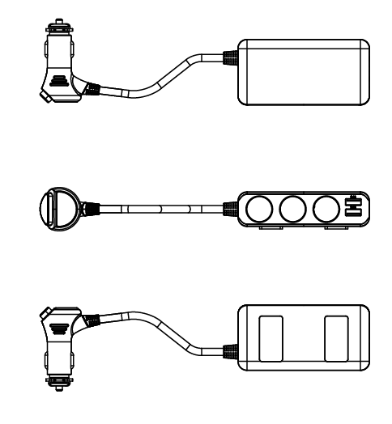

ON / OFF button
USB output:
2x 2.4A / 5V
On each side of
the charger are
two USB ports.

LED indicator

3-Socket output
DC 12V ~ 24V

2x 3M adhesive
stickers
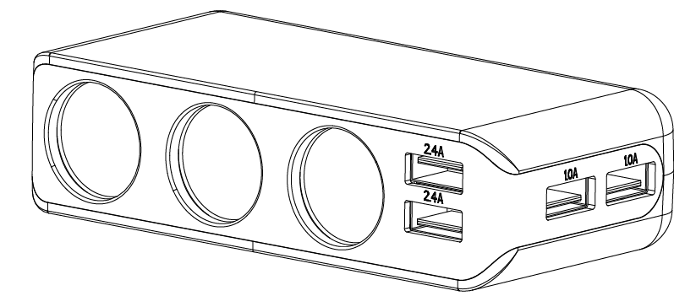

USB output:
2x 1.0A / 5V

Charging function
(1) When you charge one USB port only, the maximum output current is either 2.4A/5V, 2.4A/5V, 1.0A/5V or 1.0A/5V for each USB port.
(2) When you charge two, three or four USB ports at same time, all in all the USB ports have a maximum output current of 6.8A/5V in total.
(3) For the 3-Socket ports the maximum is DC 12V~24V/7A, Power max. 120W.

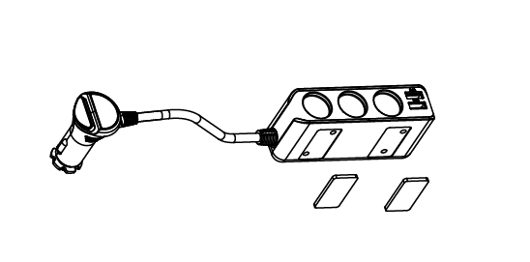
Installation
Simply plug the DC plug into the DC socket (cigarette lighter) of your car. Make sure it is fully and securely inserted. You can use the two 3M adhesive stickers to fix the base where you want.

How to charge your USB mobile device(s)
- Turn on your car.
- Make sure the DC plug is fully inserted into the DC socket of your car (cigarette lighter).
- Plug one end of your original USB cable into the any USB power and the other end into your mobile device.
- Turn on the switch. When the car charger is on you see the BLUE LED lighting constantly.
- Charging should begin automatically.
- If more USB ports needed, put any car charger adapter with USB port(s) into the any of the 3-sockets and then repeat the process.
NOTE: Turn off the switch after you leave the car for power-saving.

Recommendation: In case you have a low car battery status or an old car battery, and to conserve the battery life, do not charge any mobile device through the car cigarette lighter socket while you are in a traffic jam. Only charge your devices when the car is moving.

Warnings
● Do not attempt to disassemble, drop, shake or dismantle the charger. It may result in short-circuit or even damage of the internal circuit boards or mechanics.
● Do not expose the charger to an environment with high humidity or high temperature, extensive heat or direct sunlight, moist or underwater conditions.
● Keep the surface of the charger clean, but do not use organic solvents.
● Keep the charger away from little children.

Security and Disposal Hints for Batteries: Hold children off batteries. When a child swallowed a battery go to a doctors place or bring the child into a hospital promptly! Look for the right polarity (+) and (--) of batteries! Always change all batteries. Never use old and new batteries or batteries of different types together. Never short, open, deform or load up batteries! Risk of injury! Never throw batteries into fire! Risk of explosion!


Hints for Environment Protection: Packages materials are raw materials and can be recycled. Do not disposal old devices or batteries into the domestic waste. Cleaning: Protect the device from contamination and pollution (use a clean drapery). Avoid using rough, coarse-grained materials or solvents/aggressive cleaner. Wipe the cleaned device accurately. Important Notice: Should battery fluid leak from a battery, wipe the battery case with a soft cloth dry. Distributor: Technaxx Deutschland GmbH & Co.KG, Kruppstr. 105, 60388 Frankfurt a.M., Germany
