Technaxx ® * User Manual
Car Power Inverter with 2 USB Ports TE13

Do not use electric charge that need higher watts than
maximum 200W continuously !
This device is only suitable for CARS !

The Declaration of Conformity for this device is under the Internet link: www.technaxx.de/ (in bottom bar “Konformitätserklärung”). Before using the device the first time, please read the user manual carefully. Service phone No. for technical support: 01805 012643 (14 cent/minute from German fixed-line and 42 cent/minute from mobile networks). Free Email: support@technaxx.de

Features
● Charges various electronic devices in a car (12V cigarette ligher socket)
● 2.1A USB port & 1A USB port
● Schuko Plug with illuminated power switch
● Converts 12V DC battery power into standard 230V AC (household) power, to run a variety of electronics, e.g. tablets, smartphones, laptop computers, game systems, small TVs, DVD/MP3 players, camping accessories, GPS units and much more
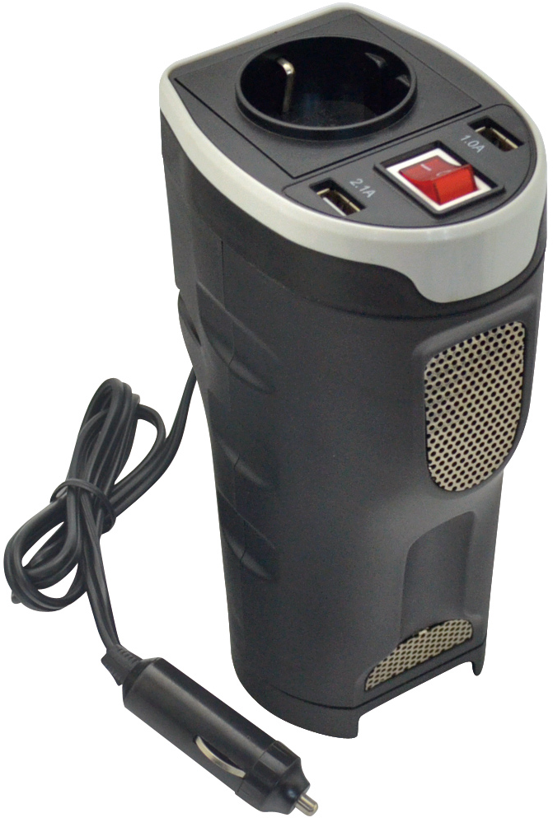
● Output power 200W (max. continuous) and 400W (peak)
● Plug into a cigarette lighter socket of a car
● Automatic safety shutdown to secure the car battery (at ~10.5V)
● High/Low voltage & overload protection
● Overheating protection (built-in ventilation fan)
● Durable plastic housing fits into a cup holder of a car

Technical specifications
Output power | 200W (maximum, continuously), 400W (peak)
Input voltage (DC) | 12 (cigarette lighter socket of a car)
Output voltage / AC frequency | 230V / 50Hz nominal
Output Waveform | PWM Sine Wave ➢ The power inverter’s PWM [Pulse Width Modulated] sinusoidal wave is suitable for almost all electric/electronical devices with max. 200W
Low battery voltage shutdown | at ~10.5V
USB output ports (DC) | 1x 5V/2.1A and 1x 5V/1A
AC output | 1x Schuko port
Circuit protection (DC overload) | 20A external car fuse (replaceable)
Weight / Dimensions | 400g / (H) 10.0–5.5 x (L) 7.0 x (W) 17.2cm  Cable length 90cm
Package Contents | Car Power Inverter with 2 USB Ports TE13, 20A Fuse, User Manual

Operation
Before using the power inverter determine your equipment’s total watts!

● Do not connect more watt than the Output Power (maximum continuous watt) of the device (➔ see technical specifications). See below table for typical equipment running times and for important notes concerning the limitations of car’s electrical systems.
● Watt ratings are usually listed in equipment manuals or on nameplates. If your equipment is rated in Amp, multiply that number times AC utility voltage to determine watts.
(mathematic example: a drill requires 1.5A → 1.5A x 230Volt = 345Watt. → This is way to much to work with a drill. Now follow these steps:
Step 1: Plug the device into the cigarette lighter socket / accessory outlet of your car.
Step 2: Turn on the power switch of the device.
Step 3: Plug equipment into the Schuko port of the device.
Note: Power switch can be off when you only use the USB output ports.

Typical running times before battery recharge
Although you can operate your device with your car’s engine off. Best results are usually achieved with the car’s engine running. Since the device only converts electrical energy and does not produce it, it’s performance is relative to the condition of the car’s electrical system (battery, alternator and wiring). If other electric charges (e.g. air conditioner, heater, lights, etc.) using power also, you may get less running time.

 | Compact Car  (4 cylinder) | Mid-size Car  (6 cylinder) | Mid-size Car  (8 cylinder)
Half load  (engine on/engine off) | Continuous /  ~ 4–6 hours | Continuous /  ~ 6–8 hours | Continuous /  ~ 8–12 hours
Full load  (engine on/engine off) | Continuous /  ~ 2–3 hours | Continuous /  ~ 3–4 hours | Continuous /  ~ 4–6 hours

Cars electrical system limitations
Due to the limitations of certain cars DC 12V cigarette lighter socket / accessory outlet electrical systems, you may not be able to continuously run a full elctric charge from the device. If you regularly blow fuses, it may indicate your car is not adequately wired to support the device as it is designed. In this case, consult car manufacturer recommendations for rewiring from the fuse block or battery with appropriate wiring (10–12 gauge) and fusing (at least 40A).

Maintenance
This device requires no maintenance and contains no user-serviceable parts (except for replaceable DC fuses, where applicable). Maximum output power (continuous or peak) only available when car’s battery is properly charged. Run car’s engine often to maintain proper charge. Peak output power is instantaneous. Replace fuse only with a fuse of equal amperage rating. Do not use higher-rated fuses.

Troubleshooting
(1) Device does not turn on when power switch is turned ON.
➢ Device shut down automatically due to low battery voltage (at ~10.5V). ➔ Turn the device OFF and start yours car’s engine to recharge the car’s battery. Only use this device with the car’s engine running.
➢ Device shut down automatically to output overload. ➔ Turn the device OFF and remove overload by unplugging high-watt devices. Electric charge should not exceed the device’s maximum continuous output power (see technical specifications).
➢ Blown fuse ➔ Replace the fuse with standard automotive fuse of identical amperage where applicable (see technical specifications).

(2) Device is unable to power connected equipment.
➢ Battery running low. Low battery voltage reduces the device’s power output. ➔ Turn the device OFF and start yours car’s engine to recharge the car’s battery. Only use this device with the car’s engine running.

(3) Connected equipment experience audio/video distortion.
➢ Loose connections ➔ Check and secure all connection.
➢ Audio/Video interferences ➔ Reposition equipment antennas and the device.

Warnings & Caution
● Use of the device in life support applications where failure of the device can reasonably be expected to cause the failure of the life support equipment or to significantly affect its safety or effectiveness is not recommended.  Do not use the device in the presence of a flammable anesthetic mixture with air, oxygen or nitrous oxide, and also not near flammable materials, fumes or gases.  Since the device requires adequate ventilation during operation, do not block fan or cooling vents and do not cover the device. Do not operate near car heating vents or in direct sunlight.  Keep the device dry at all times and disconnect when not in use.  Turn OFF connected equipment before (!) starting your engine. DO NOT plug a surge protector, line conditioner or UPS system into the device. If you attach AC extension cords, use the heaviest practical gauge.  Before connecting a battery charger or adapter, check its manual to make sure that the technical specifications of the device (including output waveform) fall within the recommendations of the external battery charger or adapter.

Hints for Environment Protection: Packages materials are raw materials and can be recycled. Do not disposal old devices or batteries into the domestic waste. Cleaning: Protect the device from contamination and pollution (use a clean drapery). Avoid using rough, coarse-grained materials or solvents/aggressive cleaner. Wipe the cleaned device accurately. Distributor: Technaxx Deutschland GmbH & Co.KG, Kruppstr. 105, 60388 Frankfurt a.M., Germany

