MusicMan® MA Display * User Manual
The Declaration of Conformity for this device is under the Internet link: www.technaxx.de/ (in bottom bar “Konformitätserklärung”). Before using, read the user manual carefully.
Service phone No. for technical support: 01805 012643 (14 cent/minute from German fixed-line and 42 cent/minute from mobile networks). Free Email: support@technaxx.de

This device has a rechargeable battery. It must be fully charged before first use. WARNING: DO NOT TURN THE VOLUME TOO HIGH – HEARING LOSS MIGHT BE THE RESULT! NOTE: Charge the battery of the device every 2–3 month if it is not used!

Features:  Mobile stereo wide range speaker system with display for MP3/4, CD/DVD, Smartphone, iPad, iPod, PSP, PC/Notebook, with integrated MP3 player for USB flash disks and MicroSD cards up to 32GB  Built-in stereo FM radio and Line-IN/AUX  Plays all songs in WMA, WAV and MP3 format.  Lightweight but very durable aluminium housing, available in 5 different metallic colours  Several power supply options: rechargeable and replaceable battery, computer USB or AC adapter* (*not included)  Ideal to use at home or for traveling, easiest installation, excellent sound quality
Charging of the battery
Plug in the USB cable* (* included) into the DC input of DC-5V of the speaker. Then connect the USB port to the USB slot of PC or other USB slot of chargers. Then the LED shines RED. The LED will shine RED until the speaker is fully charged, and it will turn off when the speaker is fully charged. (Recommendation: turn OFF the speaker while charging. When it is working, it will take a longer time to get it fully charged.) Please always fully upload the battery. NOTE: Should be repeatedly shown on the display an hourglass, then you have to change the battery.

Silver power button ON / OFF: press it to turn the device ON or OFF
VOL+ / VOL– : press for volume adjustment
: press short to move left / right, or choose last / next song
MENU: press short to enter a sub-menu or confirm
LOUDSPEAKERS: press long the MENU button to turn the speaker ON or OFF

Action | Basic operations
Short press | Key pressing time less than 2 seconds
Long press | Key pressing time more than 2 seconds
Select | Press the key and hold it pressed

Note: Unless otherwise specified, “press” in this manual means “short press”.
Time: Turn on to enter MENU. Insert card/USB to enter MUSIC play. Insert audio cable to choose Line–IN play.

Main Interface (5 applications):
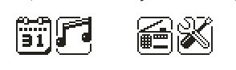
Calendar, Music, Line–IN, FM,
System Settings
Press the MENU key to access the main menu. Press and to select the application. Press the MENU key to enter. Press the MENU key to confirm the selection of the application. Plug in a memory card or a USB flash drive to go to MUSIC playback. Insert the Line–IN cable to have Line–IN playback.

FUNCTIONAL APPLICATIONS
Calendar: Choose calendar and pess the MENU key to enter. Press or only to enter the day of the week. Press the MENU key and the key to return to the main menu.

MUSIC: Before tracks will be copied to a MicroSD card or USB, both storage media must be formatted with Windows Fat32. Then, when the MicroSD card or USB with MP3 tracks is plugged into the appropriate slot, the songs are played automatically.

All music title must be pure MP3. The device cannot playback copied MP3 songs from iTunes!

WMA & MP3 music’s stop and playing interface
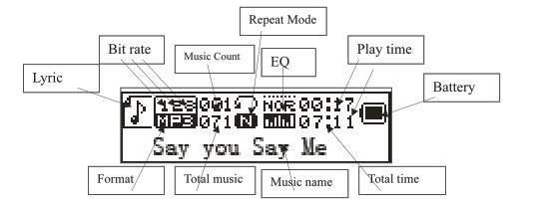
Note: 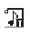 indicates the current music has lyric, otherwise the icon will be

Note: Each selection must be confirmed by pressing the MENU key.

Insert a MicroSD memory card or USB flash drive
● Before MP3 music tracks are copied on MicroSD card or USB flash drive, both memory media have to be formated under Windows to FAT32.
● The golden contacts must be directed upwards and forwards. Always do the installing and removing of the MicroSD card with care, otherwise the contacts of the device and/or the MircoSD card may be damaged.

Attention: USB / MicroSD / Line–IN ➔ the last used one has priority.

Submenu 1 and basic operation
In Stop/Pause status, press the MENU key to enter the following submenu: USB/Card catalog, Delete this file, Delete all, Back, Exit.

USB/Card catalog: Select the “USB/Card catalog”. Press or to browse the various options. Press MENU to enter the next level directory. Press MENU again to select a file and return to “music player interface”. The player supports multi-level directory structure and display. In the process of searching files press the key to return to “music broadcast”.

Play music: press to start playing. Support breakpoint playing.

Pause music: press to switch between pause and continue playing.

Change file / Fast rewind / Fast forward: when playing a file, press / to change to the previous/next file. Long press / fast rewind/fast forward (during that no voice playback).

Delete file: select “Delete file”. Press MENU to enter the next level interface. Press / to select “YES” / “NO”, to confirm/not confirm the delete of a file.

Delete all: Delete all the files in the current folder (this operation is the same as for Delete file).

Submenu 2
In the playing status press MENU to enter the following submenu:

FM Radio, Circle mode, EQ settings, Back & Exit
Circle mode: select “Circle mode” and select the desired repeat mode with the keys / and confirm it with the MENU key.

Circle Mode | Icon | Description
Normal |  | Play all files by sequence, no repeat.
Repeat one |  | Repeat the current file.
Folder |  | Play all files in the current folder, no repeat.
Repeat folder |  | Repeat all files in the current folder.
Repeat all |  | Repeat all files.
Random |  | Play files in random.
Intro |  | Play the first 10 seconds of all files by sequence.

Equalizer settings: select “Equalizer” and press the MENU key to enter into the desired mode.

EQ Mode | Icon | Description
Normal |  | Standard natural sound
Rock |  | Music of strong emotion
Pop |  | For common pop music
Classic |  | Soft classical sound
Soft |  | Sound quality is very soft
Quiet |  | Empathetic and quiet sound
Jazz |  | Sweet sound full of tender emotion
Bass |  | Bass sound
SRS WOW |  | SRS HD Audio

Back: return to main menu
Exit: return to playback mode

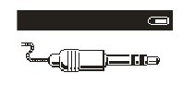
Line-In – function and operation: In the main menu interface insert the Line-In cable to turn into LINE-IN play.

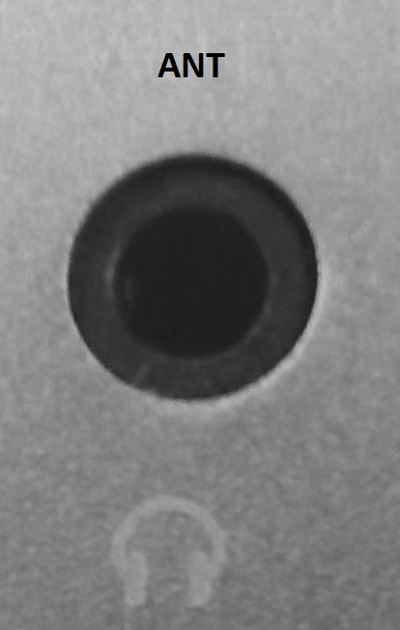
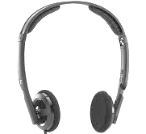
Port for antenna and headphones:
Music can be heard via USB stick, via MicroSD card or via radio, either through the speakers of the MusicMan or with headphones.

To switch between the speakers and the headphonse, press and hold the MENU button for 2–3 seconds.

FM: Select FM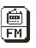in the main interface. Press MENU to enter FM Radio and long press to exit. (User should insert the audio cable as antenna to get a better signal.)

FM Interface: The status will be saved before exit. If re-enter FM, the frequency is the one exited last time. Normal band: 87.5MHz – 108.0MHz.
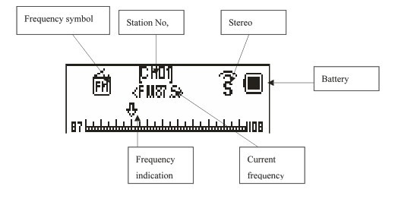

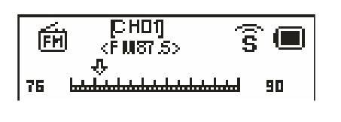

Radio Operation:
In the “Radio Interface”: Press the MENU key to enter into Automatic Search, Back to Music, Store Channel, Normal Frequency, Delete Channel, Delete All & Exit. Select a single option with the / keys and confirm with the MENU.

Long press / searchs automatically backward or forward stations. It stopps after receiving a radio broadcast. When the program already is saved, the interface shows the serial number stored. If not saved, you need to save the program manually. When saving is finished, press to switch and play among the saved stations. Press / to fine-tune the search (frequency steps 100KHz.)

Automatic search: Press the MENU key. Highlight with the keys / “Automatic Search” and confirm it with the MENU key. It is scanned into the “Normal Frequency”. The channel search will start automatically. To get a better signal, you should plug in the audio cable as an antenna.

Save: Search a station desired, press MENU to enter the submenu, select “Save” and press MENU, the system will return to the FM interface and the station is saved. “Save” supports up to 20 stations for each band.

Back to music: Press the MENU key. Highlight with the keys / “Back to Music” and confirm it with the MENU key. Is a MicroSD card or USB flash drive with WMA/MP3 songs plugged into the appropriate slot, music playback continuous.

Delete channel: Select a channel to be deleted, press MENU to enter the submenu and select Delete, press MENU, then the channel’s serial number (such as CHO2) disappears, indicating the channel CHO2 is deleted. User has to re-search this channel to listen to it again.

Exit: is it confirmed by pressing the MENU key, you exit the FM mode.

System Settings:
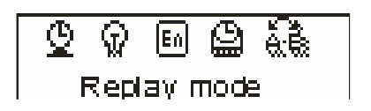
Select SYS 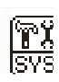 in the main interface, press MENU to enter system setting. Press / to choose different setting items. Press MENU to enter setting.

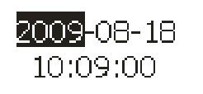
System time: Press or to adjust time. Press MENU to choose adjusting item.

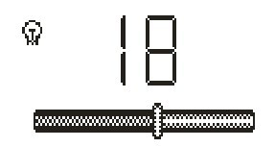
Backlight: Press or to adjust the backlight parameter. Press MENU to confirm and exit.
If the display shows „00“, the background is always bright.
If a different value is shown (01–15), the background light goes off.

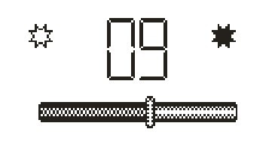
Contrast: Press or to adjust the backlight parameter. Press MENU to confirm and exit.

Language: : Press or to choose language. Press MENU to confirm and exit. (15 languages: Simplified Chinese, Traditional Chinese, English, German , French, Italian, Dutch, Spanish, Portuguese, Swedish, Czech, Danish, Polish, Russian, Turkish.

TOOL: Press MENU to enter “Tool”: Power off set, Alarm, Time FM set, Exit.

Power off set: Press MENU to enter power off time setting. Press or to adjust time. Press MENU to confirm and exit.
Is „Power Off“ set to „ON“ and no longer to „00“, then the speaker will change to the Standby Mode after the set time ends.

Alarm ON/OFF: Press MENU to turn the alarm ON or OFF.

Alarm Time: Press or to adjust time. Press MENU to choose adjust item.

Circulation (Cycle): Press or to choose the desired setting. Press MENU to set: “Every Day”, “One Time” [press or to set the alarm time] or “Cycle” [press or to choose a day]. Press MENU to choose or cancel.

Alarm Signal: Press or to choose desired setting. Press MENU to set:

Rings embedded: Press or to choose rings. Press MENU to confirm.
Card Catalog: Press MENU to enter. Choose desired ring. Press MENU to confirm and exit.

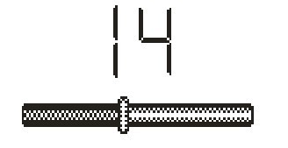
Volume Control: Press or to adjust volume. Press MENU to confirm and exit.

FM time setting
Open FM time: the display shows the radio icon
Close FM time: the display does not show the radio icon
FM time: you can set the FM time

Tape tuning
Normal frequency: choose the radio station which is to be played during the alarm and confirm it. Press the MENU key for exit.

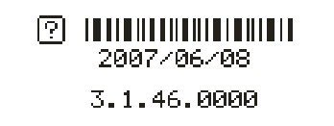
Firmware Version
FAQ
Cannot turn on the device: Check the capacity of the battery. Connect USB cable or charger and try to turn on the device again. Check whether the battery is inserted correctly.
Bad FM Radio signal: Adjust the direction and placement of the device. Pull the audio cable longer. Check whether there is interference from electronic equipment nearby.
Display shows garbage: Check whether the correct language is been choosen.

Technical specifications
Display | 128 x 32mm black-white
Memory | USB flash drive and MicroSD card (up to 32GB)
Built-in | Stereo radio FM + Line-IN/AUX (3.5mm/analog audio input)
Power supply | Lithium battery BL-5B (rechargeable, replaceable)  Playing time with MicroSD card ~4–5 hours  Playing time with USB ~3 hours  Charging time ~4 hours  PC-USB, AC Adapter* (*not included)
FM (Line-IN play with FM radio) | Receiving frequency  range |  | 87.5MHz – 108MHz (Normal band)  76MHz – 90MHz (Japan band)
FM (Line-IN play with FM radio) | Station No. |  | 20/20
FM (Line-IN play with FM radio) | Signal Noise Ratio |  | > 45dB
Antenna | FM antenna 3.5mm plug (use audio cable as FM antenna)
DC-5V | Input power (0.4-1.0 A) from USB or AC adapter*
Music format |  | MP3 / WMA / WAV
Temperature |  | –5°C up to +50°C
Weight / Dimensions |  | 220 g / 5,0 x 5,3 x 16,5 cm
Package Contents |  | MusicMan MA Display, USB/Power/Audio cable,  User manual

Security and Disposal Hints for Batteries: Hold children off batteries. When a child swallowed a battery go to a doctors place or bring the child into a hospital promptly! Look for the right polarity (+) and (--) of batteries! Always change all batteries. Never use old and new batteries or batteries of different types together. Never short, open, deform or load up batteries! Risk of injury! Never throw batteries into fire! Risk of explosion!


Hints for Environment Protection: Packages materials are raw materials and can be recycled. Do not disposal old devices or batteries into the domestic waste. Cleaning: Protect the device from contamination and pollution (use a clean drapery). Avoid using rough, coarse-grained materials or solvents/aggressive cleaner. Wipe the cleaned device accurately. Important Notice: Should battery fluid leak from a battery, wipe the battery case with a soft cloth dry. Distributor: Technaxx Deutschland GmbH & Co.KG, Kruppstr. 105, 60388 Frankfurt a.M., Germany
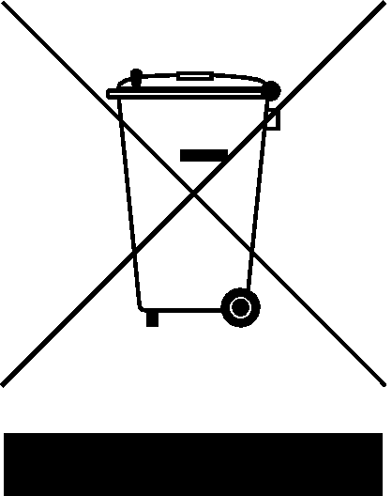

Keep this user manual for future reference or product sharing carefully. Do the same with the original accessories for this product. In case of warranty, please contact the dealer or the store where you bought this product.

Warranty 2 years

