MusicMan®
NANO Bluetooth Soundstation waterproof BT–X11
User Manual

Declaration of Conformity is under: www.technaxx.de (in bottom bar “Konformitätserklärung”)

Portable waterproof super small speaker with
Bluetooth function
Wireless mini speaker with Bluetooth function in a unique design, a nice accessory for a Smartphone, Tablet PC, computer, etc.

Features
● Special protection (IPX5) against water jet, dust and touching
● Easy music transfer with Bluetooth compatible devices
● Easy conection with Bluetooth compatible devices (= Pairing)
● Stylish holder for mounting on smooth surfaces
● Grippy silicone case
● Built-in hands-free function with built-in microphone
● Built-in rechargable lithium polymer 300mAh battery 3,7V
● Supports iPhone, iPad, Smartphones, Tablet PC, etc.
● Audio playing via Bluetooth
● Playing time approx. 4 hours by medium volume
● Bluetooth Version 3.0 with 3W output power
● Carabiner for secure attachment
● Ideal for traveling, easy installation, crystal clear sound

Charging of the battery
Lift the little silicone lash on the speaker’s side and plug in the Micro USB charging cable* (*included) into the Charge interface of the speaker. Then connect the USB port to the USB slot of PC or USB 3.7V 300mAh charging adapter** (**not included). Charging time is approximately 1.5 – 2 hours. While loading, the red LED lights continously. When the speaker is fully loaded, the red LED turns off. Once the battery is fully loaded, the circuit will be automatically broken to provide protection for the battery. Always fully upload battery!

Product overview

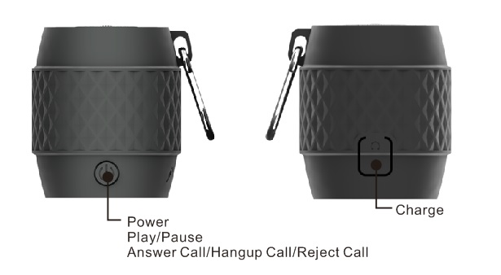
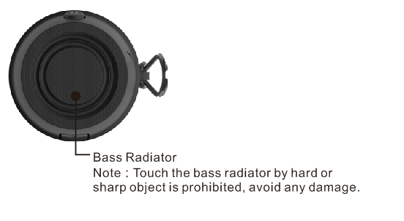

Bass Radiator
Note: Touch the bass radiator by hard or sharp object is prohibited, avoid any damange.

Power ON / OFF: Press the button  at least for 3 seconds to power ON the speaker. You hear a short sound.The WHITE and RED LED flashes alternately.
Press the button at least for 3 seconds to power OFF the speaker. You hear a short sound.
Play / Pause: Press the button to play music Short press for stop, press again to continue with music playback.

Bluetooth connection
(1) When the speaker’s battery is fully loaded, power ON the speaker. The WHITE and RED LED flashes alternately. The speaker is now ready to pairing (= connect to Bluetooth).

(2) Search in your Bluetooth compatible devices under Bluetooth settings and you find the Bluetooth device with the name “NANO BT-X11”. Select it and connect it with your Bluetooth compatible device. When the Bluetooth connection is successfully done, only the WHITE LED will shine and you hear a short sound.

NOTE: The speaker will complete paring in about 30 seconds automatically. This product possess auto-shut-off-function. When the speaker is not done the connection within 5 minutes after being started up with Bluetooth, the speaker will shut off automatically.

Hands-free function
When a call is coming in, make a short press of the button for hands-free microphone function and to accept the call. Make a lomg press of the button to reject the call. To finish the call, you either can press the button again, or you finish the call through the Bluetooth connected device, e.g. a smartphone.

The speaker can play music when linked to a mobile phone, MP3, MP4, PC, iPOD or to another audio device, which must have Bluetooth.

Warnings
● Only charge the speaker with the provided original Micro USB charging cable.
● Do not attempt to disassemble the speaker, it may result in short-circuit or even damage.
● Do not drop or shake the speaker, it may break internal circuit boards or mechanics.
● The speaker should be kept in dry and ventilated environment. Avoid high humidity and high temperature. Also batteries should not be exposed to excessive heat or direct sunlight.
● Keep the surface of the speaker clean, but do not use organic solvents.
● Keep the speaker away from little children.

Technical specifications
Bluetooth | Bluetooth Version 3.0 + EDR, A2DP Bluetooth system  BT operating distance: ~ 10m (open range)
Audio playback | Audio playback only through Bluetooth
Driver | Ø 31mm, 4Ω, 3W
Amplifier | Class D H6871
Input | 20 MV – 500 MV
Frequency | 180 Hz – 16 KHz
Signal Noise Ratio | S / N ≧ 65 dB
Total Harmonic Distortion | THD ≦10%
Battery | Built-in rechargable lithium polimer 300mAh 3.7V  (rechargeable by the Charge slot)
Charging Time | ~ 1.5 – 2 hours
Playing Time | ~ 4 hours (medium volume)  ~ 2 – 2.5 hours (highest volume)
Working temperature | –10° up to +50°C
Weight / Dimensions | 55 g / Ø 4.1 cm x 5.0 cm
Package Contents | MusicMan® NANO Bluetooth Soundstation waterproof BT–X11, Micro USB cable, Carabiner, Holder for smooth surfaces, User Manual

Hints for Environment Protection: Packages materials are raw materials and can be recycled. Do not disposal old devices or batteries into the domestic waste. Cleaning: Protect the device from contamination and pollution (use a clean drapery). Avoid using rough, coarse-grained materials or solvents/aggressive cleaner. Wipe the cleaned device accurately. Important Notice: Should battery fluid leak from a battery, wipe the battery case with a soft cloth dry. Distributor: Technaxx Deutschland GmbH & Co.KG, Kruppstr. 105, 60388 Frankfurt a.M., Germany
