MusicMan® * User Manual
Twins Bluetooth Soundstation BT–X21

Separable 2-in-1 Bluetooth Stereo Loudspeaker

The manufacturer Technaxx Deutschland GmbH & Co.KG hereby declares that this device, to which this user manual belongs, complies with the essential requirements of the standards referred to the Directive RED 2014/53/EU. The Declaration of Conformity you find here: www.technaxx.de/ (in bar at the bottom “Konformitätserklärung”). Before using the device the first time, read the user manual carefully.

Service phone No. for technical support: 01805 012643 (14 cent/minute from German fixed-line and 42 cent/minute from mobile networks).
Free Email: support@technaxx.de

This device has a rechargeable battery. It must be fully charged before first use. Turn OFF nearby Bluetooth devices to avoid signal interference!

Keep this user manual for future reference or product sharing carefully. Do the same with the original accessories for this product. In case of warranty, please contact the dealer or the store where you bought this product. Warranty 2 years

ATTENTION: Both speakers look identical. Only when applying the functions you know which is the main speaker and which is the auxiliary speaker.

Features
● Music transfer through Bluetooth V4.2 with transmission distance ~10m
● Make phone calls wireless via Bluetooth (hands-free function)
● Bluetooth loudspeaker pair with AUX–IN, ideal for mobile music transfer with dynamic sound
● Natural stereo surround-sound by separate placement of the two speakers in a room
● Two 850mAh batteries ensure a long music experience without annoying cable clutter
● Supports mobile phones/Smartphones, computer, Tablets, MP3, etc.
● Ideal at home and for travelling
● Trendy optic and handy size

Technische specifications
Bluetooth | Bluetooth V4.2 with ~10m transmission distance
Functions | Bluetooth (Main speaker & auxiliary speaker), AUX–IN (Main speaker & auxiliary speaker), Hands-free (Main speaker only)
Loudspeaker | 2x 4W stereo / SNR ≦80dB / Impedance 4Ω /  Frequency 80Hz–8kHz
Audio input | 2x 3,5mm
Power supply | Rechargeable 2x 850mAh lithium ion batteries 3.7V
Charging time | ~2–2,5 hours
Playing time | ~5–6 hours (fully charged)
Standby time | ~120 hours (5 days)
Material | ABS plastic & fabric
Weight / Dimensions | 450g / (L) 18.6 x (W) 8.0 x (H) 7.4cm
Package Contents | MusicMan® Twins Bluetooth Soundstation BT-X21, Micro USB charging cable, AUX–IN cable, User Manual

Charging
Before first use, fully load the battery with the included original Micro USB charging cable. Plug the charging cable into the Micro USB slot of the speaker, and the other end into a USB slot of PC or other USB slot of a charger* (5V/500mA, *not included).

The RED LED indicates the charging of the speaker. When the speaker is fully charged, the RED LED turns off. (We recommend to turn off the speaker while charging, otherwise it will take longer time.)

Charge the speaker at least 3 hours before first use and charge the battery of the speaker every 2–3 month, when not used!

Produkt View
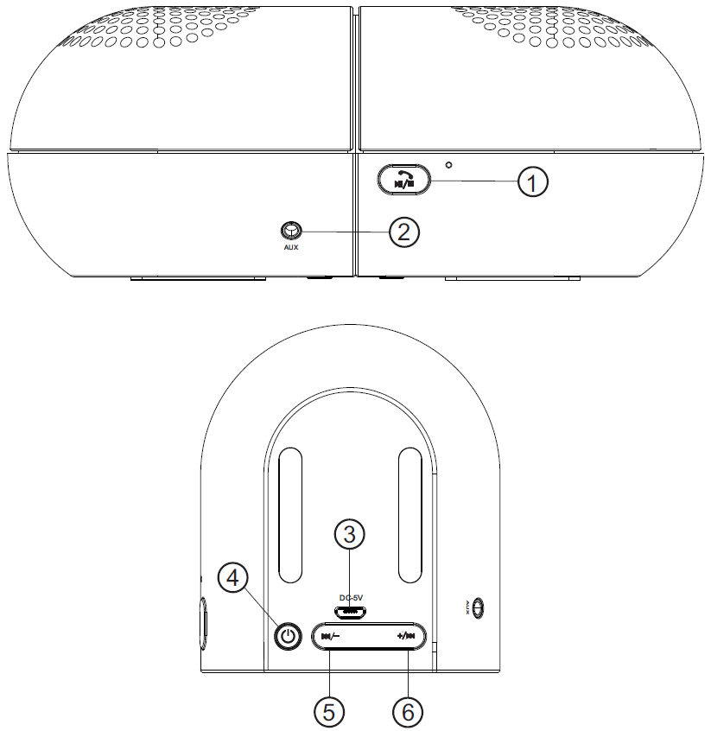

1 | Play / Pause Button  → After turning on the speaker with button (4), long press the button to enter the Bluetooth pairing mode.  → Under the Bluetooth mode, short press the button to Play/Pause the music or answer/ end calls. The incoming call can be rejected by pressing long the button (1).  → If two speakers once are connected with certain device, they will re-pair with the device when they are turned on again. To pair the speaker with another Bluetooth-enabled device, first separate the speaker from the current paired device via the Bluetooth settings, and then go to step a).
2 | AUX connection
3 | Micro USB charging connection
4 | Power on / off  Long press the button (4) to power ON / OFF the speaker. The BLUE LED flashes slowly.
5 | Back / VOL –  - Short press to go back to last music track.  - Long press to decrease the volume.
6 | Forth / VOL +  - Short press to go forth to next music track.  - Long press to increase the volume.

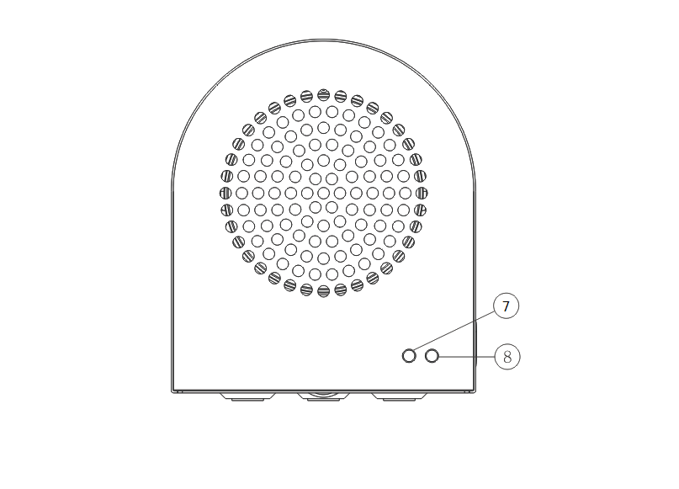

7 | Paring indicator for main speaker & auxiliary speaker (left channel and right channel)  GREEN LED flashes quickly under the pairing mode.  GREEN LED turns solid after two speakers succeed pairing process with each other.
8 | Working indicator: BLUE LED flashs slowly after the speaker is turned on. Under the Bluetooth pairing mode, it will flash quickly. After the speaker is connected with another Bluetooth enabled device and plays music, the BLUE LED flashes slowly. If no music is played or the music playback is paused, the BLUE LED is continuously on.  Charging indicator: RED LED turn solid when the speaker is being charged. When the speaker is fully charged, the RED LED will turn off.
Operating
1. Pairing of one Twin-Speaker with another Bluetooth enabled device

● To turn on the speaker, long press the power button at the bottom. Long press the Play/Pause button to connect with your Bluetooth enabled Mobile phone, Smartphone, Tablet PC, MP3 etc. When the speaker enters the Bluetooth pairing mode, you can hear an indicating sound and the BLUE LED flashes quickly.

● Enable the Bluetooth function of your device. Now you can search for the Bluetooth name of the speaker, which is „BT–X21“. When the Bluetooth name appears on your screen, select it. A few seconds later, you can hear an indicating sound that indicates pairing is completed. The LED will then turn to solid BLUE. Now you can enjoy music.

2. Pairing of the Twin-Speakers to one another (stereo playback)
Note: Stereo playback is possible in Bluetooth mode only.

● No matter which speaker you turn on first, main or auxiliary speaker, this speaker will connect automatically to the other. If this is not the case, switch both speakers off and on again. Press two times shortly the button “POWER” (4) of each speaker to get two speakers paired. The GREEN LED flashes while the speakers are pairing.

● When the two speakers succeed in pairing, the LED on both speakers will turn to solid GREEN. The BLUE LED of the main (!) speaker flashes slowly, while the BLUE LED of the assistant speaker turns off. At that moment, press long the “Play/Pause” button (1) of the main (!) speaker to enter the Bluetooth pairing mode.

● Enable the Bluetooth function of your device. Now you can search for the Bluetooth name of the speaker „BT–X21“. When the Bluetooth name appears on your screen, select it. A few seconds later, you can hear an indicating sound that indicates pairing is completed. The LED of the main speaker will then turn to solid BLUE. Now you can enjoy music from the twin speakers. After start of the music playback, the BLUE LED of both speakers flashes slowly.

NOTE:
a) No matter which speaker you turn on first, main or auxiliary speaker, this speaker will connect automatically to the other. The LEDs will turn to solid GREEN after connection is completed.

b) When both speakers are playing music, and you turn off one of them, the other speaker will be turned off as well.

c) If both speakers are connected, but they fail to play music synchronous, or one of them fails to emit sound, you can power off the two speakers simultaneously and power on again to resume normal.

3. Hands-free Function
Your Bluetooth device (e.g. mobile phone) is connected with one of the Twin speakers. When you receive a call, press the Play/Pause button on the main speaker to answer the call.

When you want to to hang up the call, press the Play/Pause button again. The incoming call can be rejected by pressing long the button (1).

NOTE: when main speaker and auxiliary speaker both are connected to your mobile phone, you can only operate the hands-free function on the main (!) speaker.

4. AUX Function
Plug one end of 3.5mm AUX cable into the AUX slot of the speaker, and plug the other end into the audio slot of your mobile phone, Smartphone, Notebook, Tablet PC, MP3 Player etc. After that, you can enjoy the music.

NOTE: when the main speaker and assistant speaker are both connected, you can only operate the AUX function on that speaker, in which you plugged in the 3.5mm AUX cable.

Warnings
● If the device does not turn on after switching it on, or it turns off after turning it on, check whether the battery is fully charged. If it is OFF power, get it fully charged and try again later. (We suggest charging the device 1x week if it is not used for a long time.)
● When the device works under LINE/AUX–IN mode, do not (!) increase the volume of your mobile phone, PC, MP3/MP4 Player, CD, DVD etc. to a large extend; a sonic boom or sound distortion may occur. In that case, decrease volume either of mobile phone, PC, MP3/MP4 Player, CD, DVD or device. The sound gets normal soon.
● If the device fails to link to your mobile device or if it fails to play music after being connected, the user shall check if the correct PIN code is entered or if your mobile device supports A2DP.
● Only charge the device with the DC 5V/500mA USB adaptor* (*not included) or in USB slot of your PC with the provided original USB charging cable. It would make the device fail to work or even damage the headphone if it is not charged with recommended voltage.
● Do not attempt to disassemble the device, it may result in short-circuit or even damage.
● Do not drop or shake the device, it may break internal circuit boards or mechanics.
● Keep the device in dry and ventilated environment. Avoid high humidity and high temperature. Also batteries should not be exposed to excessive heat or direct sunlight.
● This device is not water resistant, therefore keep it away from moisture.
● Keep the device away from little children.

Hints for Environment Protection: Packages materials are raw materials and can be recycled. Do not disposal old devices or batteries into the domestic waste. Cleaning: Protect the device from contamination and pollution (use a clean drapery). Avoid using rough, coarse-grained materials or solvents/aggressive cleaner. Wipe the cleaned device accurately. Distributor: Technaxx Deutschland GmbH & Co.KG, Kruppstr. 105, 60388 Frankfurt a.M., Germany

