MusicMan® User Manual
Bluetooth MP3 Headset BT-X24
Transform any headphone in a Bluetooth headphone with additionally FM radio and MicroSD card support

This device complies with the requirements of the standards referred to the Directive R&TTE 1999/5/EC. The Declaration of Conformity you find here: www.technaxx.de/ (in bar at the bottom “Konformitätserklärung”). Before using the device the first time, read the user manual carefully. This device has a rechargeable battery. It must be fully charged before first use. Turn OFF nearby Bluetooth devices to avoid signal interference!

Service phone No. for technical support: 01805 012643 (14 cent/minute from German fixed-line and 42 cent/minute from mobile networks).

Free Email: support@technaxx.de
WARNING: DO NOT TURN THE VOLUME TOO HIGH – HEARING LOSS MIGHT BE THE RESULT!
This headset is NOT water resistant. Keep it away from moisture/rain/high humidity and keep it dry.

Features
● Bluetooth adapter with 3.5mm audio connector to connect headphone, speaker, stereo system, etc.  Make telephone calls and listen to music wireless  Built-in microphone for the hands-free function  Control music and take calls directly  When incomming call, music stops automatically  Selfie trigger function (take pictures with your Smartphone)  Handy clip to attach to your cloth or bag

Technical specification
Bluetooth version / profile / range |  | V2.1 / A2DP / ~8m operating range
Storage / Music formats |  |  | MicroSD card up to 32GB / MP3, WMA
Functions | Hands-free, Bluetooth trigger, FM radio
Battery | Built-in rechargeable150mAh lithium polymer battery 3.7V
Charging time | ~ 2.5 hours (by DC-5V / 500mA adapter)
Playing time | ~ 3.5 hours (at maximum volume)
Standby time | ~ 6–7 hours (connected to Bluetooth)
Power supply | DC 5V/3.7V
Frequency | 20Hz – 20kHz
Audio connector | 3.5mm
Charging connector | Micro USB connector
Material | PC + ABS plastic
Weight / Dimensions | [Earphones] 12g / Length cable 76cm; [Clip] 14g / (L) 5.5 x (W) 2.5 x (H) 1.5cm
Package Contents | MusicMan® Bluetooth MP3 Headset BT-X24, Micro USB charging cable, Headphones, User Manual

Charging
Before first use, fully load the battery with the included original Micro USB charging cable. Connect the Micro USB charging cable to an USB adapter* (5V/500mA) (*not included) or computer USB port, and the other end to the Micro USB charging port of the headphone. The RED LED shines bright while charging in the OFF status. When the headphone is fully charged, the RED LED turns off and the BLUE LED turns on. (We recommend to turn off the headphone while charging. Otherwise it will take a longer time to get it fully charged.)

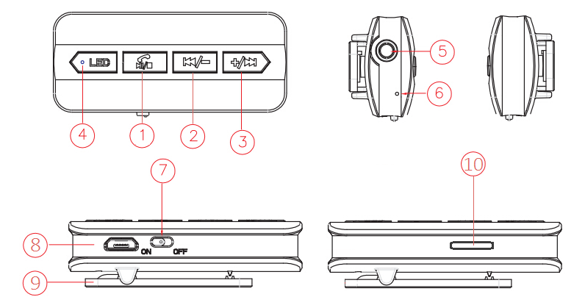
View

Note: Plug a 3.5mm earphone into Bluetooth clip before using it.

1 | Play / Pause / Change Mode: Press shortly to play/pause music and receive/end calls. Press long to change mode. Bluetooth / Bluetooth Trigger / MicroSD card / FM Radio
2 | Back / Volume – : Press shortly to go back to previous song. Press long to decrease volume.
3 | Forth / Volume + : Press shortly to move to next song. Press long to increase volume.
4 | LED indicator light: (a) BLUE LED flashes quickly after the headphone is turned on. LED turns solid after it succeeds connecting with other Bluetooth enabled devices. LED flashes slowly while the headphone is playing music. LED turns solid when music pauses.  During charging process the RED LED is on. LED turns off when the headphone is fully charged.
5 + 6 |  | Earphone jack/Audio output + Microphone
7 + 8 |  | Switch on/off + Micro USB charging connector
9 |  | Clip for fixing the device
10 |  | MicroSD card slot

Bluetooth mode
Turn on the headphone by switching the on/off button to the ON position. The BLUE LED will flash quickly. Bluetooth works spontaneously, searching for previously paired Bluetooth devices. If the headphone fails to connect, turn on your Bluetooth device to search the headphone with the name “Musicman BT-X24”. PIN code is “0000”. After pairing successfully, the BLUE LED is blinking slowly. When the headphone is connected with your Smartphone and you receive an incoming call, you can press the “PLAY” button to take the call. To reject the you have press the “PLAY” button again.
NOTE: To switch between the modes, keep the “PLAY” button pressed for about one second. You will hear that the mode changes.

Bluetooth Camera Trigger mode
If you want to make a picture with your Smartphone, and use the headphone as “Shutter” device, you have to enter the Bluetooth Trigger Function! Then press the “PLAY” button (like described above) several times until you enter into the Bluetooth Trigger Mode. Turn on Bluetooth of your mobile phone or another Bluetooth enabled device and try to connect.
! ATTENTION: For this function you have to “change” the Bluetooth mode. Now you have to select the second Bluetooth name of the headphone which is “shutter” !
Turn on the camera of the mobile phone or another Bluetooth enabled device. After completed pairing, press shortly the “BACK” or “FORTH” button to take a picture.
NOTE: Bluetooth Camera Trigger supports most Android or iOS mobile phones. Bluetooth Camera Trigger controller button differs from phone to phone, some are controlled by “BACK” while others by “FORTH”. Some phones cannot activate Bluetooth Camera Trigger. It may due to camera protocol is not compatible.

MicroSD card mode
Insert the MicroSD card in the headphone MicroSD card slot (10) before you power it on. Then press the “PLAY” button several times until you enter into the MicroSD Card Mode. The headphone will automatically play audio files from the MicroSD card (MP3/WMA formats are supported), the BLUE LED will flash slowly when the headphone plays music.

FM Radio Mode
Press the “PLAY” button several times until you enter into the FM Radio Mode. The broadcast station search starts automatically. Located broadcast stations will be saved automatically. To switch between broadcast stations press the “BACK” or “FORTH” button shortly.

Connect speaker, stereo system, etc. via the Audio output of the BT-X24: Plug one end of the 3.5mm Jack cable* (*not included) in the Audio output of the BT-X24. The other end connect with the Audio input (e.g. Line–IN, AUX–IN) of the device, which you want to connect (Speaker, Stereo System, etc.). Now you can listen to music on the connected device (Speaker, Stereo System, etc.) via Bluetooth or from a MicroSD card.
NOTE: It may happen that you need for a stereo system an Audio cable with 1x 3.5mm Jack and 2x Cinch.

Warnings:  If the device does not turn on after switching it on, or it turns off after turning it on, check whether the battery is fully charged. If it is OFF power, get it fully charged and try again later.  Only charge the device with the DC 5V/500MA adapter* (*not included) or in USB slot of your PC with the provided original Micro USB charging cable. It would make the device fail to work or even damage it if it is not charged with recommended voltage.  If the device fails to link to your mobile device or if it fails to play music after being connected, the user shall check if the correct PIN code is entered or if your mobile device supports A2DP.  When the device works under LINE/AUX–IN mode, do not (!) increase the volume of your mobile phone, PC, MP3/MP4 Player, CD, DVD etc. to a large extend. A sound distortion may occur. In that case, decrease volume either of mobile phone, PC, MP3/MP4 Player, CD, DVD or device. The sound gets normal soon.  Do not attempt to disassemble the device, it may result in short-circuit or even damage.  Do not drop or shake the device, it may break internal circuit boards or mechanics.  Keep the device in dry and ventilated environment. Avoid high humidity and high temperature.  This device is not water resistant, therefore keep it away from moisture.  Keep the device away from little children.

Security and Disposal Hints for Batteries: Hold children off batteries. When a child swallowed a battery go to a doctors place or bring the child into a hospital promptly! Look for the right polarity (+) and (--) of batteries! Always change all batteries. Never use old and new batteries or batteries of different types together. Never short, open, deform or load up batteries! Risk of injury! Never throw batteries into fire! Risk of explosion!
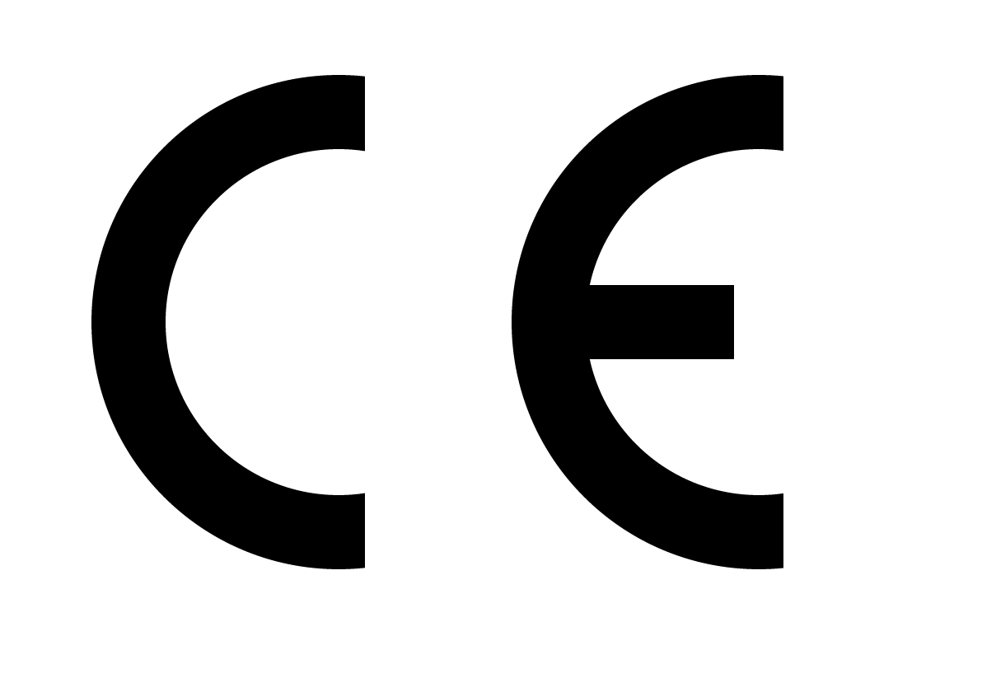

Hints for Environment Protection: Packages materials are raw materials and can be recycled. Do not disposal old devices or batteries into the domestic waste. Cleaning: Protect the device from contamination and pollution (use clean drapery). Avoid using rough, coarse-grained materials or solvents/aggressive cleaner. Wipe the cleaned device accurately. Important Notice: Should battery fluid leak from a battery, wipe the battery case with a soft cloth dry. Distributor: Technaxx Deutschland GmbH & Co.KG, Kruppstr. 105, 60388 Frankfurt a.M., Germany
