MusicMan® * User Manual
Mini Wireless Soundstation BT–X2

This device complies with the requirements of the standards referred to the Directive R&TTE 1999/5/EC. The Declaration of Conformity you find here: www.technaxx.de/ (in bar at the bottom “Konformitätserklärung”). Before using the device the first time, read the user manual carefully.

This device has a rechargeable battery. It must be fully charged before first use. Turn OFF nearby Bluetooth devices to avoid signal interference!
Service phone No. for technical support: 01805 012643 (14 cent/minute from German fixed-line and 42 cent/minute from mobile networks). Free Email: support@technaxx.de
DO NOT TURN THE VOLUME TOO HIGH – HEARING LOSS MIGHT BE THE RESULT!
NOTE: Charge the battery of the device every 2–3 month if it is not used!
Features
● Portable Mini Bluetooth speaker system with wireless audio transfer for MP3, iPhone, iPad, iPod, Mobile phones, Tablet PC, PC/Notebook
● Easy connection with Bluetooth compatible devices (mobile phones, Tablet PC, etc.)
● MicroSD card slot up to 32GB & AUX / Line–IN 5V (connect with your mobile phone)
● Grill protection for the speaker cone
● Aluminium housing in 5 colours & brilliant sound quality

Key functions
Key | Function
 | Play / Pause / Stop
VOL – | Volume down
VOL + | Volume up
 | One back / Last music
 | Next one / Next music
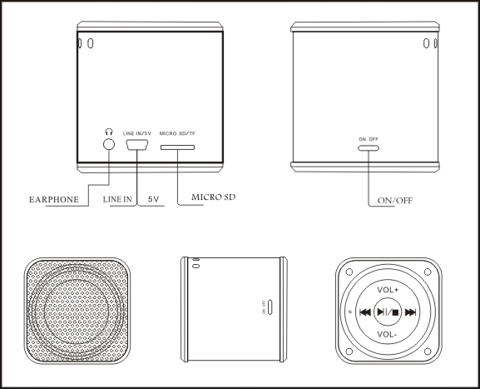

● Press VOL+ to increase volume
Press VOL – to decrease volume

● It also is possible to insert another sound source by Line-IN.

Lights
RED Charging Light: (1) it lights up while charging, (2) it goes off when battery is completely charged.

BLUE Working Light – Bluetooth Mode: indicate light is BLUE (1) while BT is connected light blinks quickly, (2) when connection is ready light blinks 3x in interval, (3) when light shines brightly, the device is in Line–IN mode.

Handling Bluetooth connection to device:
1) Make sure that the mobile phone is in Bluetooth mode.
2) Turn on the device.
3) Press long the button  to switch into Bluetooth mode. The BLUE light will blink 3x quickly. Then a sound is heard which means "Ready for Pairing".
4) Open the mobile phone Bluetooth search. It points out whether set " Mini BT MusicMan " as stereo device when searching it. Choose " YES " (this prompt may differ from the mobile phone brand) or just tip on the device’s name.
5) Put in the password " 0000 " into the prompt window (this window may differ from the mobile phone brand). The BLUE light blinks quickly and "Pairing completed" is heard. Then press long on button to connect the mobile phone with the MusicMan. It is heard "Connected" as a confirmation.
6) Open the mobile phone music player.
7) Select the desired track.

Handling Headphones: While playing music in any mode, insert the headphones into the headphone slot . The device switches to headphones automatically. After removing the headphones, the device switches back to the previous mode.

Handling MicroSD memory card: A MicroSD memory card can be inserted into the slot at any mode. The device will automatically switch to the MicroSD card and plays music. After removing the memory card, the device will switch back to the previous mode.

Handling Line–IN: Connect the Mini-USB cable with the MusicMan and put the audio plug into the audio port of the desired device. Then press long on button to switch into Line–IN mode.

Technical specifications
Loud Speaker | 1x 1.77” (external Ø 4.5cm), Magnetic resistant 4 Ohm
Line–IN / 5V | USB power supply & Audio input (AUX–IN)
Signal / Noise Ratio | ≥80dB
Battery | Built-in rechargeable (~3-4 hours) lithium battery 600mAh 3.7V  Battery playing time (with MicroSD) ~8-9 hours at medium volume / Charging time ~3-4 hours
Flash memory | MicroSD card (up to 32GB)
Earphones | Port für 3.5mm jack cable
Output | RMS 3W THD=10%
Frequency response | 150–18000Hz (±3 dB)
Power | 5V/1000mA AC power adapter* (*not included), or PC USB power cable** (**included)
Charging process  (~3-4 hours) | When power OFF, LED turns red while charging.  When charging is completed, LED turns off.  When power ON, LED turns purple while charging.  When power ON but no charging process, LED turns blue colour.
ON / OFF  (Power switch) | ON button = power ON, then music playing starts  OFF button = power OFF
Weight / Dimensions | 112g / (L) 5 x (W) 5 x (H) 5cm
Package Contents | Mini MusicMan® Wireless Soundstation BT–X2, USB cable, Audio cable, Hand strap, User Manual

Security and Disposal Hints for Batteries: Hold children off batteries. When a child swallowed a battery go to a doctors place or bring the child into a hospital promptly! Look for the right polarity (+) and (--) of batteries! Always change all batteries. Never use old and new batteries or batteries of different types together. Never short, open, deform or load up batteries! Risk of injury! Never throw batteries into fire! Risk of explosion!


Hints for Environment Protection: Packages materials are raw materials and can be recycled. Do not disposal old devices or batteries into the domestic waste. Cleaning: Protect the device from contamination and pollution (use a clean drapery). Avoid using rough, coarse-grained materials or solvents/aggressive cleaner. Wipe the cleaned device accurately. Important Notice: Should battery fluid leak from a battery, wipe the battery case with a soft cloth dry. Distributor: Technaxx Deutschland GmbH & Co.KG, Kruppstr. 105, 60388 Frankfurt a.M., Germany
