MusicMan®
Mini Style MP3 Player TX-52
User Manual
The Declaration of Conformity for this device is under the Internet link: www.technaxx.de/ (in bottom bar “Konformitätserklärung”). Before using the device the first time, read the user manual carefully.

This device has a rechargeable battery. It must be fully charged before first use.
Service phone No. for technical support: 01805 012643 (14 cent/minute from German fixed-line
and 42 cent/minute from mobile networks). Free Email: support@technaxx.de

NOTE: Charge the battery of the device every 2–3 month if it is not used!

Features
 MP3 Player
 USB 2.0
 Supports MP3 & WMA music formats
 Built-in MicroSD card slot
 Supports MicroSD cards up to 32GB (Fat32 formatted)
 Built-in port for earphones
 Elegant aluminium shell
 Very small pocket size, practicable to take everywhere you want
Technical Specifications
Music format | MP3 & WMA
Bit rate | 8 ~ 320 kbps
Battery | Built-in rechargeable 130mAh lithium polymer battery
Charging time | 1.5 ~ 2 hours
Playing time | ~ 7 hours
Environmental temperature | –20 ~ +60°C
Relative humidity | 20% ~ 93% (40°C)
Weight / Dimensions | 10 g / (L) 2.1 x (W) 2.1 x (H) 2.1 cm
Package Contents | MusicMan® Mini Style MP3 Player TX-52, Earphones,  3.5mm Jack cable to USB charging cable, User Manual
1. Charging
Before first use, fully load the battery with the included original USB/3.5mm charging cable. Plug in the charging cable into the 3.5mm slot of the player (6) and the other side to the USB slot of your PC/Notebook or another USB slot of chargers. When the player is being charged, the LED (8) turns to RED and lighting constantly. Once it is fully charged, the LED gets OFF. (It is recommended to turn off the player while charging, because it will take longer time to get completely charged if the player works while being charged). Please charge the player at least 2 hours before first use! NOTE: Charge the battery of the device every 2–3 month if it is not used!

2. Product overview
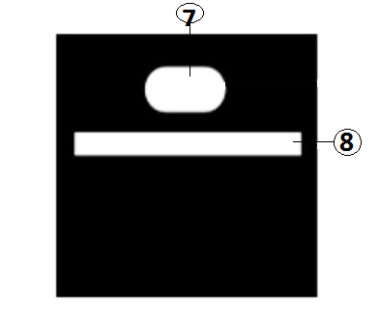

Table for the product overview
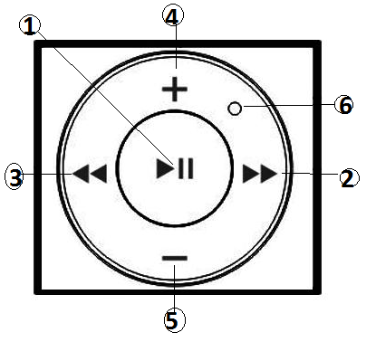
1 | ON / OFF / PLAY / PAUSE
 | ON  OFF  PLAY  PAUSE | Press the button (1) to get the player ON  Press the button (1) to get the player OFF  Press the button (1) to play the paused track  Press the button (1) to pause the playing track
2 | NEXT | Press short to go forth to the next song.
3 | PREV | Press short to go forth to the previous song.
4 | Vol+ | Press and hold to increase the volume
5 | Vol- | Press and hold to decrease the volume
6 | Status indicator | The LED indicator will be blinking or lighting constantly depending on the status of the player
7 | Earphone | Insert your headset*(*included) here to hear the track playing
8 | MicroSD card slot

3. Turn ON – OFF (see key 1)
(a) Turn ON the player: press key (1) for 2–3 seconds; you will see the LED (6) lighting GREEN

(b) Turn OFF the player: press key (1) for 2–3 seconds; you see the GREEN LED (6) goes OFF.

4. Handling MicroSD card
(a) Insert first the earphone in to the earphone slot (7)

(b) Insert a MicroSD card into the MicroSD card slot (8). Then the music starts playing automatically. The GREEN LED (6) is blinking. To pause the music playback, press the key once; press it again and music playback will continue.

(c) Press short the  key to you hear the previous song. Press short the  key to hear the next song. Press and hold the (+) key to increase the volume. Press and hold the (-) key to decrease the volume.

(d) When you need to connect the player with an external speaker then connect the player with the speaker with 3.5 mm cable both sides.

Warnings
● If the player does not turn on after switching it on, or it turns off after turning it on, check whether the battery is fully charged. If it is OFF power, get it fully charged and try again later. (We suggest charging the player once a week if it is not used for a long time.)
● Only charge the player with in the slot of a PC/Notebook/charging adapter with the provided original 3.5mm Jack/USB charging cable.
● Do not attempt to disassemble the player, it may result in short-circuit or even damage.
● Do not drop or shake the player, it may break internal circuit boards or mechanics.
● Keep the player in dry and ventilated environment. Avoid high humidity and high temperature. Also batteries should not be exposed to excessive heat or direct sunlight.
● This player is not water resistant; therefore keep it away from moisture.
● Keep the player away from little children.

Hints for Environment Protection: Packages materials are raw materials and can be recycled. Do not disposal old devices or batteries into the domestic waste. Cleaning: Protect the device from contamination and pollution (use a clean drapery). Avoid using rough, coarse-grained materials or solvents or aggressive cleaner. Wipe the cleaned device accurately. Important Notice: Should battery fluid leak from a battery, wipe the battery case with a soft cloth dry. Distributor: Technaxx Deutschland GmbH & Co.KG, Kruppstr. 105, 60388 Frankfurt a.M., Germany
