MusicMan®
PowerBank Bluetooth Soundstation BT–X16
User Manual

This device complies with the requirements of the standards referred to the Directive R&TTE 1999/5/EC. The Declaration of Conformity you find here: www.technaxx.de/ (in bar at the bottom “Konformitätserklärung”). Before using the device the first time, read the user manual carefully.

This device has a rechargeable battery. It must be fully charged before first use.
Turn OFF nearby Bluetooth devices to avoid signal interference!

Service phone No. for technical support: 01805 012643 (14 cent/minute from German fixed-line
and 42 cent/minute from mobile networks). Free Email: support@technaxx.de

DO NOT TURN THE VOLUME TOO HIGH – HEARING LOSS MIGHT BE THE RESULT!
NOTE: Charge the battery of the device every 2–3 month if it is not used!
Features
● Music transfer through Bluetooth version 4.0 with transmitting distance ~10m  Charger for external mobile devices  Built-in FM radio  Make phone calls wireless via Bluetooth (hands-free function)  LED indicator shows the working status  When incoming call, music playback is paused automatically  Supports computer, Tablets, MP3, CD & AUX–IN  Charge your devices and hear music at the same time
Technical Specifications
BT version / Transmitting distance |  |  |  | Version 4.0 / ~ 10m (open range)
Functions | Bluetooth, Power Bank, AUX–IN , Hands-free, FM radio, MicroSD card (supports MP3 music format), USB flash drive
PowerBank output |  |  | DC 5V / 1.5A
Speaker output |  |  | 2 x 5W
Frequency range |  |  | 90Hz – 18KHz
Power supply |  |  | Built-in rechargeable rechangeable lithium ion 4000mAh battery with 3.7V
Charging time |  |  | 5 ~ 6 hours (Adapter DC 5V/2A)
Playing time  (fully charged) |  |  | ~ 20 hours (medium volume)
 |  |  | ~ 8 hours (maximum volume)
 |  |  | 3 ~ 5 hours (max. volume + charging external devices)
Standby time |  |  | approx. 2 weeks
Speakers / Diameter |  |  | Stereo soundtrack / Ø 52mm, protection grill for the speaker cone (2 front stereo speakers)
SNR / Speaker impedance |  |  | ≦ 80 dB / 4 Ω
Memory |  |  | supports MicroSD cards up to 32GB
Weight / Dimensions |  |  | 495 g / (L) 19 x (W) 7 x (H) 7 cm
Package Contents |  | MusicMan® PowerBank Bluetooth Soundstation BT–X16, AUX cable, Micro USB to USB charging cable, Power adapter DC 5V/2A, Pouch, User Manual
1. Charging
Before first use, fully load the battery with the included original Micro USB charging cable. Plug in the charging cable into the Micro USB slot (15) of the speaker and the other side to the USB slot of your PC/Notebook or another USB slot of chargers. When the speaker is being charged, the right LED (9) turns to BLUE and it flashes slowly. Once it is fully charged, the LED turns off. (It is recommended to turn off the speaker while charging, because it will take longer time to get completely charged if the speaker works while being charged.) When the battery is low, the right LED (9) is on, the two others (middle and left LED) are off. When battery is medium, the right LED (9) turns solid, the middle LED (9) blinks and the left LED (9) is off. When the battery is almost fully charged, the right LED (9) and the middle LED (9) turn solid, the left LED (9) blinks. When the battery is completely charged, all three LEDs (9) turn solid. Please charge the speaker at least 5 ~ 6 hours before first use! NOTE: Charge the battery of the device every 2–3 month if it is not used!

2. Product overview
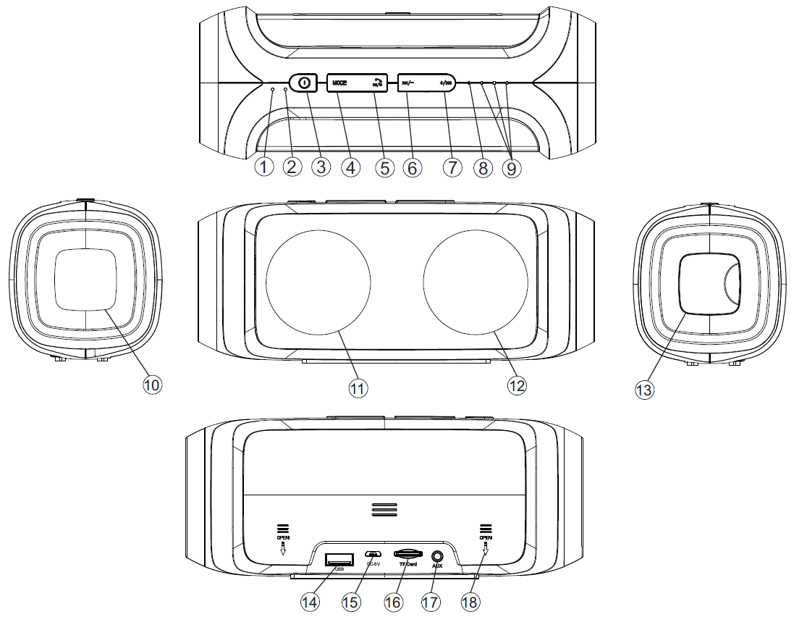

Table for the product overview
1 | Microphone
2 | Reset |  | Press with a pair of tweezers or the like, to restart if the speaker stops.
3 | Power  ON / OFF |  | Press long to turn ON the speaker, LED turns on BLUE.  When the speaker is on, press long to turn it OFF.
4 | MODE |  | Press short to select USB, MicroSD, AUX, FM, Bluetooth.
5 | Play  Pause  Hands-free |  | Press short to play, pause or restart streming music when the speaker is connected via Bluetooth with another Bluetooth device. It can also answer a call or hang up while being connected with a Smartphone.
6 | Back  Volume – | Press short to go back to the previous song.  Press and hold to decrease the volume.
7 | Forth  Volume + | Press short to go forth to the next song. Press and hold to increase the volume. If you put the speaker on maximum volume, you will hear a sound to show, VOL cannot be increased any more, and music playback will stop. But after several seconds the speaker will continue to play music.
8 | Working LED  indicator |  | (a) GREEN LED: under USB, MicroSD, AUX, FM it blinks slowly when the speaker plays music. It turns solid when the speaker pauses. It blinks quickly when the radio si carrying on autmatic searching – and it turns solid when the radio pauses.
8 |  |  | (b) BLUE LED: under Bluetooth pairing mode it blinks quickly. It blinks slowly when the speaker is playing music via Bluetooth. It turns solid when the speaker pauses.
9 | LED (left,  middle, right)  for battery  status |  | (a) Under power bank mode: all three LEDs light if battery is completely charged; two LEDs light if battery is medium; one LED lights if battery is low.
9 |  |  | (b) Under charging mode: LEDs blink slowly when the speaker is in charging process. LEDs turn solid when the speaker is completely charged.
10 | Built-in bass loud speaker
11 | + 12: Two stereo loud speakers
13 | Built-in USB port (open the black protection lash)
14 | USB flash drive port
15 | Micro USB charging port
16 | MicroSD card slot
17 | AUX–IN port
18 | Rear cover | How to change the battery:  Push the rear cover with both thumbs to the direction of the arrow, which is shown on the rear cover. Pull out the battery and replace it with the new one (same power, same volt). Look for the right polarity (+) and (--) of the battery.

3. Turn ON – OFF (see key 3)
(a) Turn ON the speaker: Press key (3) for 2–3 seconds; you will hear a “Beep” sound.

(b) Turn OFF the speaker: Press key (3) for 2–3 seconds; you hear a “Beep” sound again.

4. Bluetooth Pairing
Turn ON the speaker. The speaker is in the Bluetooth mode directly and the BLUE LED flashes. Then turn on your mobile device, go to settings and choose Bluetooth. Now you can search for the Bluetooth name of the speaker, which is „MusicMan PowerBank“. When you found it click on it.

After the Bluetooth connection is established and you will hear a “Beep” sound, and the BLUE LED on the speaker lights constantly. Now you can play music from your mobile device and the music will stream through the speaker.

If the speaker fails to connect, please start the Bluetooth connection (as described above) again, until you get connected.

5. Bluetooth Phone Calls
Before using the hands-free function make sure that Bluetooth is connected. When there is an incoming phone call, press short the  key to answer the call through your speaker. Press short the key again to hang up the call.

6. Bluetooth Music
Press the MODE button and change to Bluetooth mode. After successful pairing, press the key once to play music sourcing from your mobile device. Press it again to pause the music playback. Change songs: Press short the +/ key for the next song, press short the /- key for the previous song. Adjust volume: Press and hold long the +/ key to increase the volume, press and hold long the /- key to decrease the volume.

7. Handling USB and MicroSD card
Press the MODE button and change to USB mode or MicroSD mode.

(a) Insert a USB flash drive into the USB slot (14) or a MicroSD card into the MicroSD card slot (16). Then the music starts directly. The GREEN LED (8) is flashing slowly. To pause the music playback, press the key once; press it again and music playback will continue.
(b) Press short the /- key to you hear the previous song. Press and hold the /- key to decrease the volume. Press short the +/ key to hear the next song. Press and hold the +/ key to increase the volume. NOTE: The last (!) inserted device has priority.

8. FM Radio Mode

For better reception you can plug in the provided AUX cable in the AUX–IN port (17).
Press the MODE button and change to FM mode

(a) The GREEN LED is flashing (the operation keys will not work yet). Now you have to search for channels. Press the key for 2–3 seconds to start the channel search function. The GREEN LED is blinking fast. The speaker now is searching available channels in your area (frequency range 87.5–108.0MHz), and save them automatically.
When channel searching is finished, the speaker will play the first channel found. If a channel is found, the GREEN LED is flashing slowly.

If a channel is received you hear the channel; if no channel is received, you hear a rushing noise. In that case start the channel searching function again.

(b) Press short the /- key to you hear the previous channel. Press and hold the /- key to decrease the volume. Press short the +/ key to hear the next channel. Press and hold the +/ key to increase the volume.

(c) If you want to leave the FM mode, press the MODE key (4) to transfer to MicroSD card, to USB flash drive, AUX–IN or Bluetooth.

9. AUX–IN Mode (17)
To use the AUX–IN mode plug in the provided AUX cable (3.5mm cable) in the AUX–IN port (17) and the other end into audio slot of a mobile phone, notebook, tablet PC, MP3/MP4 player etc.

If you are in AUX–IN mode, you can hear the audio sourcing from other devices (e.g. computer/mobile devices). With the +/ key you can increase the volume, and with the /- key you can decrease the volume. Press short the key for playback or pause music. NOTE: To change the track you are hearing, you have to use the buttons on your mobile device! The GREEN LED is blinking when AUX–IN is connected!

10. Charging of external devices
Plug one end of the charging cable into the built-in USB charging port (13) and the Micro USB end into the charging port your external device. Then press short the power bank switch (3) to start charging.

NOTE
(a) Charge the speaker for at least 8 hours before first use.

(b) The default charging end is MICRO USB port. To charge devices without MICRO USB port, you need the relevant adapter.

(c) Some devices may not charge due to incompatibility. Reasons of incompatibility could differ. In most cases, the incompatibility could be due to a different cable chipset design.

(d) This speaker with power bank function has a maximum output of 1.5A. Some devices which require more than 1.5A input may charge slowly, charge in sleep mode or not charge.

How often can charge my mobile phone?
Capacity | Time for full recharge power bank | iPhone 5 | Sony Z1, Z2 | Galaxy Note3 | Galaxy  S4, S5
4000mAh | approx. 5 ~ 6 hours | 2 times | 1.2 times | 1.2 times | 1.4 times

Warnings
● If the speaker does not turn on after switching it on, or it turns off after turning it on, check whether the battery is fully charged. If it is OFF power, get it fully charged and try again later. (We suggest charging the speaker once a week if it is not used for a long time.)
● Only charge the speaker with the provided DC 5V/2A adapter or in the USB slot of a PC/Notebook with the provided original Micro USB charging cable. You also can use an USB charging adapter but ONLY (!) up to DC 5V. Do not (!) charge the speaker with more power
● When the speaker works under AUX–IN mode, do not (!) increase the volume of your mobile phone, PC, MP3/MP4 Player, CD, DVD etc. to a large extend; a sonic boom or sound distortion may occur. In that case, decrease volume either of mobile phone, PC, MP3/MP4 Player, CD, DVD or the speaker. The sound gets normal soon.
● If the speaker fails to link to your mobile device or if it fails to play music after being connected, the user shall check if the correct PIN code is entered or if your mobile device supports A2DP.
● Do not attempt to disassemble the speaker, it may result in short-circuit or even damage.
● Do not drop or shake the speaker, it may break internal circuit boards or mechanics.
● Keep the speaker in dry and ventilated environment. Avoid high humidity and high temperature. Also batteries should not be exposed to excessive heat or direct sunlight.
● This speaker is not water resistant; therefore keep it away from moisture.
● Keep the speaker away from little children.

Security and Disposal Hints for Batteries: Hold children off batteries. When a child swallowed a battery go to a doctors place or bring the child into a hospital promptly! Look for the right polarity (+) and (--) of batteries! Always change all batteries. Never use old and new batteries or batteries of different types together. Never short, open, deform or load up batteries! Risk of injury! Never throw batteries into fire! Risk of explosion!
Hints for Environment Protection: Packages materials are raw materials and can be recycled. Do not disposal old devices or batteries into the domestic waste. Cleaning: Protect the device from contamination and pollution (use a clean drapery). Avoid using rough, coarse-grained materials or solvents or aggressive cleaner. Wipe the cleaned device accurately. Important Notice: Should battery fluid leak from a battery, wipe the battery case with a soft cloth dry. Distributor: Technaxx Deutschland GmbH & Co.KG, Kruppstr. 105, 60388 Frankfurt a.M., Germany
