MusicMan®
Disco Bluetooth Soundstation BT–X17
User Manual

This device complies with the requirements of the standards referred to the Directive R&TTE 1999/5/EC. The Declaration of Conformity you find here: www.technaxx.de/ (in bar at the bottom “Konformitätserklärung”). Before using the device the first time, read the user manual carefully.

This device has a rechargeable battery. It must be fully charged before first use.
Turn OFF nearby Bluetooth devices to avoid signal interference!

Service phone No. for technical support: 01805 012643 (14 cent/minute from German fixed-line
and 42 cent/minute from mobile networks). Free Email: support@technaxx.de

DO NOT TURN THE VOLUME TOO HIGH – HEARING LOSS MIGHT BE THE RESULT!
NOTE: Charge the battery of the device every 2–3 month if it is not used!

Features
● Music transfer through Bluetooth version 4.0 with transmitting distance ~ 10m  Built-in FM radio  Make phone calls wireless via Bluetooth (hands-free function)  When incoming call, music playback is paused automatically  Supports computer, Tablets, MP3, CD & AUX–IN  Get a “Party feeling” when the LED dome lights are flashing with tempo of the music.

Technical Specifications
BT version / Transmitting distance |  |  |  | Version 4.0 / ~ 10m (open range)
Functions | Bluetooth, AUX–IN , Hands-free, FM radio, MicroSD card (supports MP3 music format), USB flash drive, Antimagnetic function
Speaker output |  |  | 1 x 4W (Mono)
Frequency range |  |  | 90Hz – 18KHz
Power supply |  |  | built-in rechargeable lithium ion 600mAh battery 3.7V
Charging time |  |  | ~ 4 hours
Playing time (fully charged) |  |  | 2 ~ 2.5 hours (USB, MicroSD, via Bluetooth)  3 ~ 3.5 hours (Radio)
Standby time |  |  | approx. 2 weeks
SNR / Speaker impedance |  |  | ≦ 80 dB / 4 Ω
Memory |  |  | supports MicroSD cards up to 32GB
Weight / Dimensions |  | 284 g / Ø (L, W) 6,5 x (H) 11 cm
Package Contents |  | MusicMan® Disco Bluetooth Soundstation BT–X17, AUX–IN cable, Micro USB to USB charging cable, User Manual

1. Charging
Before first use, fully load the battery with the included original Micro USB charging cable. Plug in the charging cable into the Micro USB slot (8) of the speaker and the other side to the USB slot of your PC/Notebook or another USB slot of chargers. When the speaker is being charged, the LED (12) turns to RED and it flashes slowly. Once it is fully charged, the LED turns off. (It is recommended to turn off the speaker while charging, because it will take longer time to get completely charged if the speaker works while being charged). Please charge the speaker at least 4 hours before first use. NOTE: Charge the battery of the device every 2–3 month if it is not used!

2. Product overview
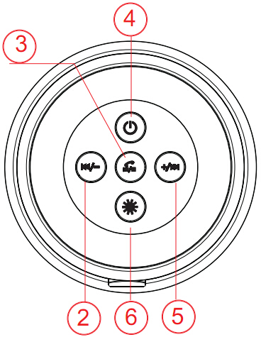
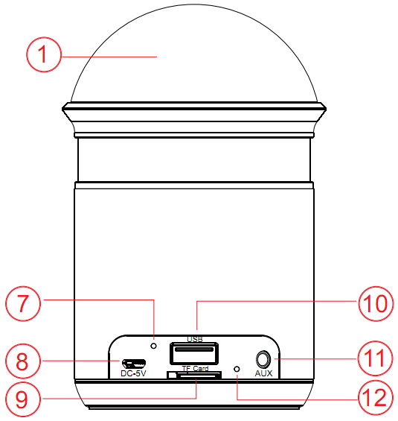
1 | LED dome lights | 2 | Back / Volume –
7 | Microphone | 3 | Play / Pause / Hands-free
8 | Micro USB charging port | 4 | Power / ON / OFF
9 | MicroSD card slot | 5 | Forth / Volume +
10 | USB flash drive port | 6 | LED dome lights controller
11 | AUX–IN port
12 | LED indicator light

Table for the product overview
1 | LED dome lights
2 | Back  Volume – | Press short to go back to the previous song.  Press and hold to decrease the volume.
3 | Play  Pause  Hands-free | Press short to play, pause or restart streming music when the speaker is connected via Bluetooth with another Bluetooth device. It can also answer a call or hang up while being connected with a Smartphone.  Press long to switch from the Bluetooth mode into another mode (MicroSD, USB, AUX–IN, FM).
4 | Power  ON / OFF | Press long to turn ON the speaker, LED turns on BLUE.  When the speaker is on, press long to turn it OFF.
5 | Forth  Volume + | Press short to go forth to the next song.  Press and hold to increase the volume. If you put the speaker on maximum volume, you will hear a “beep” sound to show, VOL cannot be increased any more, and music playback will stop. But after several seconds the speaker will continue to play music.
6 | LED dome lights  controller |  | Press short to switch to the “Light flashing mode”.  Press long to enter the Bluetooth “re-pairing” mode.
7 | Microphone
8 | Micro USB charging port
9 | MicroSD card slot
10 | USB flash drive port
11 | AUX–IN port
12 | LED indicator light
3. Turn ON – OFF (see key 4)
(a) Turn ON the speaker: Press key (4) for 2–3 seconds; you will hear a “Beep” sound.
(b) Turn OFF the speaker: Press key (4) for 2–3 seconds; you hear a “Beep” sound again.

4. Bluetooth Pairing
Turn ON the speaker. The speaker is in the Bluetooth mode directly and the BLUE LED flashes. Then turn on your mobile device, go to settings and choose Bluetooth. Now you can search for the Bluetooth name of the speaker, which is „MusicMan Disco“. [Put the PIN code “0000” for Bluetooth connection if necessary.] When you found it click on it. After the Bluetooth connection is established and you will hear a “Beep” sound, and the BLUE LED on the speaker lights constantly. Now you can play music from your mobile device and the music will stream through the speaker. If the speaker fails to connect, please start the Bluetooth connection (as described above) again, until you get connected.

5. Bluetooth Phone Calls
When there is an incoming phone call, press short the  key to answer the call through your speaker. Press short the key again to hang up the call.

6. Bluetooth Music
Press the PLAY/PAUSE/HANDS-FREE key and change to Bluetooth mode. After successful pairing, press the key once to play music sourcing from your mobile device. Press it again to pause the music playback. The BLUE LED lights constantly. Change songs: Press short the +/ key for the next song, press short the /- key for the previous song. Adjust volume: Press and hold long the +/ key to increase the volume, press and hold long the /- key to decrease the volume.

When the speaker is playing from music from your Smartphone connected via Bluetooth, the BLUE LED is blinking.

7. Handling USB and MicroSD card
(a) Insert a USB flash drive into the USB slot (10) or a MicroSD card into the MicroSD card slot (9). Then the music starts directly. The BLUE LED (12) is blinking. To pause the music playback, press the key once; press it again and music playback will continue.
(b) Press short the /- key to you hear the previous song. Press and hold the /- key to decrease the volume. Press short the +/ key to hear the next song. Press and hold the +/ key to increase the volume.
NOTE: The last (!) inserted device has priority.

If you want to change the mode to USB, MicroSD card, AUX, FM radio or Bluetooth, press long the key.

8. FM Radio Mode

For better reception you can plug in the provided AUX cable in the AUX–IN port (11).

(a) Press long the key to change to FM mode
The BLUE LED is flashing. Now you have to search for channels. Press the key for 2–3 seconds to start the channel search function. The BLUE LED will not stop blinking fast, until the channel searching ends. The speaker is searching available channels in your area (frequency range 87.5–108.0MHz), and save them automatically. When channel searching is finished, the speaker will play the first channel found. If a channel is found, the BLUE LED is flashing slowly.
If a channel is received you hear the channel; if no channel is received, you hear a rushing noise. In that case start the channel searching function again.
(b) Press short the /- key to you hear the previous channel. Press and hold the /- key to decrease the volume. Press short the +/ key to hear the next channel. Press and hold the +/ key to increase the volume.
(c) If you want to leave the FM mode, press long the key to transfer to MicroSD card, to USB flash drive, AUX–IN or Bluetooth.

9. AUX–IN Mode (1)
To use the AUX–IN mode plug in the provided AUX cable (3.5mm cable) in the AUX–IN port (11) and the other end into audio slot of a mobile phone, notebook, tablet PC, MP3/MP4 player etc.
If you are in AUX–IN mode, you can hear the audio sourcing from other devices (e.g. computer/mobile devices). With the +/ key you can increase the volume, and with the /- key you can decrease the volume. If you press the key once, (only) the speaker is in “MUTE MODE”, but the connected device continues playing. Short press the key for playback or pause music. NOTE: To change the track you are hearing, you have to use the buttons on your mobile device! The BLUE LED is blinking when AUX–-IN is connected!

10. Handling LED dome lights
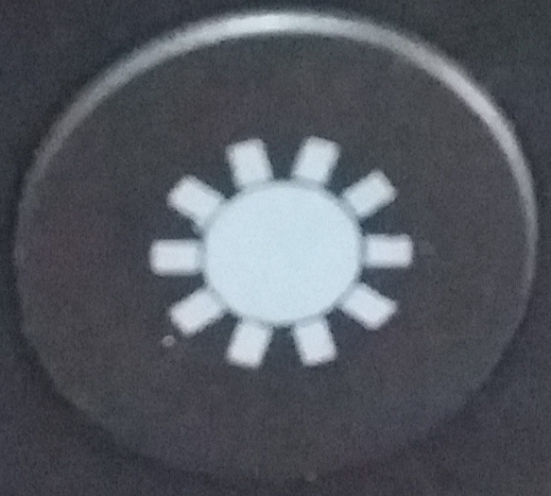
Press the LED dome light controller key (6) to start the LEDs. There are only mixed colours (from red, blue, yellow, green), which are produced by random. If the speaker is in “Playback” mode, the LEDs are flashing with tempo of the music. If the speaker is in “Pause” mode, the LEDs are flashing slowly in different colours.

Warnings
● If the speaker does not turn on after switching it on, or it turns off after turning it on, check whether the battery is fully charged. If it is OFF power, get it fully charged and try again later. (We suggest charging the speaker once a week if it is not used for a long time.)
● Only charge the speaker with in the slot of a PC/Notebook with the provided original Micro USB charging cable. You also can use an USB charging adapter but ONLY (!) up to DC 5V. Do not (!) charge the speaker with more power!
● When the speaker works under AUX–IN mode, do not (!) increase the volume of your mobile phone, PC, MP3/MP4 Player, CD, DVD etc. to a large extend; a sonic boom or sound distortion may occur. In that case, decrease volume either of mobile phone, PC, MP3/MP4 Player, CD, DVD or the speaker. The sound gets normal soon.
● If the speaker fails to link to your mobile device or if it fails to play music after being connected, the user shall check if the correct PIN code is entered or if your mobile device supports A2DP.
● Do not attempt to disassemble the speaker, it may result in short-circuit or even damage.
● Do not drop or shake the speaker, it may break internal circuit boards or mechanics.
● Keep the speaker in dry and ventilated environment. Avoid high humidity and high temperature. Also batteries should not be exposed to excessive heat or direct sunlight.
● This speaker is not water resistant; therefore keep it away from moisture.
● Keep the speaker away from little children.

Hints for Environment Protection: Packages materials are raw materials and can be recycled. Do not disposal old devices or batteries into the domestic waste. Cleaning: Protect the device from contamination and pollution (use a clean drapery). Avoid using rough, coarse-grained materials or solvents or aggressive cleaner. Wipe the cleaned device accurately. Important Notice: Should battery fluid leak from a battery, wipe the battery case with a soft cloth dry. Distributor: Technaxx Deutschland GmbH & Co.KG, Kruppstr. 105, 60388 Frankfurt a.M., Germany
